# Section Check In – Pure Mathematics: Proof

## Questions

1.*  and  prove that .

2. Prove the following result .

3. Prove by exhaustion that, in the set of natural numbers less than 50, there are fewer square numbers than prime numbers.

4. Let *p* be a prime number such that . Prove, by exhaustion, that for all such *p*,  is divisible by .

5.* Prove by deduction that the sum of all even numbers less than or equal to  is divisible by. You may find the arithmetic series results helpful.

6.* Prove by contradiction that the curves  and  do not cross.

7. Prove that an integer is divisible by 5 if and only if it is the sum of five consecutive integers.

8.* (i) Find a counter example to disprove the conjecture that curves of the form 

do not cross the *x*-axis.

(ii) Find a counter example to disprove the conjecture that an asymptote cannot be crossed by a curve by considering rational functions of the form

 where .

9. A cylindrical tin to hold food needs to have a volume of 500 cm3.

(i) Prove that a tin with diameter equal to its height has minimum total surface area for this volume.

(ii) Jason measures a tin with volume 500 cm3 and finds that it has height 11 cm. Show that Jason’s tin has about 1% more surface area than a tin with minimum surface area.

10.* (i) Prove by contradiction that for any integer ,  and  do not have a prime factor

in common.

(ii) Explain why this implies that  must have at least two distinct prime factors.

(iii) What can you conclude about the number of distinct prime factors which  has?

*[This was the basis of Filip Saidak’s proof of the infinity of primes in 2005*.]

**Extension**

1. Read about Filip Saidak’s proof of the infinity of primes.

2. If the circle  and the line  do not meet prove that .

## Worked solutions

1. 

2. 

Proof:









Hence proven.

3. Proof by exhaustion:

All square numbers less than  are 

All prime numbers less than  are 

Therefore there are fewer squares than primes.

4. Proof by exhaustion:

|  |  |  |
| --- | --- | --- |
|  |  | Multiple of 8? |
| 3 | 2(4) | 8 |
| 5 | 4(6)24 | 3(8) |
| 7 | 6(8) | 6(8) |
| 11 | 10(12) | 15(8) |
| 13 | 12(14) | 21(8) |
| 17 | 16(18) | 36(8) |
| 19 | 18(20) | 45(8) |
| 23 | 22(24) | 66(8) |

Therefore for *p* prime such that ,  is divisible by .

5. 







Therefore the sum of all even numbers less than or equal to  is divisible by .

6. Suppose the curves cross.

At the crossing points, .





 or  but there are no real values of *x* for either of these. So the original assumption that the curves cross must be untrue. The curves do not cross.

7. Since this is an if and only if statement, it needs to be proved both ways.

Suppose an integer is the sum of five consecutive integers.

Let the integers be , , , , .

Sum  which is divisible by 5.

So

Integer is sum of five consecutive integers  integer is divisible by 5.

Suppose an integer is divisible by 5.

The integer can be written as  where *n* is an integer.

 which is the sum of five consecutive integers.

Hence

Integer is sum of five consecutive integers  integer is divisible by 5.

8. (i) Use graphing software to check that your example is a true counter example with a curve which crosses the *x*-axis.

You could search for a counter example by considering transformations of the curve  or by looking for values of *a*, *b* and *x* for which .

For instance, .

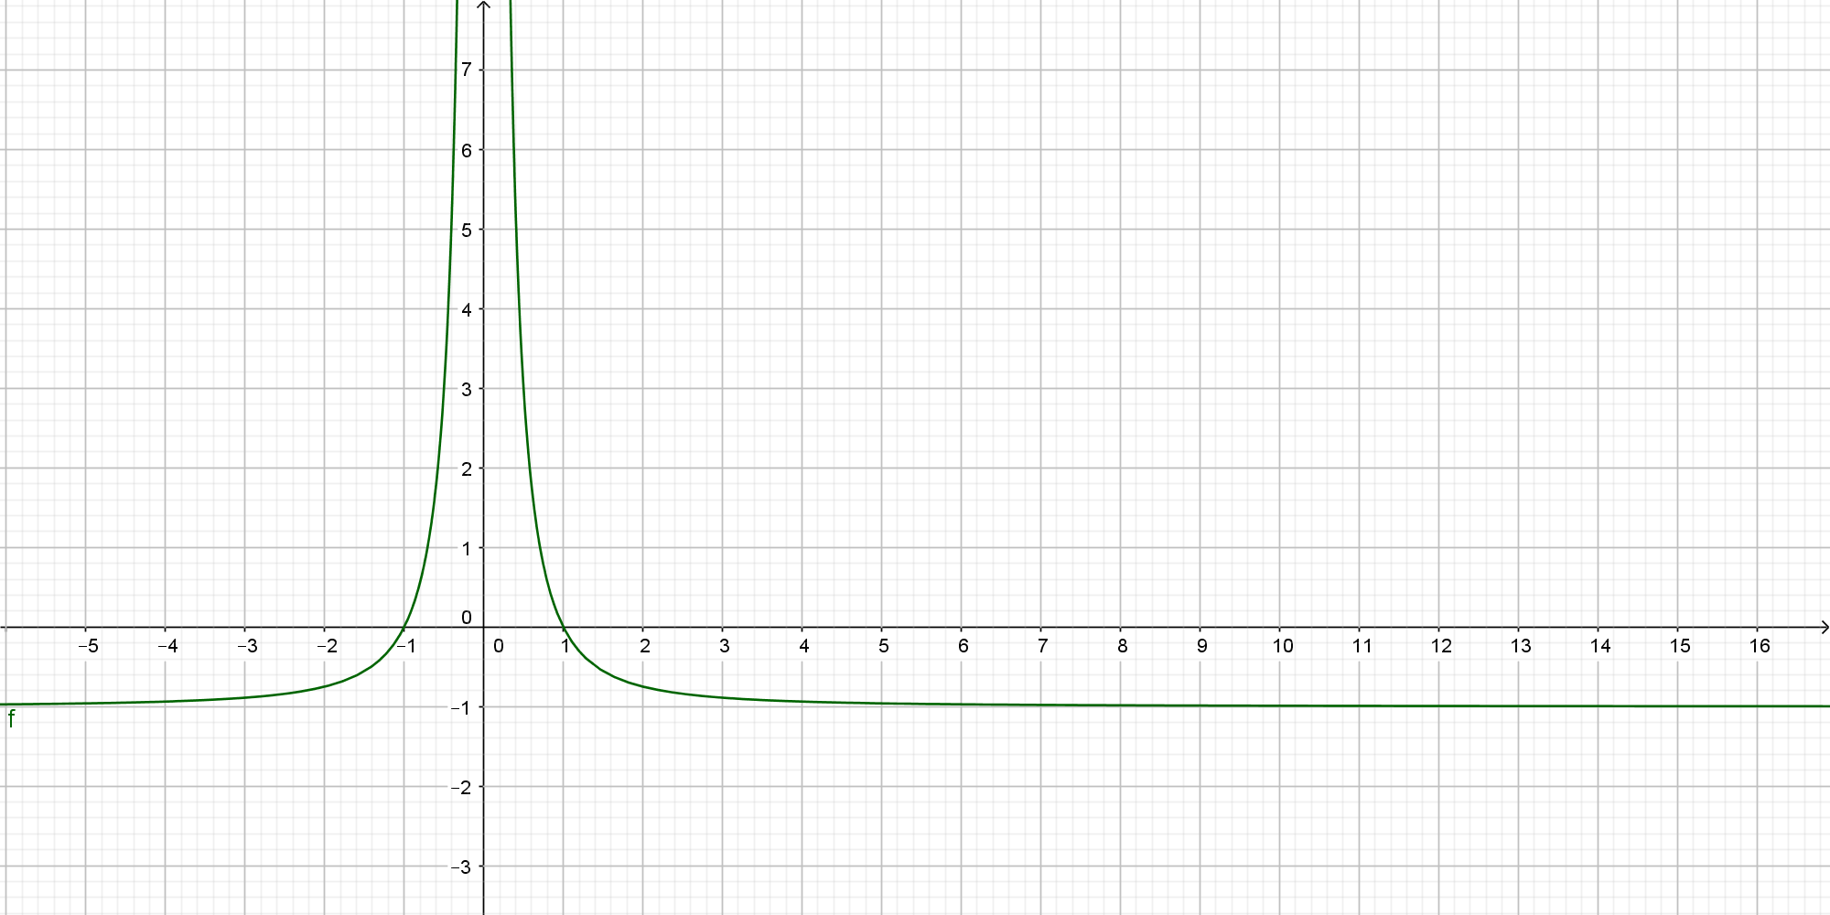

(ii) Use graphing software to check that your example is a true counter example with an asymptote which is also crossed by the curve itself.

For instance,  has the *x*-axis as an asymptote but also crosses the *x*-axis at .

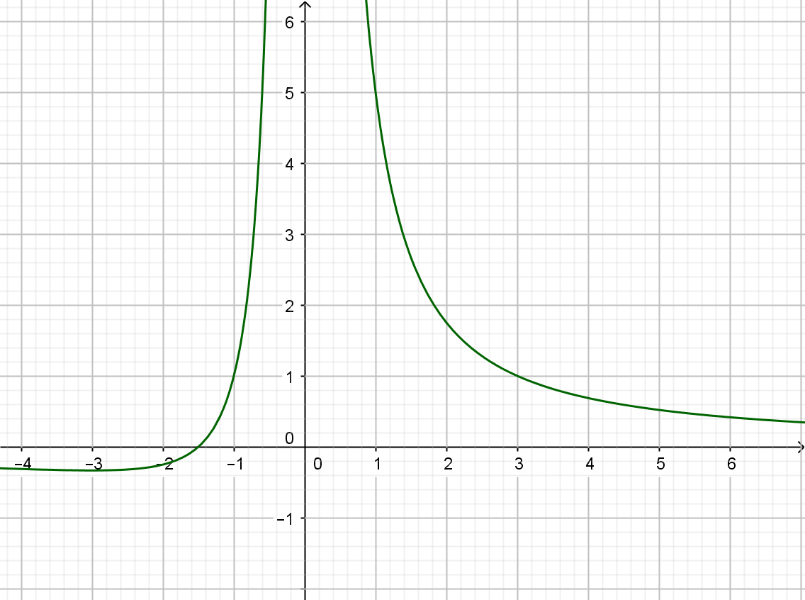

9. (i) Volume 



Surface area (say)

So 



For minimum 

So .





The height is twice the radius, hence equal to the diameter.

It remains to show that this is a minimum rather than a maximum.

. This is positive so the surface area is a minimum.

(ii) 

Minimum surface area 

 and 



 i.e. about 1% more.

10. (i) Suppose  and  have a prime factor, *p*, in common.



 where *s* and *t* are integers.

Subtracting,  where each of  and  are integers but 1 only has itself

as a factor so this is a contraction.

Hence,  and  cannot have a prime factor, *p*, in common.

(ii) Each of  and  have at least one prime factor and these are not the same.

(iii)  is 1 more than  and so has no prime factor in common with .

 has at least two prime factors so  has at least three prime factors.

**Extension**

 and 







If circle and line do not meet then 

Which leads to 

Hence to . Which is proven.

**OCR Resources**: *the small print*OCR’s resources are provided to support the delivery of OCR qualifications, but in no way constitute an endorsed teaching method that is required by the Board, and the decision to use them lies with the individual teacher. Whilst every effort is made to ensure the accuracy of the content, OCR cannot be held responsible for any errors or omissions within these resources.

© OCR 2017 - This resource may be freely copied and distributed, as long as the OCR logo and this message remain intact and OCR is acknowledged as the originator of this work.

OCR acknowledges the use of the following content: n/a

Please get in touch if you want to discuss the accessibility of resources we offer to support delivery of our qualifications: [resources.feedback@ocr.org.uk](mailto:resources.feedback@ocr.org.uk)

We’d like to know your view on the resources we produce. By clicking on [‘Like’](mailto:resources.feedback@ocr.org.uk?subject=I%20liked%20the%20AS%20and%20A%20Level%20Maths%20B%20MEI%20Section%20Check%20In%20Pure%20Mathematics%20Proof) or ‘[Dislike](mailto:resources.feedback@ocr.org.uk?subject=I%20disliked%20the%20AS%20and%20A%20Level%20Maths%20B%20MEI%20Section%20Check%20In%20Pure%20Mathematics%20Proof)’ you can help us to ensure that our resources work for you. When the email template pops up please add additional comments if you wish and then just click ‘Send’. Thank you.

Whether you already offer OCR qualifications, are new to OCR, or are considering switching from your current provider/awarding organisation, you can request more information by completing the Expression of Interest form which can be found here: [www.ocr.org.uk/expression-of-interest](http://www.ocr.org.uk/expression-of-interest)

Looking for a resource? There is now a quick and easy search tool to help find free resources for your qualification:   
[www.ocr.org.uk/i-want-to/find-resources/](http://www.ocr.org.uk/i-want-to/find-resources/)