# Section Check In – 4.02 Complex Numbers

## Questions

1. Given the complex numbers  and .

(i) Find

(a) 

(b) 

(c) 

(ii) Plot ,  and your answers to part (i) on a single Argand diagram.

2. (i) Given that  find the two possible values of .

(ii) Plot  and its two square roots on an Argand diagram.

3.* (i) Write the two complex numbers  and  in the form .

(ii) Hence find  in the form .

4. Given that  find the two values of in modulus-argument form.

5. Draw on the same diagram the locus of points given by and .

Shade the region satisfied by the inequalities  and .

6.* Using the identities for  and  in terms of  show that .

7. In an Argand diagram the points *A* and *B* represent the numbers  and .

Given that *ABC* is an equilateral triangle, find the two possible numbers which could be represented by *C*.

8.* Given that  find the roots of  in the form .

Sketch these roots on an Argand diagram and hence find the length of the sides of the shape you have drawn.

9. Given that  is one root of the cubic polynomial  and that the sum of all three roots is 10, find the values of , ,  and .

10.* (i) Use de Moivre’s theorem to express  in terms of powers of .

(ii) Hence solve the equation  for .

**Extension**

Can you find a quadratic where one of the roots is

(i)  (ii)  (iii)  (iv) 

## Worked solutions

1. (i) (a) 



(b) 



(c) 



(ii)

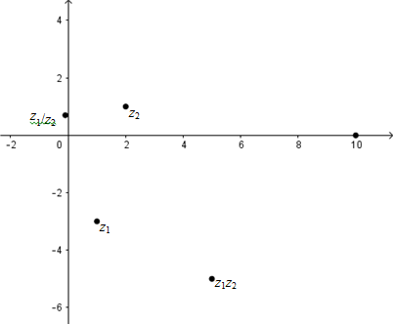

2. (i) 

, 



  and 

(ii)

3-i

8-6i

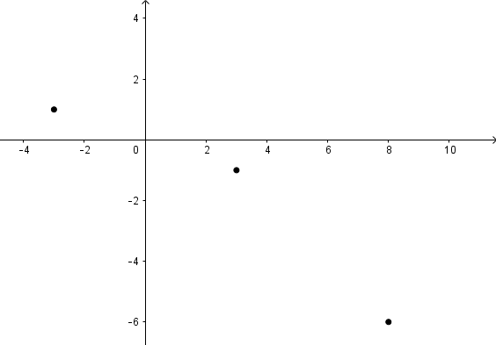

-3+i

3. (i) 











(ii) 





4. 





,  and  giving  or 

5.

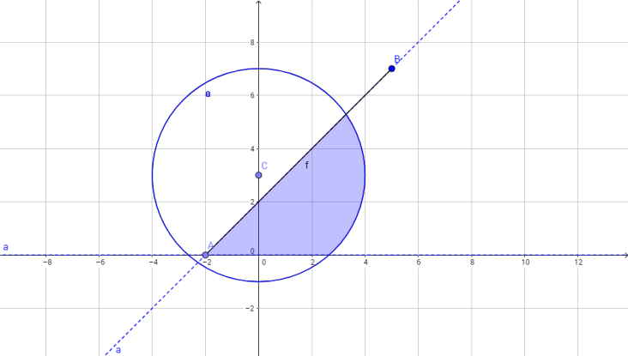

6. 





7.

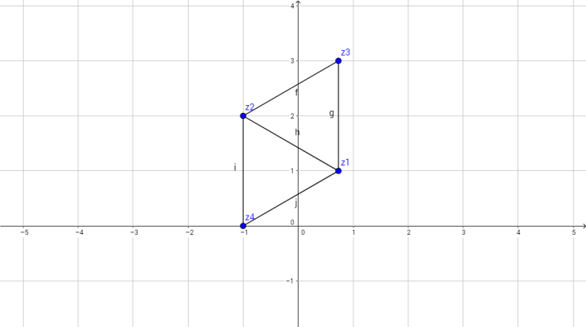



 or 

8. 







, , ,, 

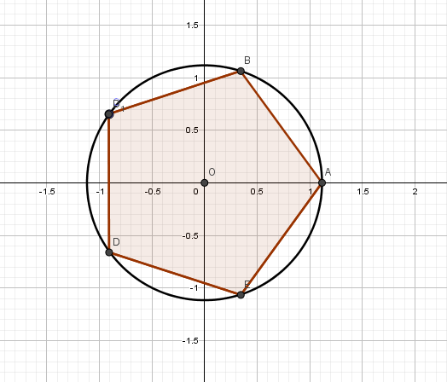

Length of pentagon side



9. 







So they are the roots of 



so  and the cubic is 

Therefore , ,  and .

10. (i) Using de Moivre





Taking real parts





giving 

(ii) Now make the substitution  so that  becomes  so  with .

 means that we only want roots leading to positive values of 

so , giving , ,  to 2 dp.

**Extension**

(i) 





(ii) 





(iii) 





(iv) 





**OCR Resources**: *the small print*OCR’s resources are provided to support the teaching of OCR specifications, but in no way constitute an endorsed teaching method that is required by the Board, and the decision to use them lies with the individual teacher. Whilst every effort is made to ensure the accuracy of the content, OCR cannot be held responsible for any errors or omissions within these resources.   
© OCR 2016 - This resource may be freely copied and distributed, as long as the OCR logo and this message remain intact and OCR is acknowledged as the originator of this work.

OCR acknowledges the use of the following content: n/a

Please get in touch if you want to discuss the accessibility of resources we offer to support delivery of our qualifications: [resources.feedback@ocr.org.uk](mailto:resources.feedback@ocr.org.uk)

We’d like to know your view on the resources we produce. By clicking on ‘[Like](mailto:resources.feedback@ocr.org.uk?subject=I%20liked%20the%20AS%20and%20A%20Level%20Further%20Maths%20A%20Section%20Check%20In%20–%204.02%20Complex%20Numbers)’ or ‘[Dislike](mailto:resources.feedback@ocr.org.uk?subject=I%20disliked%20the%20AS%20and%20A%20Level%20Further%20Maths%20A%20Section%20Check%20In%20–%204.02%20Complex%20Numbers)’ you can help us to ensure that our resources work for you. When the email template pops up please add additional comments if you wish and then just click ‘Send’. Thank you.

If you do not currently offer this OCR qualification but would like to do so, please complete the Expression of Interest Form which can be found here: [www.ocr.org.uk/expression-of-interest](http://www.ocr.org.uk/expression-of-interest)