M1.3 – Construct and interpret frequency tables and diagrams, bar charts and histograms

Teacher answers

Quiz
For the below data sets:
- Determine whether a histogram or bar chart is the more appropriate graph to plot with reasons.
- Plot the graph.

- Blood samples were taken from a group of patients and the frequency of blood groups is presented in the table below.
Blood group | Frequency
A | 40
B | 10
AB | 5
O | 40

- Bar chart – qualitative categoric data
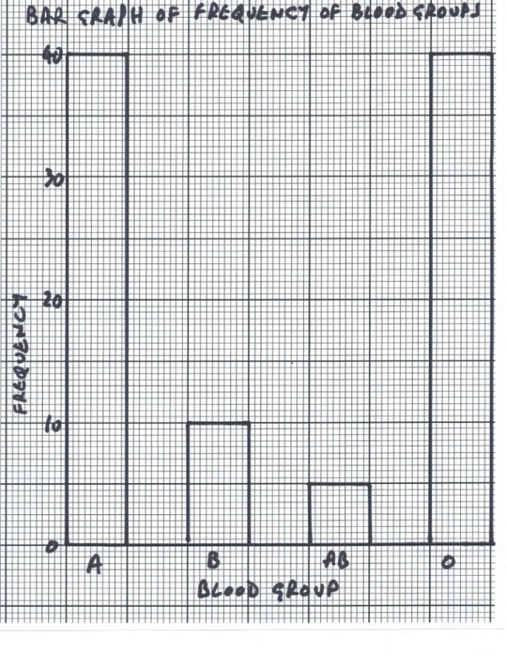

- The ages of teenage boys and men attending at least one hour of gym class in a week were recorded. Process and present these data to show how the numbers doing this kind of exercise vary with age.

Age (years) | Age (years) | Age (years) | Age (years) | Age (years) | Age (years) | Age (years) | Age (years) | Age (years) | Age (years)
15.7 | 56.1 | 50.1 | 34.1 | 16.4 | 44.2 | 65.5 | 45.0 | 57.4 | 22.2
31.7 | 35.4 | 17.8 | 19.2 | 32.2 | 62.9 | 77.0 | 28.1 | 33.4 | 18.8
23.6 | 25.6 | 27.7 | 48.7 | 39.9 | 30.9 | 34.4 | 77.8 | 53.7 | 52.2
27.0 | 17.2 | 43.5 | 21.1 | 54.2 | 31.1 | 24.4 | 18.1 | 34.0 | 21.5
16.3 | 25.0 | 20.6 | 19.9 | 22.7 | 64.0 | 29.9 | 24.2 | 32.4 | 17.7
36.4 | 22.0 | 21.0 | 50.4 | 18.6 | 19.6 | 49.1 | 38.6 | 49.9 | 46.1
48.8 | 31.1 | 39.8 | 57.3 | 30.1 | 33.1 | 23.5 | 36.1 | 41.1 | 43.7

Histogram – quantitative continuous data
Firstly decide what classes you are going to organise the data into. Create a table for these data:
Age (years) | Number of men and teenage boys
15-24
25-34
35-44
45-54
55-64
65-74
75-84

Annotating the original data table can help keep track of which data items you are assigning to which classes as well as counting up the totals:

Age (years) | Age (years) | Age (years) | Age (years) | Age (years) | Age (years) | Age (years) | Age (years) | Age (years) | Age (years)
15.7 | 56.1 | 50.1 | 34.1 | 16.4 | 44.2 | 65.5 | 45.0 | 57.4 | 22.2
31.7 | 35.4 | 17.8 | 19.2 | 32.2 | 62.9 | 77.0 | 28.1 | 33.4 | 18.8
23.6 | 25.6 | 27.7 | 48.7 | 39.9 | 30.9 | 34.4 | 77.8 | 53.7 | 52.2
27.0 | 17.2 | 43.5 | 21.1 | 54.2 | 31.1 | 24.4 | 18.1 | 34.0 | 21.5
16.3 | 25.0 | 20.6 | 19.9 | 22.7 | 64.0 | 29.9 | 24.2 | 32.4 | 17.7
36.4 | 22.0 | 21.0 | 50.4 | 18.6 | 19.6 | 49.1 | 38.6 | 49.9 | 46.1
48.8 | 31.1 | 39.8 | 57.3 | 30.1 | 33.1 | 23.5 | 36.1 | 41.1 | 43.7

Complete the processed data table:
Age (years) | Number of men and teenage boys
15-24 | 23
25-34 | 18
35-44 | 10
45-54 | 11
55-64 | 5
65-74 | 1
75-84 | 2

Plot the histogram:
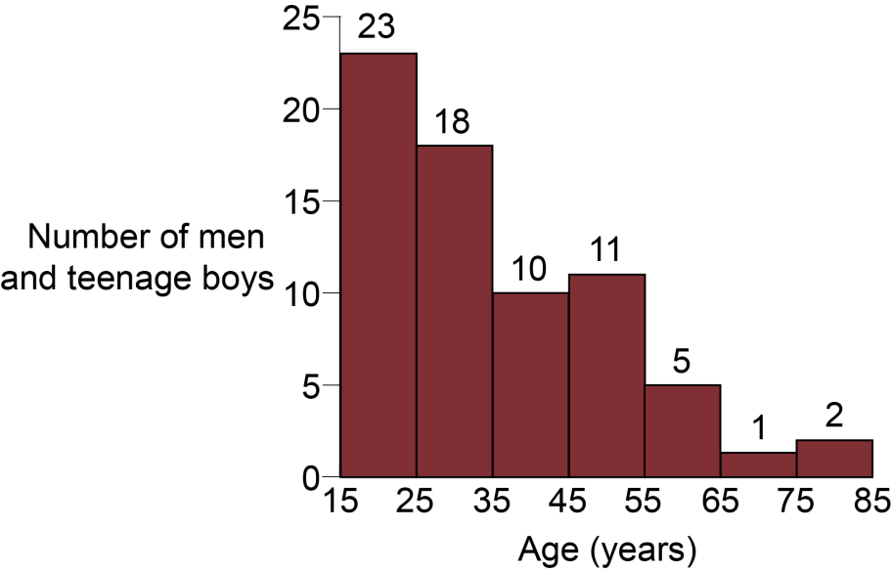

- Vitamin C content of fruits
Fruit | Vitamin C content (mg 100g ⁻¹)
Apple | 6
Banana | 9
Lemon | 46
Kiwi fruit | 96
Orange | 53
Strawberry | 57

Bar chart – quantitative categoric data
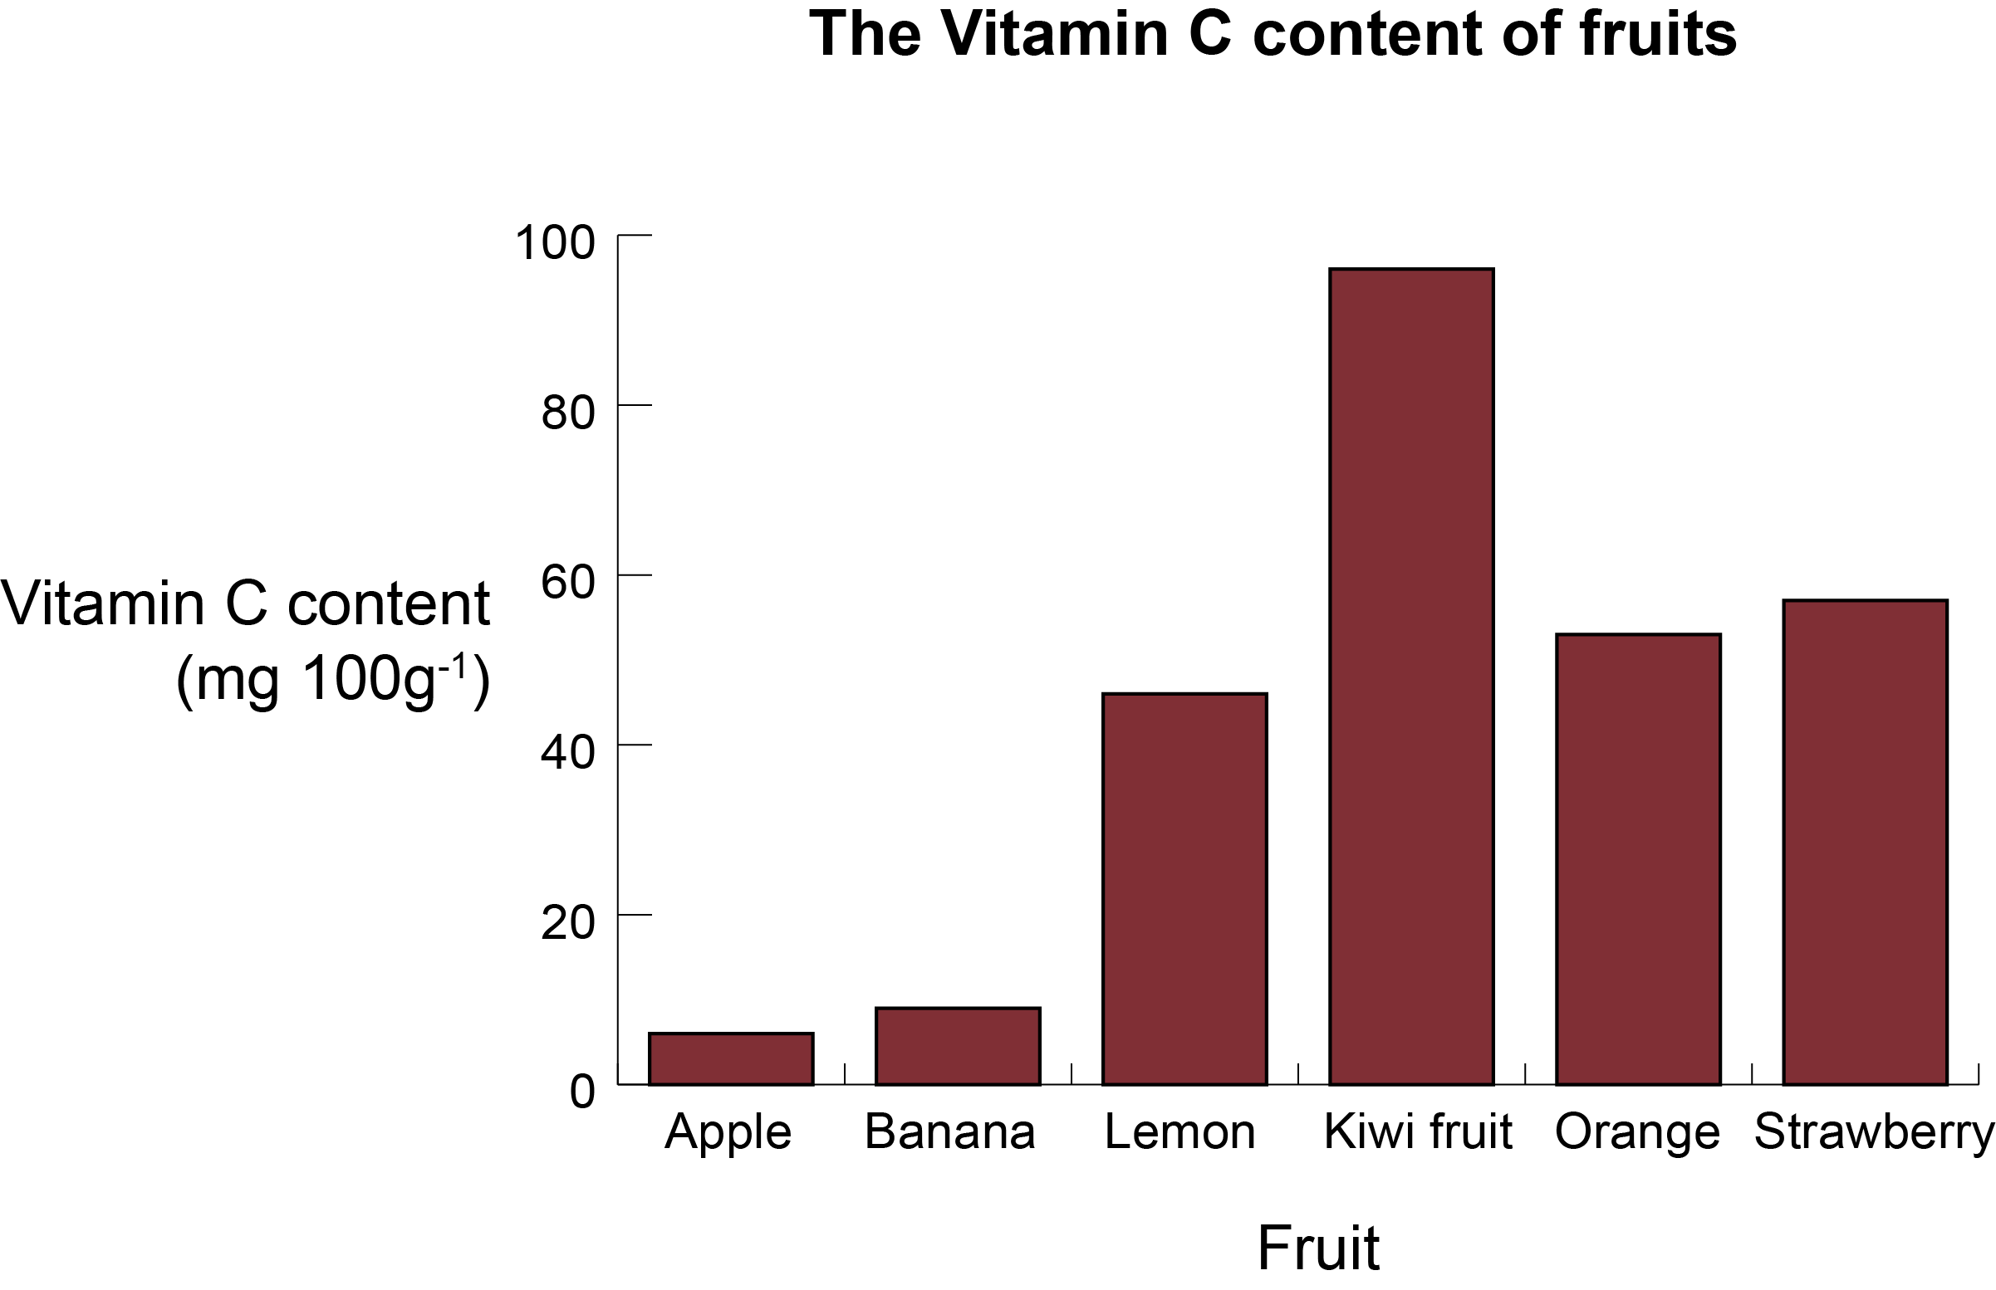

This formative assessment resource has been produced as part of our free A Level teaching and learning support package. All the A Level teaching and learning resources, including delivery guides, topic exploration packs, lesson elements and more are available on the qualification webpages.
If you are looking for examination practice materials, you can find the Sample Assessment Materials (SAMs) on the qualification webpages: Biology A / Biology B

We’d like to know your view on the resources we produce. By clicking on ‘Like’ or ‘Dislike’ you can help us to ensure that our resources work for you. When the email template pops up please add additional comments if you wish and then just click ‘Send’. Thank you.
If you do not currently offer this OCR qualification but would like to do so, please complete the Expression of Interest Form which can be found here: www.ocr.org.uk/expression-of-interest
Looking for a resource? There is now a quick and easy search tool to help find free resources for your qualification:
www.ocr.org.uk/i-want-to/find-resources/

OCR Resources: the small print
OCR’s resources are provided to support the delivery of OCR qualifications, but in no way constitute an endorsed teaching method that is required by the Board, and the decision to use them lies with the individual teacher. Whilst every effort is made to ensure the accuracy of the content, OCR cannot be held responsible for any errors or omissions within these resources.
© OCR 2016 - This resource may be freely copied and distributed, as long as the OCR logo and this message remain intact and OCR is acknowledged as the originator of this work.
OCR acknowledges the use of the following content: n/a
Please get in touch if you want to discuss the accessibility of resources we offer to support delivery of our qualifications: resources.feedback@ocr.org.uk

Produced in collaboration with the University of East Anglia

OCR Resources: the small print
OCR’s resources are provided to support the delivery of OCR qualifications, but in no way constitute an endorsed teaching method that is required by the Board, and the decision to use them lies with the individual teacher. Whilst every effort is made to ensure the accuracy of the content, OCR cannot be held responsible for any errors or omissions within these resources.
© OCR 2017 - This resource may be freely copied and distributed, as long as the OCR logo and this message remain intact and OCR is acknowledged as the originator of this work.
OCR acknowledges the use of the following content: n/a
Please get in touch if you want to discuss the accessibility of resources we offer to support delivery of our qualifications: resources.feedback@ocr.org.uk

Produced in collaboration with the University of East Anglia
We’d like to know your view on the resources we produce. By clicking on ‘Like’ or ‘Dislike’ you can help us to ensure that our resources work for you. When the email template pops up please add additional comments if you wish and then just click ‘Send’. Thank you.
If you do not currently offer this OCR qualification but would like to do so, please complete the Expression of Interest Form which can be found here: www.ocr.org.uk/expression-of-interest
Looking for a resource? There is now a quick and easy search tool to help find free resources for your qualification:
www.ocr.org.uk/i-want-to/find-resources/

This formative assessment resource has been produced as part of our free A Level teaching and learning support package. All the A Level teaching and learning resources, including delivery guides, topic exploration packs, lesson elements and more are available on the qualification webpages.
If you are looking for examination practice materials, you can find the Sample Assessment Materials (SAMs) on the qualification webpages: Biology A / Biology B

