# M1.8 Make order of magnitude calculations

### Tutorials

Learners may be tested on their ability to:

* use and manipulate the magnification formula,



### Order of magnitude

Orders of magnitude are used to make approximate comparisons of size or quantity. If two numbers have the same order of magnitude, they are about the same size. If two numbers differ by one order of magnitude, one is about ten times larger than the other. If they differ by two orders of magnitude, they differ by a factor of about 100, and so on.

|  |  |
| --- | --- |
| [**Powers**](https://simple.wikipedia.org/wiki/Exponent#Powers_of_ten) **of ten** | **Order of magnitude** |
| 0.0001 | −4 |
| 0.001 | −3 |
| 0.01 | −2 |
| 0.1 | −1 |
| 1 | 0 |
| 10 | 1 |
| 100 | 2 |
| 1,000 | 3 |
| 10,000 | 4 |

For example, if you were comparing the surface of an orange with that of the earth, one would say the surface of the earth is many orders of magnitude larger than that of the orange.

The formula used to calculate magnification is:



You can rearrange the formula to calculate any of the three unknowns, as long as you have the other two. However for this to work you must make sure that both quantities/sizes are in the same units.

For example take the following micrograph showing a section of mouse pancreas at high power, one acinus (a cluster of cells) is circled. The magnification of the micrograph is x400 and the length of the circled acinus is 32 mm. We want to calculate the actual size of the acinus.

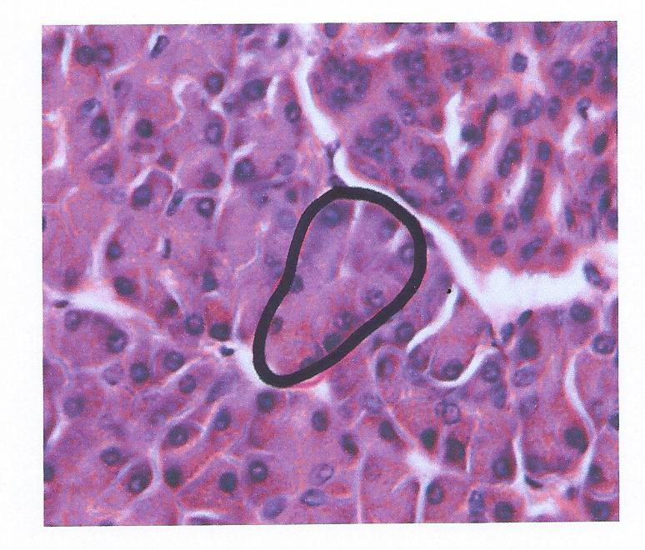

Magnification 🡪 x400

Length of the circled acinus in the image 🡪 32 mm

We want to calculate the actual size of the acinus. This means we need to rearrange the magnification formula (*rearranging formulas is covered in detail in section M2.2*) to make the size of real object the subject of the equation. This gives us the size of the real object equals the size of the image divided by the magnification.





In this example this means the actual size of the acinus is equal to 32 mm (the size of the acinus in the image) divided by 400 (the magnification). Therefore the actual size of the acinus is 0.080mm, or in more appropriate units, 80 µm.

32 mm / 400 = 0.080 mm = 80 µm

### Produced in collaboration with the University of East Anglia

This resource has been produced as part of our free A Level teaching and learning support package. All the A Level teaching and learning resources, including delivery guides, topic exploration packs, lesson elements and more are available on the qualification webpages.

If you are looking for examination practice materials, you can find the Sample Assessment Materials (SAMs) on the qualification webpages: [Biology A](http://www.ocr.org.uk/qualifications/as-a-level-gce-biology-a-h020-h420-from-2015/) / [Biology B](http://www.ocr.org.uk/qualifications/as-a-level-gce-biology-b-advancing-biology-h022-h422-from-2015/)

We’d like to know your view on the resources we produce. By clicking on ‘[Like](mailto:resources.feedback@ocr.org.uk?subject=I%20liked%20the%20A%20Level%20Biology%20A%20and%20B%20M1.8%20Make%20order%20of%20magnitude%20calculations)’ or ‘[Dislike](mailto:resources.feedback@ocr.org.uk?subject=I%20disliked%20the%20A%20Level%20Biology%20A%20and%20B%20M1.8%20Make%20order%20of%20magnitude%20calculations)’ you can help us to ensure that our resources work for you. When the email template pops up please add additional comments if you wish and then just click ‘Send’. Thank you.

If you do not currently offer this OCR qualification but would like to do so, please complete the Expression of Interest Form which can be found here: [www.ocr.org.uk/expression-of-interest](http://www.ocr.org.uk/expression-of-interest)

Looking for a resource? There is now a quick and easy search tool to help find free resources for your qualification:   
[www.ocr.org.uk/i-want-to/find-resources/](http://www.ocr.org.uk/i-want-to/find-resources/)

**OCR Resources**: *the small print*OCR’s resources are provided to support the delivery of OCR qualifications, but in no way constitute an endorsed teaching method that is required by the Board, and the decision to use them lies with the individual teacher. Whilst every effort is made to ensure the accuracy of the content, OCR cannot be held responsible for any errors or omissions within these resources.   
© OCR 2017 - This resource may be freely copied and distributed, as long as the OCR logo and this message remain intact and OCR is acknowledged as the originator of this work.

OCR acknowledges the use of the following content: n/a

Please get in touch if you want to discuss the accessibility of resources we offer to support delivery of our qualifications: [resources.feedback@ocr.org.uk](mailto:resources.feedback@ocr.org.uk)