M1.8 Make order of magnitude calculations

Quiz
1 This is an electron micrograph of a mitochondrion. Its actual length is 5 μm. Calculate the magnification of the image.
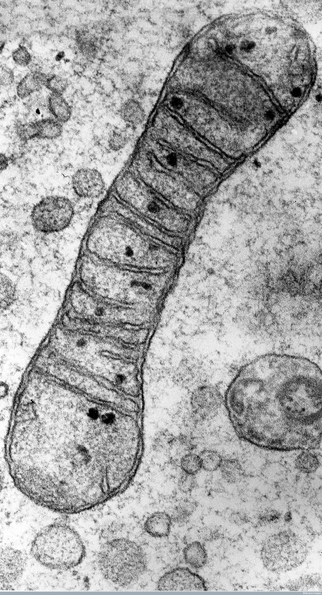
B0000119 Credit Prof. R. Bellairs, Wellcome Images
TEM of a mitochondrion
A transmission electron micrograph of a mitochondrion in a chick embryo cell.
Collection: Wellcome Images
Copyrighted work available under Creative Commons Attribution only licence CC BY 4.0 http://creativecommons.org/licenses/by/4.0/

2 This botanical illustration from about 250 years ago shows a banana plant. The image has a scale line where each division represents 30 cm. What is the magnification?
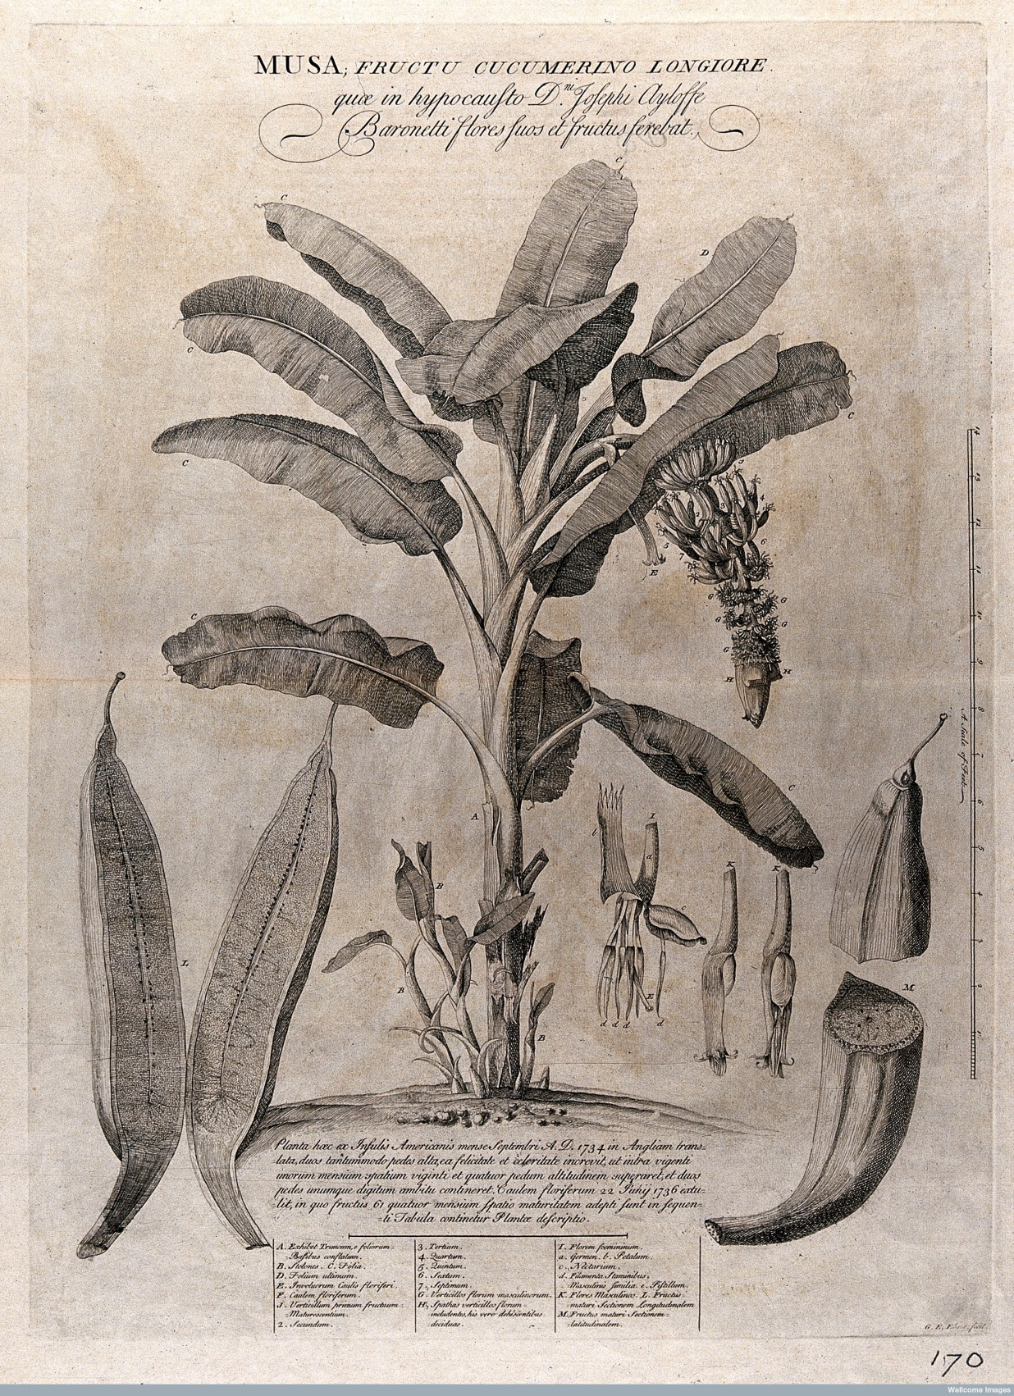
V0043033 Credit: Wellcome Library, London
Banana plant (Musa species): flowering and fruiting plant with stolons and separate floral segments and sectioned fruit, also a description of the plant's growth, anatomical labels and a scale bar. Etching by G. D. Ehret, c. 1742, after himself.
By: Georg Dionysius Ehret
Size: platemark 63.2 x 46.5 cm.
Collection: Iconographic Collections
Library reference no.: ICV No 43624
Full Bibliographic Record Link to Wellcome Library Catalogue
Copyrighted work available under Creative Commons Attribution only licence CC BY 4.0 http://creativecommons.org/licenses/by/4.0/

3 A false-colour transmission EM image of a white blood cell has a magnification of x2000. What is the diameter of the white blood cell?
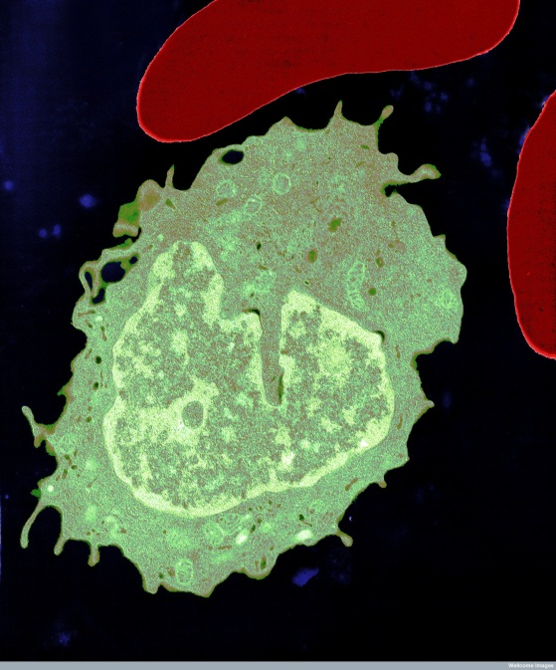
B0004162 Credit University of Edinburgh, Wellcome Images
Monocyte and two red blood cells
Colour-enhanced image of a monocyte and two red blood cells. Monocytes are white blood cells that develop into macrophages, cells that ingest and destroy dead cells and micro-organisms.
Transmission electron micrograph 1980 - 2000
Collection: Wellcome Images
Copyrighted work available under Creative Commons by-nc 4.0 https://creativecommons.org/licenses/by-nc/4.0/

Produced in collaboration with the University of East Anglia
OCR Resources: the small print
OCR’s resources are provided to support the delivery of OCR qualifications, but in no way constitute an endorsed teaching method that is required by the Board, and the decision to use them lies with the individual teacher. Whilst every effort is made to ensure the accuracy of the content, OCR cannot be held responsible for any errors or omissions within these resources.
© OCR 2017 - This resource may be freely copied and distributed, as long as the OCR logo and this message remain intact and OCR is acknowledged as the originator of this work.
OCR acknowledges the use of the following content: Q1 B0000119 Credit Prof. R. Bellairs, Wellcome Images Collection: Wellcome Images Copyrighted work available under Creative Commons Attribution only licence CC BY 4.0 http://creativecommons.org/licenses/by/4.0/; Q2 V0043033 Credit: Wellcome Library, London Copyrighted work available under Creative Commons Attribution only licence CC BY 4.0 http://creativecommons.org/licenses/by/4.0/; Q3 B0004162 Credit University of Edinburgh, Wellcome Images Copyrighted work available under Creative Commons by-nc 4.0 https://creativecommons.org/licenses/by-nc/4.0/
Please get in touch if you want to discuss the accessibility of resources we offer to support delivery of our qualifications: resources.feedback@ocr.org.uk

