Foundation Check In - 8.05 Circles

Each of these circles has its centre at O. Name the following parts of these circles.

1. | 2. |  | 3.
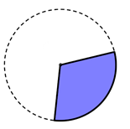  O | O
4. |  | 5.
O |  | O

Decide whether the statements in questions 6 and 7 are sometimes true, always true or never true. Explain your reasoning.

- A chord on a circle is shorter than a diameter of that circle.

- If two points are drawn on the circumference of a circle, the route between them on a chord is always shorter than the route between them on an arc.

- A semicircle is drawn on a page. Violet says it is also a sector. Max says it is also a segment. Who is correct? Explain your reasoning.

- Draw a circle of radius 6 cm. Mark a point on the circumference of the circle. Using just a pair of compasses, a pencil and a ruler, construct a tangent to the circle at this point.

- A circle has nine points spaced equally around its circumference. A chord is drawn connecting two of the nine points. How many different lengths of chord are possible? (You do not need to work out the lengths of the chords.)

Extension

Consider the circle in question 10. If there were ten equally spaced points on the circumference, how many different lengths of chords are possible? How about n points?

Answers

- Sector (or minor sector)

- Chord

- Segment (or major segment)

- Tangent

- Arc (or minor arc)

- Sometimes true. When a chord goes through the centre of a circle it will be the same as a diameter, however chords not going through the centre of the circle will always be shorter than the diameter.

- Always true. The shortest distance between two points on a 2D surface is a straight line. A curved path will always be longer.

- Both are correct. Violet is correct since a sector is enclosed by two radii and an arc: the diameter of the semicircle can be split into two radii. Max is correct since a segment is enclosed by a chord and an arc: the diameter of the semicircle is a chord.

- Tangents to a circle are at 90° to a radius, therefore (a) draw a radius from the centre of the circle to the point, then (b) construct a perpendicular line to the radius that passes through the point.

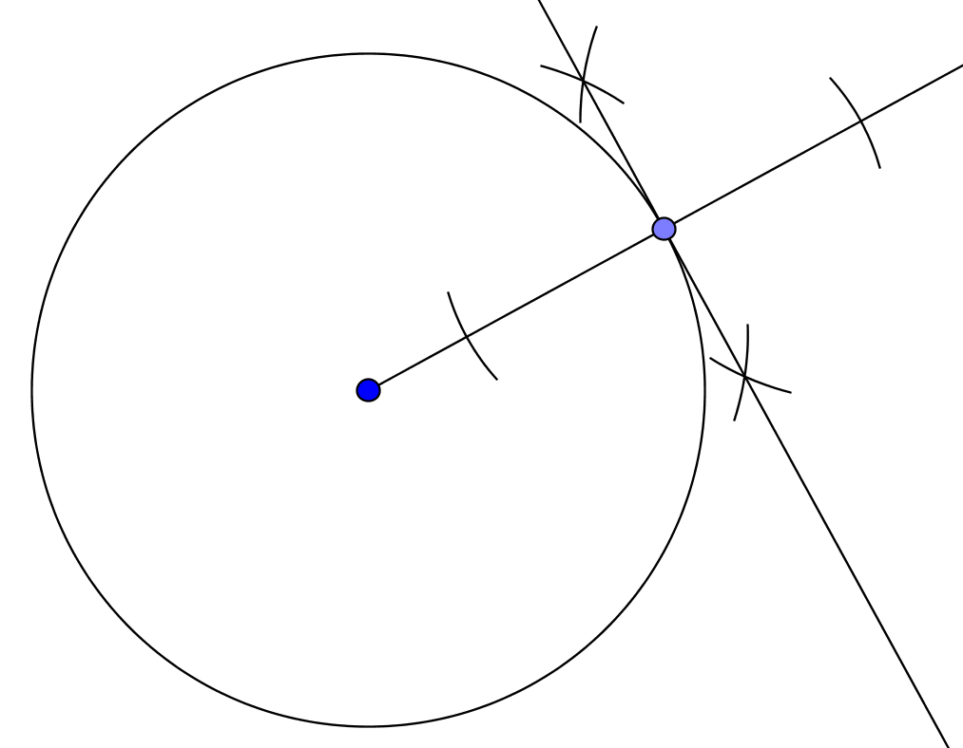

- Choosing a single point to draw a chord from, there are eight possibilities for the second end point of the chord. However because of the symmetry of the circle, four of these (shown as dotted lines below) will be mirror images of other chords and therefore the same length. There are four distinct lengths of chord joining these nine points.
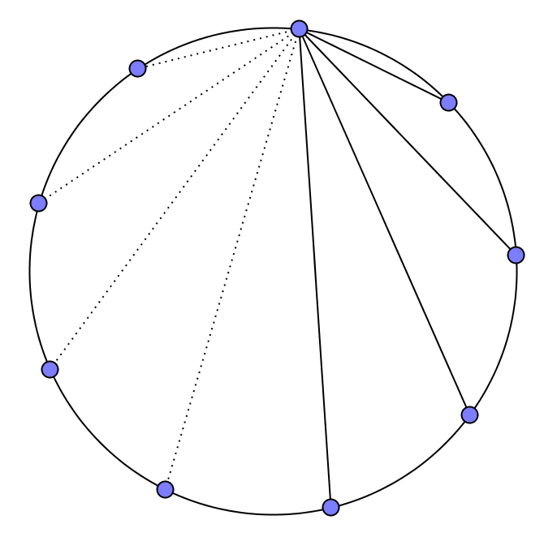

Extension

With ten points, there are nine chords from a given point. However, the chord that is a diameter will not have a mirror image. Therefore, five different lengths of chord will be possible.

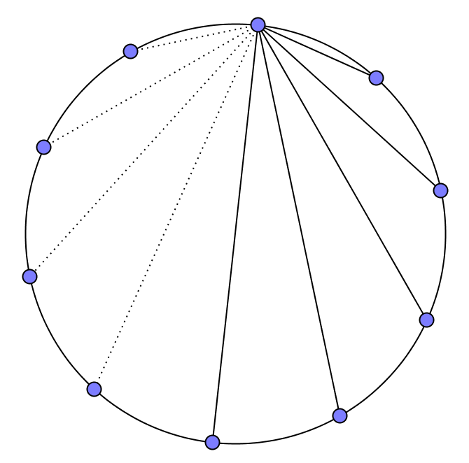

With n points:
- For an odd number of equally spaced points on the circumference of a circle, there will be different lengths of chord.
- For an even number of equally spaced points on the circumference of a circle, there will be different lengths of chord.
OCR Resources: the small print
OCR’s resources are provided to support the delivery of OCR qualifications, but in no way constitute an endorsed teaching method that is required by the Board, and the decision to use them lies with the individual teacher. Whilst every effort is made to ensure the accuracy of the content, OCR cannot be held responsible for any errors or omissions within these resources. This formative assessment resource has been produced as part of our free GCSE teaching and learning support package. All the GCSE teaching and learning resources, including delivery guides, topic exploration packs, lesson elements and more are available on the qualification webpages. If you are looking for examination practice materials, you can find Sample Assessment Materials (SAMs) and Practice Papers on the qualification webpage http://www.ocr.org.uk/qualifications/gcse-mathematics-j560-from-2015/
© OCR 2018 - This resource may be freely copied and distributed, as long as the OCR logo and this message remain intact and OCR is acknowledged as the originator of this work.
OCR acknowledges the use of the following content: n/a
Please get in touch if you want to discuss the accessibility of resources we offer to support delivery of our qualifications: resources.feedback@ocr.org.uk
We’d like to know your view on the resources we produce. By clicking on ‘Like’ or ‘Dislike’ you can help us to ensure that our resources work for you. When the email template pops up please add additional comments if you wish and then just click ‘Send’. Thank you.
Whether you already offer OCR qualifications, are new to OCR, or are considering switching from your current provider/awarding organisation, you can request more information by completing the Expression of Interest form which can be found here: www.ocr.org.uk/expression-of-interest
Looking for a resource? There is now a quick and easy search tool to help find free resources for your qualification:
www.ocr.org.uk/i-want-to/find-resources/

To give us feedback on, or ideas about the OCR resources you have used, email resourcesfeedback@ocr.org.uk
To give us feedback on, or ideas about the OCR resources you have used, email resourcesfeedback@ocr.org.uk
To give us feedback on, or ideas about the OCR resources you have used, email resourcesfeedback@ocr.org.uk
To give us feedback on, or ideas about the OCR resources you have used, email resourcesfeedback@ocr.org.uk
To give us feedback on, or ideas about the OCR resources you have used, email resourcesfeedback@ocr.org.uk
To give us feedback on, or ideas about the OCR resources you have used, email resourcesfeedback@ocr.org.uk
OCR Resources: the small print
OCR’s resources are provided to support the teaching of OCR specifications, but in no way constitute an endorsed teaching method that is required by the Board, and the decision to use them lies with the individual teacher. Whilst every effort is made to ensure the accuracy of the content, OCR cannot be held responsible for any errors or omissions within these resources.
© OCR 2014 - This resource may be freely copied and distributed, as long as the OCR logo and this message remain intact and OCR is acknowledged as the originator of this work.

OCR Resources: the small print
OCR’s resources are provided to support the teaching of OCR specifications, but in no way constitute an endorsed teaching method that is required by the Board, and the decision to use them lies with the individual teacher. Whilst every effort is made to ensure the accuracy of the content, OCR cannot be held responsible for any errors or omissions within these resources.
© OCR 2014 - This resource may be freely copied and distributed, as long as the OCR logo and this message remain intact and OCR is acknowledged as the originator of this work.
OCR acknowledges the use of the following content::
Garden: Elen Eliseeva/Shutterstock.com Flag: Pixel Europe/Shutterstock.com

To give us feedback on, or ideas about the OCR resources you have used, email resourcesfeedback@ocr.org.uk
Assessment Objective | Qu. | Topic | R | A | G |  | Assessment Objective | Qu. | Topic | R | A | G
AO1 | 1 | Understand the term sector |  |  |  |  | AO1 | 1 | Understand the term sector
AO1 | 2 | Understand the term chord |  |  |  |  | AO1 | 2 | Understand the term chord
AO1 | 3 | Understand the term segment |  |  |  |  | AO1 | 3 | Understand the term segment
AO1 | 4 | Understand the term tangent |  |  |  |  | AO1 | 4 | Understand the term tangent
AO1 | 5 | Understand the term arc |  |  |  |  | AO1 | 5 | Understand the term arc
AO2 | 6 | Understand and use the terms chord and diameter |  |  |  |  | AO2 | 6 | Understand and use the terms chord and diameter
AO2 | 7 | Understand and use the terms chord and arc |  |  |  |  | AO2 | 7 | Understand and use the terms chord and arc
AO2 | 8 | Understand and use the terms semicircle, segment and sector |  |  |  |  | AO2 | 8 | Understand and use the terms semicircle, segment and sector
AO3 | 9 | Understand the term tangent and construct the perpendicular to a line at a point |  |  |  |  | AO3 | 9 | Understand the term tangent and construct the perpendicular to a line at a point
AO3 | 10 | Solve a problem involving chords |  |  |  |  | AO3 | 10 | Solve a problem involving chords
Assessment Objective | Qu. | Topic | R | A | G |  | Assessment Objective | Qu. | Topic | R | A | G
AO1 | 1 | Understand the term sector |  |  |  |  | AO1 | 1 | Understand the term sector
AO1 | 2 | Understand the term chord |  |  |  |  | AO1 | 2 | Understand the term chord
AO1 | 3 | Understand the term segment |  |  |  |  | AO1 | 3 | Understand the term segment
AO1 | 4 | Understand the term tangent |  |  |  |  | AO1 | 4 | Understand the term tangent
AO1 | 5 | Understand the term arc |  |  |  |  | AO1 | 5 | Understand the term arc
AO2 | 6 | Understand and use the terms chord and diameter |  |  |  |  | AO2 | 6 | Understand and use the terms chord and diameter
AO2 | 7 | Understand and use the terms chord and arc |  |  |  |  | AO2 | 7 | Understand and use the terms chord and arc
AO2 | 8 | Understand and use the terms semicircle, segment and sector |  |  |  |  | AO2 | 8 | Understand and use the terms semicircle, segment and sector
AO3 | 9 | Understand the term tangent and construct the perpendicular to a line at a point |  |  |  |  | AO3 | 9 | Understand the term tangent and construct the perpendicular to a line at a point
AO3 | 10 | Solve a problem involving chords |  |  |  |  | AO3 | 10 | Solve a problem involving chords

