GCSE (9-1) Chemistry A & B

AS and A Level Chemistry A & B

Language of Measurement in Context

The purpose of this exemplar investigation is to illustrate the use of the language of measurement terms in the context of a Chemistry practical activity. Measurement terms in bold are fully defined in the glossary.

Determining the rate of a reaction
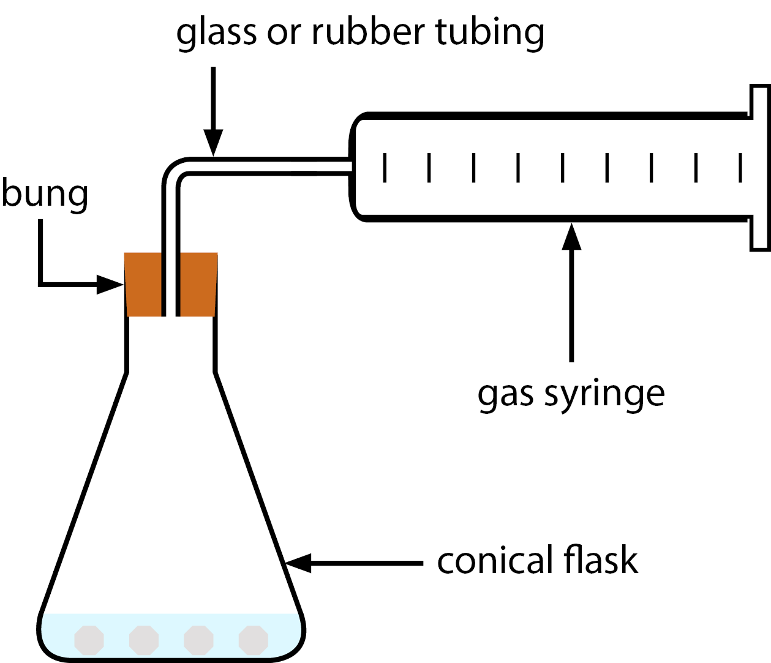
This practical investigates the rate of the reaction between calcium carbonate and hydrochloric acid. The volume of gas produced by the reaction is measured and used to monitor the rate of the reaction.
The volume and concentration of the hydrochloric acid used ensures that the acid is used up (so the calcium carbonate is in excess).

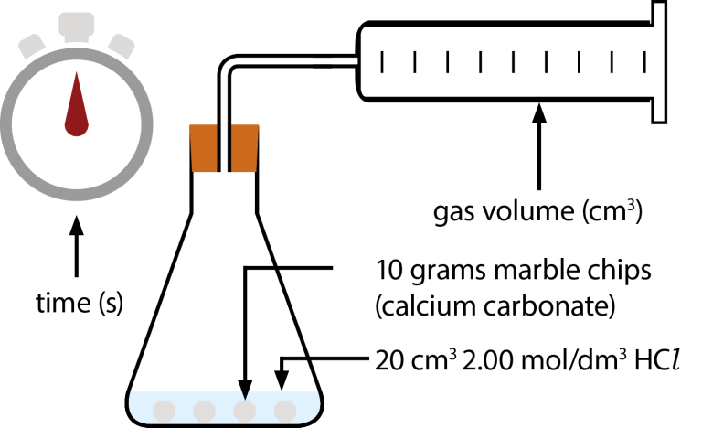
Before starting their investigation, the student identifies the variables involved:
For this practical, the mass of marble chips and the volume and concentration of hydrochloric acid are control variables (kept the same).
The independent variable is time (changes during the practical).
The gas volume is the dependent variable (measured during the practical).

To collect the gas produced, the student has to choose from two gas syringes:
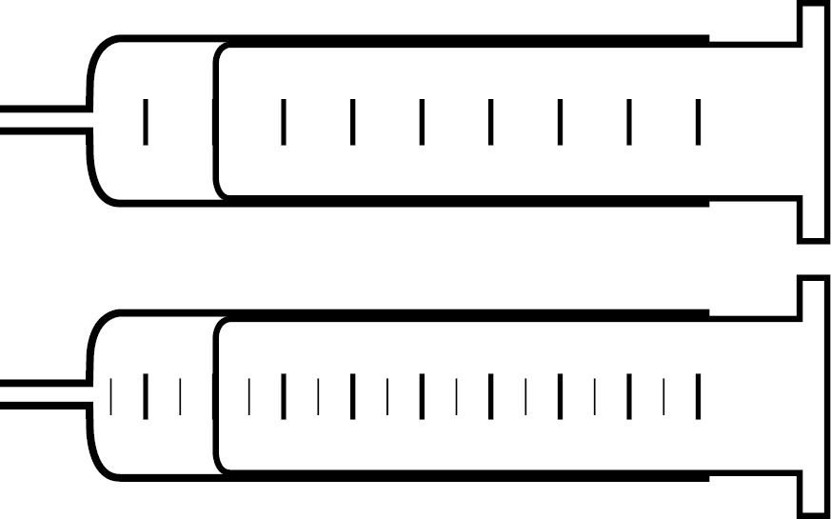
The bottom gas syringe has more graduations than the top syringe, so it can measure smaller changes. We can say it has a higher resolution.
Precision is used in reference to repeated measurement values, and shouldn’t be used instead of resolution.

The student identifies some potential sources of random error in their experiment:
Some gas may escape before the student places the bung in the conical flask at the start of the procedure. There may also be a delay between them noting a time on the stopwatch and making a measurement.

The student then records their results.
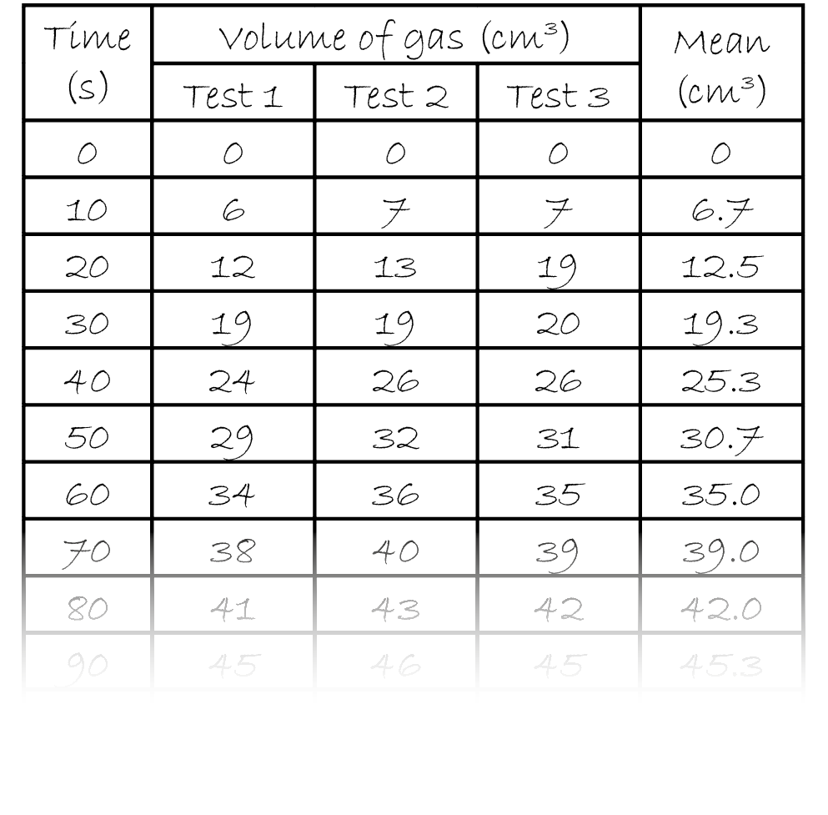
The repeated measurements of gas volume, obtained by the same student using the same method, are close together for each value of time. We can say that they have good repeatability. If we wanted to know if the results are reproducible we’d need to see if similar results are obtained using different students, methods or equipment. The term ‘reliable’ shouldn’t be used, as its meaning is unclear.
Repeated measurements that are close together can be described as precise.

An anomalous result can be ignored. Repeat the test or exclude the result from the mean calculation.
Repeated test values usually differ slightly due to random error. Averaging repeat measurements reduces the effect of random error.

After recording their results, the student calculates the uncertainty in each measurement.
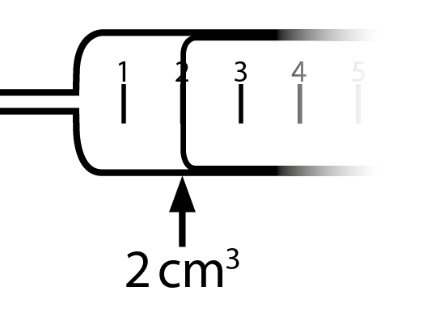
When using apparatus with an analogue graduated scale, we assume that the uncertainty in a single measurement is plus or minus half the smallest graduation. For the gas syringe shown to the left, the uncertainty is ±0.5 cm³.
In cases where a measurement value comes from two readings (for example, a burette), we double the uncertainty value to reflect this.

The student wants to know how the volume of gas produced by the end of their experiment compares to the volume of gas predicted by the reaction equation and quantities used.
CaCO₃(s) + 2HCl(aq) → CaCl₂(aq) + CO₂(g) + H₂O(l)
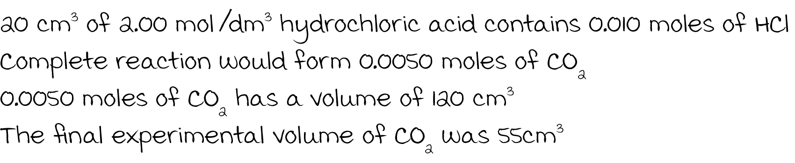
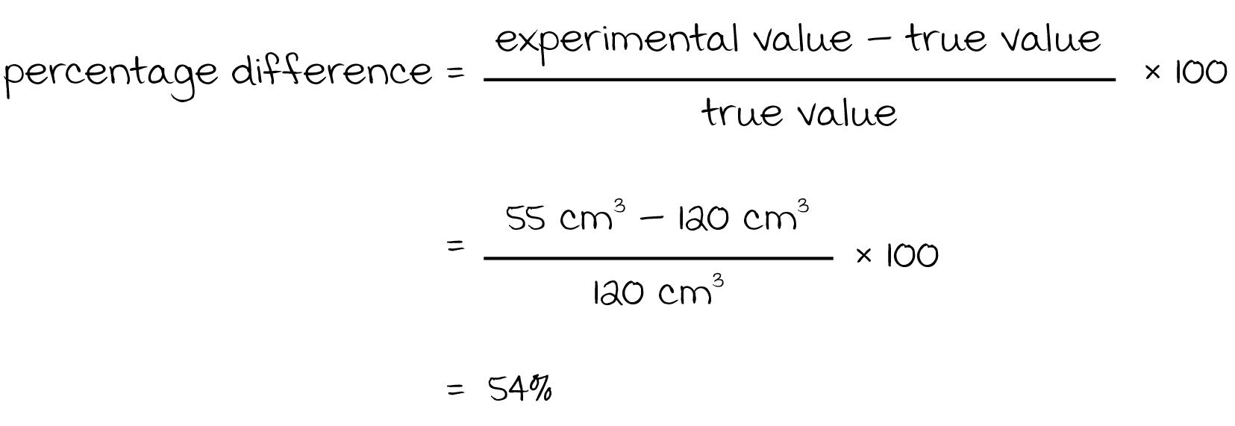
A result is accurate if it is close to the true value.
The percentage difference between the student’s experimental result and the calculated value for the volume of gas produced is very high. The student concludes that the final volume of gas at the end of their experiment is not an accurate value.
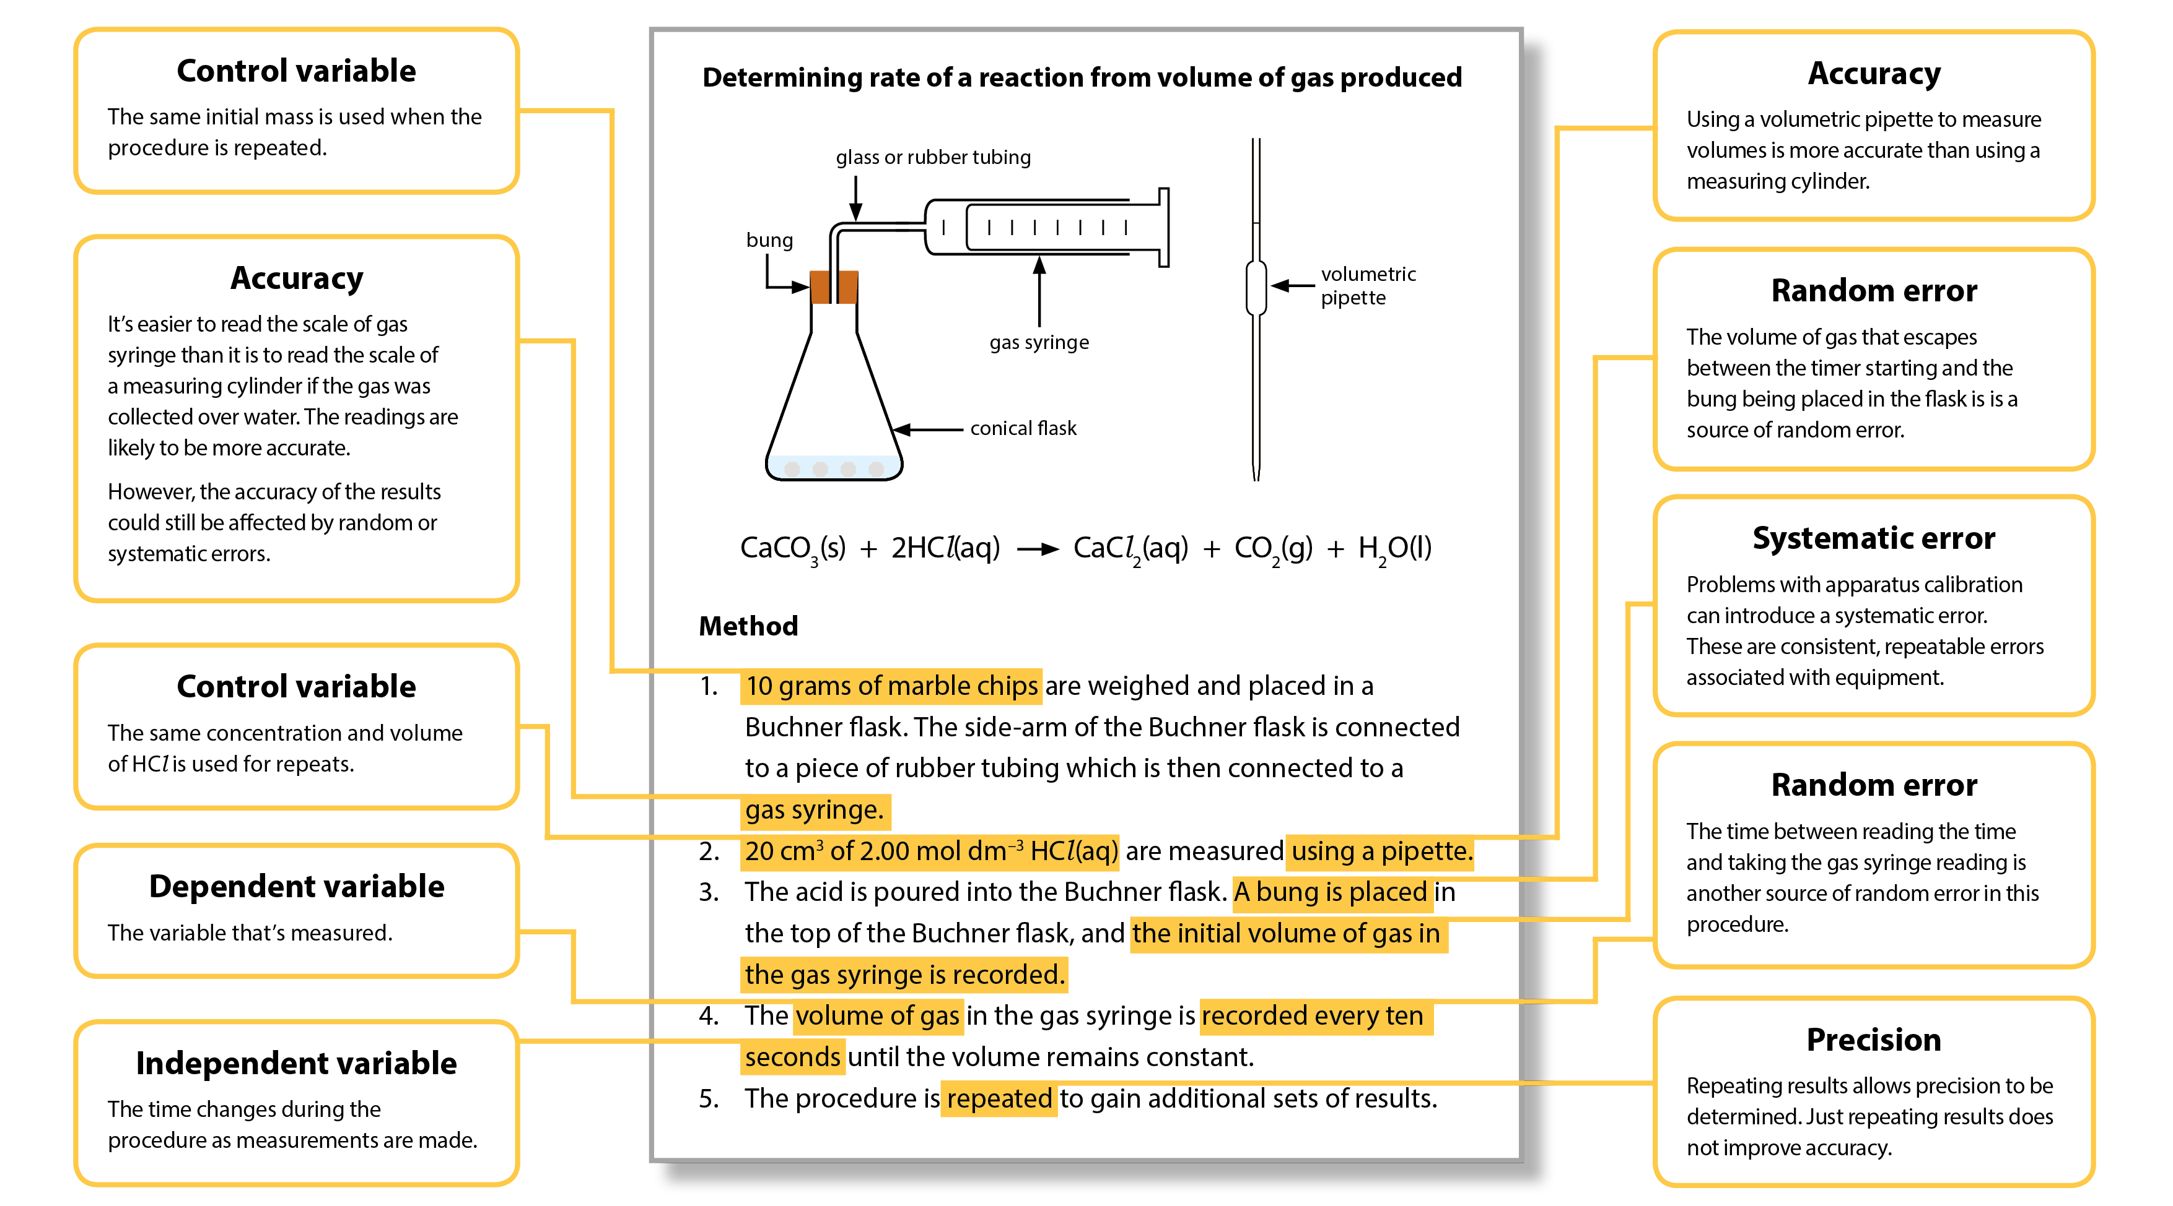

Glossary of terms
Term | Definition | Notes
accuracy | a measurement result is considered accurate if it is judged to be close to the true/acceptable value | Accuracy is a property of a single result. Random and systematic errors reduce accuracy.
anomaly (outlier) | value in a set of results that is judged not to be part of the inherent variation | Calculate the mean without the anomaly if you suspect an anomaly due to an error or due to different conditions.  If you identify an anomaly during the practical, then consider repeating the measurement.  In Maths, you may use the term ‘outlier’.
control variable | variables other than the independent and dependent variables which are kept the same | These are quantities or conditions that are kept the same in a practical. Changes in these conditions could affect the validity of your method and results.
dependent variable | variable which is measured whenever there is a change in the independent variable | The dependent variable is recorded as either numerical values with units (quantitative) or in the form of descriptive comments (qualitative).
independent variable | variable which is deliberately changed or selected by the person in the planning of a practical activity | The independent variable is recorded in the first column of a results table.  The dependent variable is recorded to the right with processed data in the far right columns.  In a graph, the independent variable is usually plotted on the x-axis with the dependent variable on the y-axis.
line of best fit | a line drawn on a graph that passes as close as possible to the data points. It represents the best estimate of the underlying relationship between the variables. | A line of best fit can be a straight line or a curve.  This differs from GCSE Maths, where a line of best fit is always a straight line.
precision | a quality denoting the closeness of agreement between measured values obtained by repeated measurements | Precision refers to more than one value. Precise results are clustered together. You can only determine if your results are precise by repeating the measurement.  Reducing the effect of random errors improves precision. A systematic error does not affect precision, as it is the same error each time. You may have precise results with a systematic error, but not accurate results.
random error | error in a measurement due to small uncontrollable effects | We can’t correct random errors, but we can reduce their effect by making more measurements and calculating the mean.  Random errors contribute to uncertainty.
range (of a variable) | the maximum and minimum values of the independent or dependent variables | In Maths the range is the difference between the biggest and smallest value of a variable.
repeatability | precision obtained when measurement results are produced in one laboratory, by a single operator, using the same conditions, over a short timescale | A measurement is repeatable when repetition under the same conditions gives similar results.  Anomalous results can be identified by repeating the measurement. However, never discard data simply because it does not correspond with expectations.
reproducibility | precision obtained when measurement results are produced by different laboratories and therefore by different operators using different pieces of equipment | A measurement is reproducible when similar results are produced by different groups or different equipment or altered methods. If the results are reproducible then you can be more confident in the quality of the results.
resolution | smallest change in the input quantity being measured by a measuring instrument that gives a perceptible change in the reading of the measuring instrument | For example, the resolution of a ruler is 1 mm and the resolution of a burette is 0.1 cm³. It is not correct to describe equipment with a higher resolution as being more precise, as precision is a property of repeated results.
systematic error | error due to the measured value differing from the true value by the same amount each time | Methods or equipment may introduce systematic errors, producing consistent errors in results. Using the same equipment each time avoids introducing more systematic errors. Calibrating equipment where appropriate reduces systematic errors.  A zero error is when the measuring device indicates a value when the quantity being measured is zero.  Systematic errors contribute to uncertainty.
uncertainty | interval within which the true value can be expected to lie, with a given level of confidence or probability | Uncertainties depend on a range of factors, including systematic and random errors. Analogue apparatus have an uncertainty of ± half the smallest graduation.  The uncertainty of digital apparatus is ± the resolution of the apparatus.  The A Level Practical Skills handbooks contain further guidance on uncertainties.
validity (of an experiment) | suitability of the method used to answer the question being asked | To ensure validity, identify control variables and keep them constant to avoid affecting the dependent variables.  In field studies there are naturally changing variables. Ensure the control variables are as similar as possible when repeating.

We’d like to know your view on the resources we produce. Click ‘Like’ or ‘Dislike’ to send us an auto generated email about this resource. Add comments if you want to. Let us know how we can improve this resource or what else you need. Your email will not be used or shared for any marketing purposes.
Looking for another resource? There is now a quick and easy search tool to help find free resources for your qualification.
OCR is part of Cambridge Assessment, a department of the University of Cambridge.
For staff training purposes and as part of our quality assurance programme your call may be recorded or monitored.
Oxford Cambridge and RSA Examinations is a Company Limited by Guarantee. Registered in England. Registered office
The Triangle Building, Shaftesbury Road, Cambridge, CB2 8EA. Registered company number 3484466. OCR is an exempt charity.
OCR operates academic and vocational qualifications regulated by Ofqual, Qualifications Wales and CCEA as listed
in their qualifications registers including A Levels, GCSEs, Cambridge Technicals and Cambridge Nationals.
OCR provides resources to help you deliver our qualifications. These resources do not represent any particular teaching method we expect you to use. We update our resources regularly and aim to make sure content is accurate but please check the OCR website so that you have the most up to date version. OCR cannot be held responsible for any errors or omissions in these resources.
Though we make every effort to check our resources, there may be contradictions between published support and the specification, so it is important that you always use information in the latest specification. We indicate any specification changes within the document itself, change the version number and provide a summary of the changes. If you do notice a discrepancy between the specification and a resource, please contact us.
© OCR 2021 - You can copy and distribute this resource freely if you keep the OCR logo and this small print intact and you acknowledge OCR as the originator of the resource.
OCR acknowledges the use of the following content: N/A
Whether you already offer OCR qualifications, are new to OCR or are thinking about switching, you can request more information using our Expression of Interest form.
Please get in touch if you want to discuss the accessibility of resources we offer to support you in delivering our qualifications.

