Health and Social Care

Unit 2 – Equality, Diversity and Rights in Health and Social Care

Scheme of work

(60 GLH)

Introduction
This outline scheme of work (SOW) is to offer a perspective of how to deliver the Cambridge Technicals in Health and Social Care. There are many alternatives methods and structures that could be used and therefore it is important to explore different methods of delivering the specification, considering different approaches depending on staffing and expertise within your centre and the resources you have available.

Consideration of how the theoretical content of the specification can be covered is best delivered in different ways, through:

- A variety of different teacher resources
- Stimulate discussions
- Group work
- Learner activities
- Variety of questions relating to all the different topics

Aiming for quality communication and professional standards of work will help to establish the connections between this qualification and real world practice.

Scheme of Work in Detail

Week/  Lesson | Learning outcomes and topics | Unit content to be covered, activities, links to useful resources
Health and Social Care Unit 2: Equality, diversity and rights in health and social care

2 hours | Introduction.  Examining prejudices.  Why is this unit relevant to working in health and social care? | Tutors provide images via power point of people who might be judged and/or with ‘protected characteristics.’ (e.g. pregnant teenager smoking; people in traditional religious dress; same sex couple with their baby) Learners are asked to respond to the images with any words that come to mind. Discussion points.  Are we all prejudiced in some way?  Which groups of people are likely to experience prejudice? Why?  Appreciating our own prejudices is essential if we work in health and social care. Why?
LO1  2 hours | 1.1 Concepts | Equality, Diversity and Rights – see existing delivery guide (4 tasks)  Class discussion: Would you rather be male or female? Justify your choice with reference to statistics e.g. life expectancy, average weekly wage, females and males in managerial posts, mental health.
2 hours  2 hours  3 hours  2 hours | 1.2 Application of the concepts | Allocate one of the 9 values of care to a student or pair/small group of students. They design a poster for the value of care and must present the concept to the class with a specific example of how this works in practice. (How do schools promote diversity, involve parents, keep children safe, make learning exciting, ensure equality, work with other professionals and maintain confidentiality etc)  Allocate one of the values of care in health and social care services, i.e. promoting equality and diversity; promoting individual rights and beliefs; maintaining confidentiality. They design a poster for the value of care and must present the concept to the class with a specific example of how this works in practice  Look at the experience of the Jenny Hammond School - ‘Wouldn’t it be boring if we were all the same?’ – creating a school community that celebrates diversity: The Jenny Hammond Primary School and list all the examples of ways to promote diversity.  https://assets.publishing.service.gov.uk/government/uploads/system/uploads/attachment_data/file/678747/The_20Jenny_20Hammond_20Primary_20School_20-_20good_20practice_20example.doc  Allocate a health, social and care setting to a group of learners (eg Nursery, hospital, residential care home) They should mind map as many ways as possible to promote diversity in this setting. This should then be turned into a rating exercise for the rest of the class to complete and discuss. Eg ‘training children to recognise and challenge homophobic language’ 1-4 (1 =highly likely to work; 4 = unlikely to work)  Watch the documentary about Stafford Hospital which can be found on You Tube. ‘Stafford – The hospital That Didn’t Care’  Apply the rights - choice, confidentiality, protection from abuse and harm, equal and fair treatment, consultation, right to life. For each explain how it was or wasn’t met.
3 hours | 1.3 Support networks | See existing delivery guide
LO2  6 hours | 2.1 Discriminatory practices  2.2 Individuals affected  2.3 Impact on individuals | The basis of discrimination should be divided amongst the learners. For each base (e.g. race, culture, age, gender, sexual orientation, religion) the learners should prepare a presentation for the rest of the group.  Learners should use specific examples. These could be located by the tutor or the learners:  What kind of discrimination?  Who is affected?  What is the likely impact?  The EHRC website provides several examples:  https://www.equalityhumanrights.com/en/secondary-education-resources/useful-information/equality-case-studies  Age UK provides examples of poor care and unfair treatment:  https://www.ageuk.org.uk/latest-press/real-life-stories/  Mencap provides good disability examples:  https://www.mencap.org.uk/blog/how-i-beat-odds-get-job  Stonewall provides good sexual orientation examples:  https://www.stonewall.org.uk/lgbt-britain-hate-crime-and-discrimination  The existing delivery guide suggests that learners write a first person account of a real life incident of discriminatory practice. This could be developed into a hot seating activity where learners in role are questioned about their experiences of discrimination and how they were made to feel.
LO3  2 hours  2 hours  2 hours | 3.1 Key aspects of current legislation | Learners should be allocated one of the pieces of legislation and outline key areas. How are individual rights supported? Find a case study which shows what the act means in practice?  The EHRC website is a great resource for the Equality Act and the Human Rights Act.  Research the murder of Zahid Mubarek. Which aspect of the Human Rights Act proved relevant to this case?  Human Rights Act impact on everyday life: http://www.lse.ac.uk/sociology/human-rights/research/past-projects  Care Act example https://www.ms-solicitors.co.uk/community-care-law/planning-and-paying-for-care/case-study-care-act-2014-eligibility-criteria/  For the Children Act learners can research what happened to Victoria Climbie and how this led to Every Child Matters.  Learners can discuss:  - the purpose of legislation,  - whether the legislation stops discrimination and abuse  - the reasons why people who have been discriminated against might not want to take cases to court.
2 hours  2 hours  2 hours  2 hours  2 hours | 3.2 Overview of national Initiatives | For each national initiative learners should consider the impact/benefits of the initiative for the practitioner and the service users/clients/children.  The Care Certificate: http://www.skillsforcare.org.uk/Learning-development/Care-Certificate/Care-Certificate.aspx  A learner could imagine he/she has just been employed as a health care assistant in a care home. Learners should read and complete the Care Certificate standard 4 - Equality and Diversity. The class can discuss how well this has prepared them for working in the care home.  Ofsted: Learners should locate an online Ofsted report for a local primary school. What was the rating? What areas were inspected? What are the recommended improvements?  Care Quality Commission (CQC). Learners should locate an online CQC report for a local service/hospital. What was the rating? What areas were inspected? What are the recommended improvements?  Equality and Human Rights Commission. https://www.equalityhumanrights.com/en  Learners should browse the website and give a specific example of some information/guidance provided and how this may help practitioners and/or service users.  NICE. https://www.nice.org.uk/about Learners should browse the website. They could take one condition which is relevant to a class or family member such as asthma and see if the individual involved has received the care according to the guidelines.  https://www.nice.org.uk/guidance/ng80/resources/asthma-diagnosis-monitoring-and-chronic-asthma-management-pdf-1837687975621
2 hours  3 hours | 3.3 The impact of legislation and national initiatives | Organisational Policies:  In small groups learners mind map what should be in an anti-bullying policy. What sections are there likely to be in the policy?  Find an example of an anti-bullying policy online or use the policy of your school. Compare with your mind map.  Discussion. Will an anti-bullying policy stop bullying? How can a policy help? How can schools promote anti-bullying?  This can be done for all organisational policies.  Similarities and differences can be listed in terms of content and impact of the policy. How can you ensure these policies are used, understood and effective?
LO4  2 hours  3 hours  2 hours  2 hours  6 hours  2 hours | 4.1 Applying best practice in health, social care or child care environments  4.2 Explaining discriminatory practice in health, social care or child care environments  4.3 Choosing appropriate action/ response to promote equality, diversity and rights | This section is all about how to prevent discriminatory practice or poor practice and/or what to do if poor practice occurs. Learners should know what happened at Stafford Hospital and Winterbourne View – extreme examples of neglect and abuse.  https://www.youtube.com/watch?v=iHXOFS9ec2Q (Stafford)  https://www.youtube.com/watch?v=subMgwyJOK8 (Winterborne View)  Learners could consider  - what they could have done if they had worked there  - what the management should do to ensure that such poor care does not happen again.  - what aspects of the unit 2 specification are relevant? (what good practice has been neglected and why?)  Learners could research the actual recommendations that were made and again link these findings to the good practice in the specification  https://www.nhs.uk/news/medical-practice/winterbourne-view-failures-lead-to-care-system-review/  https://www.independent.co.uk/life-style/health-and-families/health-news/the-francis-report-key-findings-8484071.html  Helene Donnelly received an OBE for the whistle blowing she did at Stafford Hospital. Learners should consider why whistle-blowing is so important and why it may be very difficult to be a whistle blower.  https://www.telegraph.co.uk/news/health/news/11398148/The-NHS-whistle-blowers-who-spoke-out-for-patients.html  SCIE video on whistleblowing  https://www.scie.org.uk/contact/concerns/whistleblowingvideo  Learners could prepare the outline plan of a staff day for a newly opened Stafford or Winterbourne View where key principles of good practice (based on the unit 2 specifications) are emphasised.  Learners could prepare a role play of an interview which complies with the Equality Act and another where discriminatory questions are asked. The class have to spot the differences.  https://www.independent.co.uk/extras/jobs/7-questions-never-asked-job-interview-recruitment-a7685161.html  https://www.equalityhumanrights.com/en/publication-download/what-equality-law-means-you-employer-when-you-recruit-someone-work-you

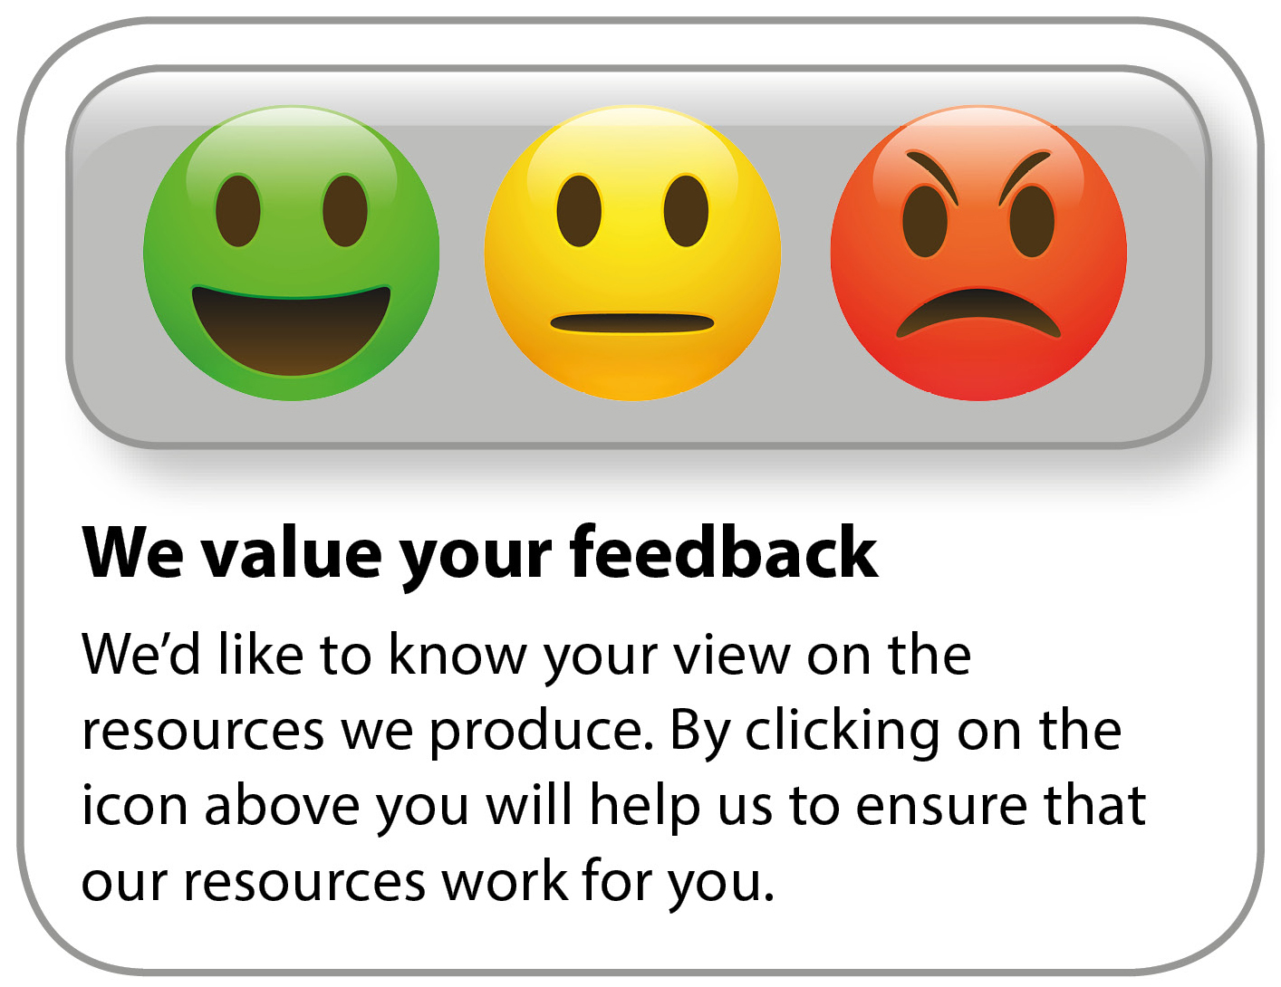
Whether you already offer OCR qualifications, are new to OCR, or are considering switching from your current provider/awarding organisation, you can request more information by completing the Expression of Interest form which can be found here: www.ocr.org.uk/expression-of-interest
Looking for a resource? There is now a quick and easy search tool to help find free resources for your qualification:
www.ocr.org.uk/i-want-to/find-resources/

OCR Resources: the small print
OCR’s resources are provided to support the delivery of OCR qualifications, but in no way constitute an endorsed teaching method that is required by the Board, and the decision to use them lies with the individual teacher. Whilst every effort is made to ensure the accuracy of the content, OCR cannot be held responsible for any errors or omissions within these resources.
© OCR 2019 - This resource may be freely copied and distributed, as long as the OCR logo and this message remain intact and OCR is acknowledged as the originator of this work.
OCR acknowledges the use of the following content: n/a
Please get in touch if you want to discuss the accessibility of resources we offer to support delivery of our qualifications: resources.feedback@ocr.org.uk

