Building a Topic Test using ExamBuilder
For our GCSE Gateway Science A qualifications, we have created some end of topic tests using the ExamBuilder tool. These tests are designed to reflect the overall assessment requirements of the qualification and each test focuses on content from individual topics of the specification.
The tests are approximately 40 marks with a suggested duration of 50 minutes. You can create your own topic tests using ExamBuilder by using the following guidance.

Design your own end of topic quiz
Remember that you can look at Combined Science questions as well as Separate Science questions. Also remember the Twenty First Century Science B Suite covers the same content so you could use questions from there too; you will need to search for topics by key word. These questions will come out in separate documents and need to be combined in Word afterwards.

Question style:
- five multiple choice questions
- one 6-mark level of response style question (if possible, or a 4/5 mark question)
- short-answer style questions for the remaining marks on a range of sub-topics.

Demand & Assessment objectives (AOs):
For this, you need to ensure that there is an even spread of demand and AOs, where possible. If you would like to follow the structure of an exam paper more closely, we would suggest the following:
- Foundation: Low demand 20 marks, medium demand 20 marks.
- Higher: Medium demand 20 marks, high demand 20 marks.
- Foundation and Higher together: An even mix of the three demands.
The AOs should be approximately:
- AO1 – 16 marks (40%)
- AO2 – 16 marks (40%)
- AO3 – 8 marks (20%)
When you create a quiz, the demand of the questions should increase as a student works through the paper. This should be true for each part of the paper taken separately. That is the multiple choice section should increase in demand and then the free response questions should also increase in demand. If you are doing a paper that has Foundation and Higher questions in, ensure your Higher questions are towards the end of the paper.

Skills
- Maths questions (minimum marks): Biology – 4 marks, Chemistry – 8 marks, Physics – 12 marks.
- Practical skills questions (minimum marks): 15% or 6 marks.

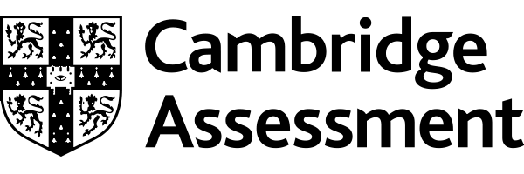

We’d like to know your view on the resources we produce. Click ‘Like’ or ‘Dislike’ to send us an auto generated email about this resource. Add comments if you want to. Let us know how we can improve this resource or what else you need. Your email will not be used or shared for any marketing purposes.
Looking for another resource? There is now a quick and easy search tool to help find free resources for your qualification.
OCR is part of Cambridge Assessment, a department of the University of Cambridge.
For staff training purposes and as part of our quality assurance programme your call may be recorded or monitored.
Oxford Cambridge and RSA Examinations is a Company Limited by Guarantee. Registered in England. Registered office
The Triangle Building, Shaftesbury Road, Cambridge, CB2 8EA. Registered company number 3484466. OCR is an exempt charity.
OCR operates academic and vocational qualifications regulated by Ofqual, Qualifications Wales and CCEA as listed
in their qualifications registers including A Levels, GCSEs, Cambridge Technicals and Cambridge Nationals.
OCR provides resources to help you deliver our qualifications. These resources do not represent any particular teaching method we expect you to use. We update our resources regularly and aim to make sure content is accurate but please check the OCR website so that you have the most up to date version. OCR cannot be held responsible for any errors or omissions in these resources.
Though we make every effort to check our resources, there may be contradictions between published support and the specification, so it is important that you always use information in the latest specification. We indicate any specification changes within the document itself, change the version number and provide a summary of the changes. If you do notice a discrepancy between the specification and a resource, please contact us.
© OCR 2021 - You can copy and distribute this resource freely if you keep the OCR logo and this small print intact and you acknowledge OCR as the originator of the resource.
OCR acknowledges the use of the following content: N/A
Whether you already offer OCR qualifications, are new to OCR or are thinking about switching, you can request more information using our Expression of Interest form.
Please get in touch if you want to discuss the accessibility of resources we offer to support you in delivering our qualifications.

