Computer Science (9-1)
J276/01 Computer Systems
Please note that you may see slight differences between this paper and the original.  Candidates answer on the Question paper.  OCR supplied materials:  Additional resources may be supplied with this paper.  Other materials required:  • Pencil  • Ruler (cm/mm) | Duration: 90 mins

Candidate  forename |  | Candidate  surname

Centre number |  |  |  |  |  | Candidate number

INSTRUCTIONS TO CANDIDATES
• Write your name, centre number and candidate number in the boxes above. Please write clearly and in capital letters.
• Use black ink. HB pencil may be used for graphs and diagrams only.
• Answer all the questions, unless your teacher tells you otherwise.
• Read each question carefully. Make sure you know what you have to do before starting your answer.
• Where space is provided below the question, please write your answer there.
• You may use additional paper, or a specific Answer sheet if one is provided, but you must clearly show your candidate number, centre number
and question number(s).

INFORMATION FOR CANDIDATES
• The quality of written communication is assessed in questions marked with either a pencil or an asterisk. In History and Geography
a Quality of extended response question is marked with an asterisk, while a pencil is used for questions in which Spelling, punctuation and
grammar and the use of specialist terminology is assessed.
• The number of marks is given in brackets [ ] at the end of each question or part question.
• The total number of marks for this paper is 80.
• The total number of marks may take into account some 'either/or' question choices.

1. | Here are some statements about the CPU of a computer.  Tick one box in each row to show whether each of the following statements is true or false.  Statement True False  CPU stands for Central Processing Unit.  The CPU fetches and decodes instructions.  The speed of a CPU is usually measured in GigaHertz (GHz).  If a CPU has many cores, this slows down the computer.  The hard disk drive is part of the CPU.  [5]

2(a). | Ann wants to purchase a new computer and is looking at two models. The specification of the CPU in each computer is shown in Fig. 1.  Explain one reason why the cache size affects the performance of the CPU.  [2]

(b). | When running a 3D flight simulator, Computer 1 is likely to run faster than Computer 2.  Using the information in Fig. 1, identify one reason for this.  [1]

3(a). | The CPU has a clock speed of 3.8 GHz.  Describe what is meant by a clock speed of 3.8 GHz.  [2]

(b). | Alicia says:  “My computer has a quad-core processor, so it will run twice as fast as a computer with a dual-core processor”.  Explain why this statement is not always true.  [3]

4. | Gareth has a satellite navigation system (Sat Nav) in his car that uses RAM and ROM.  Fig. 2 lists some characteristics of computer memory. Tick (✓) one box in each row to show whether each of the statements is true for the RAM or ROM in Gareth's Sat Nav.  [3]

5(a). | Amin buys a new computer with an operating system and some utilities.  The table below shows some of the utilities in Amin's computer.  Tick one box in each row to show whether the utility is used for security or disk organisation.  Utility Used for security Used for disk organisation  Antivirus  Defragmenter  File transfer  Firewall  [4]

(b). | State two functions of the operating system.  1  2  [2]

6(a). | The following table has descriptions of Ethernet and WiFi.  Tick (✓) one box in each row to identify if the description is more appropriate for Ethernet or WiFi.  Description Ethernet Wifi  A wired connection  More likely to be affected by interference  Data can be transmitted at a faster speed  Wireless transmission  Shorter transmission range before data is lost  [5]

(b). | A house has computers in each room and a central router. Every room allows both Ethernet and WiFi connections to the router.  - Describe the purpose of the router in the house’s network.  [2]  - Identify two additional items of network hardware, apart from cables and a router, that may be used within the house network.  1  2  [2]

(c). | The house owner is concerned about potential threats to the network from being connected to the Internet.  - Describe three possible threats to the computers connected to the network and give one way each threat can be reduced or prevented.  Threat 1  Prevention  Threat 2  Prevention  Threat 3  Prevention  [9]

7. | The owners of a large bakery have a Local Area Network (LAN) with a star topology. They order their supplies over the Internet. When data is transmitted from the bakery to the supplier, network protocols are used.  The owners of a large bakery have a Local Area Network (LAN) with a star topology.  Explain four reasons why the bakery may use a star network topology for their LAN.  [4]

8. | Order the following units from smallest to largest:  GB bit PB byte nibble MB  [1]

9. | - Convert the denary number 132 into an 8 bit binary number.  [2]  - Convert the binary number 10110101 to its hexadecimal equivalent.  [2]  - Show the effect of a binary shift right of two places on the binary number 00110100.  [1]  - Describe a shift that can be used to double the value of the binary number 00100100.  [2]

10. | William is creating a film for a school project using a digital video camera.  William transfers the videos to a computer for editing.  - The computer has 1GB of storage free.  Calculate the number of videos that could be stored on the computer if each video was 100MB in size.  Show your working.  [2]  - A program needs to calculate the size of files in bytes. The program must:  ○ Ask the user to input a file size in megabytes  ○ calculate and output the number of bytes this represents in a user friendly format (e.g. "There are 5242880 bytes in 5MB").  - Write an algorithm using pseudocode to calculate the number of bytes in a given number of megabytes.  [6]

11. | A house has computers in each room and a central router. Every room allows both Ethernet and WiFi connections to the router.  A user enters a uniform resource locator (URL) into a web browser on one of the computers in the house.  A system is then used to find the IP address of the web server associated with the URL.  - Name the system which matches URLs to IP addresses on the web.  [1]  - The following statements describe what happens after the IP address has been found and returned to the user’s computer.  There are five missing statements in the table.  Write the letter of the missing statements from the table in the correct place to complete the description.  1 The request is put into packets  2  3 The packets are sent across the network  4  5  6 If they have not arrived:  7 A timeout is sent to request the packets are resent  8 If they have arrived:  9  10  Letter Statement  A The server checks if all the packets have arrived  B The packets are put in order  C The request is processed by the web server  D The packets are received by the host server  E Each packet is given the address and a number  [5]

12. | A law firm currently use a Local Area Network (LAN) linked to a Wide Area Network (WAN).  Fig. 3 lists some actions that may take place in the law firm's office. Tick (✓) one box in each row to show which legislation applies to each action.  [6]

13. | A small island has 100 people living on it. The island has just been connected to the Internet, after previously having no Internet or mobile phone signal.  Discuss the impact on the island’s inhabitants and businesses of getting access to the Internet.  In your answer you might consider the impact on:  - inhabitants  - businesses  - ethical issues  - privacy issues  [8]

END OF QUESTION PAPER

Mark scheme
Question |  |  | Answer/Indicative content | Marks | Guidance
1 |  |  | Statement True False  CPU stands for Central Processing Unit ?  The CPU fetches and decodes instructions ?  The speed of a CPU is usually measured in GigaHertz (GHz) ?  If a CPU has many cores, this slows down the computer ?  The hard disk drive is part of the CPU ?  One mark per row | 5 | ?Examiner's Comments??  This question was generally well answered.
 |  |  | Total | 5
2 | a |  | - data is transferred faster (1)…  - …which makes a CPU more efficient (1)  - It is faster to transfer to and from cache (1)…  - …than transferring to and from RAM (1). | 2 | 1 mark to be awarded for each correct identification and 1 mark to be awarded for the associated explanation to a maximum of 2 marks.
 | b |  | It has more cores. | 1 | Although Computer 1 has a lower clock speed than the CPU in Computer 2 it has more cores, which means that it can be faster than Computer 2.  Any answer relating to splitting a program into processes that be carried out consecutively will be accepted.
 |  |  | Total | 3
3 | a |  | 1 mark per bullet to max 2  - The number of FDE cycles run per given time/second  / the frequency that the clock ‘ticks’  - 3.8 billion cycles/instructions …  - …per second | 2  AO1 1b (1)  AO2 1a (1) | Do not award: how fast the computer is / speed of CPU  3.8 = 3,800,000,000  Examiner’s Comments  This question was answered well with many candidates able to demonstrate an understanding of the clock speed of a computer. Fewer candidates correctly translated the 3.8 GHz into the correct number of instructions/FDE cycles performed. Less able candidates did not identify an appropriate time frame, for example ‘the number of instructions it can process’ has a different meaning to ‘the number of instructions it can process per second’. Another common misconception was it is the number of instructions it can perform at a time, a processor can only perform one instruction at a time.
 | b |  | 1 mark per bullet to max 3  e.g.  - Software may be designed to run on 1 core and not multiple cores  / depends on the task(s)  - …some tasks cannot be split across cores  - Clock speed also affects speed  / dual core may have a faster clock speed  / quad-core may have slower clock speed  - …so one task may be run faster/slower  - RAM size also affects speed  / Quad-core may have less RAM  / amount of VM being used  - Cache size also affects speed  / Quad-core may have less cache | 3  AO1 1b (1)  AO2 2b (2) | Allow marks for other components that could affect the speed e.g. secondary storage access speed, onboard GPU.  Award description of concurrent processing.  Examiner’s Comments  Most candidates were able to identify other features that could also have an impact on the speed of the computer such as the processor speed, amount of RAM etc. The more able candidates were also able to identify that the tasks being performed will also impact on the speed, for example how software may not be optimised for quad-core, or that a process may have to wait for a different process to finish execution before it can be processed.
 |  |  | Total | 5
4 |  |  | RAM ROM  Stores the boot up sequence of the Sat Nav. ✓  The contents are lost when the Sat Nav is turned off. ✓  Holds copies of open maps and routes. ✓ | 3 | Award 1 mark for each correct tick.  No marks should be awarded if ticks are in both boxes in a given row.
 |  |  | Total | 3
5 | a |  | Utility Used for security Used for disk organisation  Antivirus ?  Defragmenter ?  File transfer ?  Firewall ? | 4 | Examiner's Comments  This question was answered correctly by almost all candidates.
 | b |  | e.g.  - Provides interfaces between user and computer / Determines look and feel of the computer  - Provides a platform for software to run  - Manages peripherals used by the system  - Manages memory | 2 | Examiner's Comments  This question was fairly well answered.
 |  |  | Total | 6
6 | a |  | 1 mark per row  Description Ethernet Wifi  A wired connection ✓  More likely to be affected by interference ✓  Data can be transmitted at a faster speed ✓  Wireless transmission ✓  Shorter transmission range before data is lost ✓ | 5  AO1 1a (5) | 0 mark for row with > 1 tick  Examiner’s Comments  This question was answered well with the majority of candidates getting each answer correct.
 | b | i | 1 mark per bullet to max 2  - Directs packets/data to destination / directs packets/data in a network  - Receives packets/data from the network/Internet  - Forwards packets/data to other computers on the network/Internet  - Connects (different) networks together / e.g. joins home network to Interne  - Has (public) IP address for LAN  - Designates (private) IP addresses to network nodes | 2  AO1 1a (1)  AO1 1b (1) | Controls flow of data as BOD for bullet 1.  Bullet 1 needs to refer to the router directing the destination e.g. it is making a decision/choice on where to send it.  Bullet 4 - it has to be referring to the connection between the Internet and home network, or forwarding of data between them. Just referring to accessing Internet is not enough.  Do not allow information for data/packets  Examiner’s Comments  This question required candidates to demonstrate their understanding of a router and its purpose in a network. Candidates need to have an understanding of the purpose of the hardware in a network as to the roles is performs, and how it does this. Less able candidates gave generic descriptions such as ‘it connects devices together’, or ‘lets a user go on the Internet’. These are not in-depth enough to explain the actual purpose of the router, i.e. to receive packets from a computer, read the address and forward the packet to its destination. Similarly, with access to the Internet, the router receives the package to go onto the Internet, packets it appropriately for the new type of network and then sends it onto the new network. The more able candidates were able to describe the purpose of directing packets to their destination, as opposed to sending it arbitrarily to other devices.
 |  | ii | 1 mark per item to max 2  e.g.  - Network Interface card / NIC  - Wireless access point / WAP  - Wireless network interface card / WNIC / wi-fi card  - Bridge  - Switch  - Hub  - Repeater / wireless extender/booster  - Server | 2  AO1 1a (2) | Accept modem, power line adapter,  Ethernet jack  Must be an item of network hardware  Examiner’s Comments  Many candidates were able to identify at least one device, most commonly switches and hubs.
 | c |  | 1 mark for naming threat, 1 for description, 1 for prevention.  Max 3 per threat  e.g.  - Virus / trojan / worm / malware  - Piece of software/code/a program that replicates itself / causes damage e.g. editing/deleting files  - Running anti-virus/anti-malware software / don’t download from unknown sources / don’t click on unknown links  - Spyware / malware / keylogger  - Piece of software/code/a program that records actions/key presses and sends this data to a third party for analysis  - Running anti-spyware/anti-malware software/firewall  - Data interception / passive  - Data is sent to another device and is intercepted by a third party  - Encryption  - Phishing  - An e-mail has a link that when clicked directs the user to a fake website that collects personal data  - Network policy / firewall  - Pharming  - A piece of code installed that redirects user to fake website that collects personal data  - Anti-malware / firewall  - Hacker  - Person attempting to gain unauthorised access to the network/computers/ data/files / unauthorised access and then deleting/editing data/files  - Firewall / strong password / biometrics / penetration testing  - Brute force attack  - Person/software using every combination of passwords to gain access  - Firewall/strong passwords  - Social engineering  - Person being the weak point of the system / by example e.g. any example of deception  - e.g. Strong passwords / check validity of sources | 9  AO1 1b (3)  AO2 1a (3)  AO2 1b (3) | Must be relevant to home use i.e. not denial of service, SQL injection.  Do not allow adware, spam.  Do not allow backup as a prevention – it does not prevent the threat occurring. Do not allow encryption for stopping a hacker.  Description must do more than repeat the threat.  Read whole response to threat, identify threat first (may not be at the start and may be within description), then look for description.  If no threat identified, then no mark for prevention.  Allow any example of hacking for hacker e.g. cracking (password), active. But only once.  Only award malware once, for virus or spyware e.g. virus identified, then malware identified both can be awarded.  Virus, then malware, then spyware, would get a repeat for final spyware.  Allow:  - Ransomware  - Prevents access to your files unless a ransom is paid  - Anti-virus/firewall  Examiner’s Comments  This question required candidates to consider the different threats to networks and computers that they have learnt about, and to identify which are appropriate in this situation. Most candidates were able to identify three threats, but at times these were not appropriate to the scenario, for example describing denial of service threats to a website, and SQL injection. This identifies the importance of candidates reading the questions carefully and identifying whether it is asking for a generic response i.e. a recall of knowledge (AO1), or an application of their knowledge (AO2). The most common threats identified included viruses and hackers, with candidates being able to describe the threats and identify appropriate measures to prevent them. Some candidates gave repeated answers, for example giving a virus as a threat, then a worm, then a Trojan – both of which are examples of viruses therefore already covered by their previous answer.  Exemplar 5  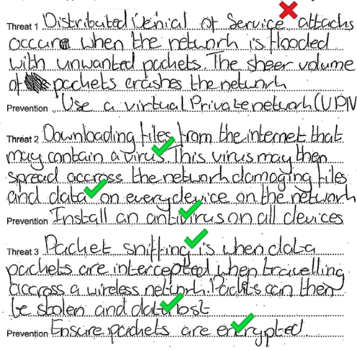  This candidate has given DDOS for the first answer which is not appropriate to the context; this is a threat to a webserver which is not part of the house owner’s home network. They have given two further appropriate threats, described these appropriately and given reasonable preventions. It is important that candidates consider the context and give threats that are appropriate to the situation given in the question.
 |  |  | Total | 18
7 |  |  | - It is easy to add a new node or device  - Management of the network can be done centrally  - Fewer data collisions can occur  - If a node or device fails it does not affect the rest of the network  - A signal does not need to be transmitted to all computers in the network | 4 | 1 mark is to be awarded for each correct reason to a maximum of 4 marks.  Any valid comparisons to other topologies can be awarded marks.
 |  |  | Total | 4
8 |  |  | bit, nibble, byte, MB, GB, PB 1 | 1 | Correct Answer Only
 |  |  | Total | 1
9 |  | i | - 1000 0100 | 2 | 1 mark per nibble. Mark right to left.  Examiner’s Comments  This question was answered correctly by the vast majority of candidates. Pleasingly, conversion of numbers to and from binary is now obviously a comfortable skill for candidates of all levels.
 |  | ii | - B 5 | 2 | 1 mark per hex digit  Examiner’s Comments  Slightly fewer candidates were able to answer this question successfully compared to 5(a)(i). Most were able to split the binary number up into two nibbles, but then the conversion to binary for each nibble sometimes was incorrectly completed. Common wrong answers included 11 5 (which achieved 1 mark for 5 but did not recognise that 11 in denary equates to B in hexadecimal) or C5, where a mistake was made once the hexadecimal value went over 9. Very few answers showed a complete lack of understanding, but where this was seen, candidates tended to simply convert the binary to denary and ignore the requirement to use hexadecimal. This achieved no marks.
 |  | iii | 1 mark per bullet, max 1.  - 00001101  - Divides by 4 | 1 | Accept 001101 / 1101. Allow any number of leading zeros.
 |  | iv | 1 mark per bullet, max 2.  - Left shift  - one place | 2 | Do not accept answers that simply show the number shifted.  Examiner’s Comments  Candidates showed a good understanding of binary shifts, which is especially pleasing as this is a new point that was not covered in the old GCSE Computing specification. The majority of candidates were able to both carry out a shift and describe a shift that matched a give outcome. One common mistake was for candidates to describe the direction of a shift but not say how many places to shift (e.g. ‘shift left’ but missing ‘by one place’).
 |  |  | Total | 7
10 |  | i | 1 mark for working, 1 mark for answer  - 1024(1000) / 100 / 10*100 = 1000  - = 10 (videos) | 2  AO2 1a (1)  AO2 1b (1) | Final answer must be 10, not 10.24  Examiner’s Comments  Most candidates were able to answer this question fully. They performed the correct calculation and gained the correct answer, rounding the number of videos appropriately. The most common error involved candidates multiplying 100 by 1000.
 |  | ii | 1 mark per bullet to max 6  - Output asking for file size (in megabytes)  - Taking number of MB as input  - Multiplying by 1024 or 1000  - Multiplying by 1024 or 1000 (may be same line as bullet 3, this must be the final value with no further changes)  - Outputting the final bytes value…  - …in an appropriate message  output "Please enter the file size in megabytes"  input numberMB  numberKB = numberMB * 1024 (or 1000)  numberBytes = numberKB * 1024 (or 1000)  output "There are " & numberBytes & " bytes in " & numberMB & "MB" | 6  AO3 2b (6) | Award bullet 5 even if bullets 3 and 4 are wrong. Do not award if outputting the original input value.  Bullet 4 must be the final calculation to get the mark. If there are any further calculations, or changes to the final bytes value then bullet 4 cannot be awarded.  Input = value is incorrect, variable must be on left.  Bullet 6 is dependent on bullet 5.  Input must be stored e.g. user input – no mark  Outputs must have "" around strings, variable identifiers must not have "".  If bullet 5 is not given because the variable is in "", still award bullet 6 if correct.  Bullet 3 and 4, could be multiplying by 1,000,000 or 1,048,576 (award both bullets).  numberMB = input("Enter the file size") would get both bullets 1 and 2.  Concatenation is not required for the final bullet.  input("Filesize") will get 1 mark for outputting File size, it will not get the input as there is no variable.  Examiner’s Comments  This question covered the synoptic algorithm element of the examinations. Candidates were required to use their knowledge of binary numbers to write a pseudocode algorithm. Most candidates attempted to write a pseudocode algorithm. A small number of candidates drew a flowchart, which does not meet the criteria of pseudocode. Most candidates were able to gain at least some marks, most commonly for the output of a message, and then input of the required data.  Common errors including inaccurate use of assignment, for example INPUT = FileSize is incorrect. This line of code states that the data within FileSize is stored in INPUT. The correct assignment is FileSize = INPUT.  Candidates need to be aware of how to output strings and values within variables. These could have been output as individual statements, but when combined candidates need to differentiate between the variables and text. For example, OUTPUT (The new file size is & FileSize) makes use of concatenation, but the text is not identified as a string and requires speech marks e.g. OUTPUT (The new file size is & “FileSize”).  Some candidates did not attempt to output a message to the user, asking them to input the file size. Candidates need to read all aspects of the question carefully to make sure they are meeting all of the criteria.  Exemplar 1  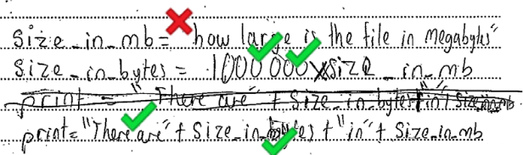  This candidate has not identified that “how large is the file in megabytes” is an output, and has not explicitly asked for an input therefore cannot gain either of these marks. This first line of code is assigning a string to the variable size_in_mb. This error is not followed through, and the candidate has performed the correct calculation, and then output an appropriate message along with the new variable.  Exemplar 2  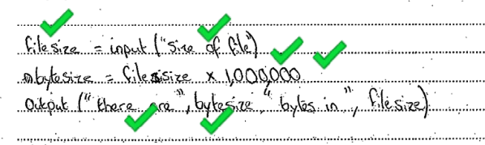  This candidate has outputted an appropriate message and read the input into the variable filesize. They have performed the appropriate calculation (although ∗ is preferable for multiplication, as an algorithm x is accepted). They have output an appropriate message and the correct variable.
 |  |  | Total | 8
11 |  | i | Domain Name Server / DNS. | 1  AO1 1a (1) | Allow Server/service/system  Examiner’s Comments  This question required an understanding of a Domain Name Server/System to convert URLs to IPs. Few candidates were able to identify this system, with many making guessing such as HTTP. Many candidates did not attempt to answer this question.
 |  | ii | 1 mark for each letter in the correct place  1 The request is put into packets  2 Е  3 The packets are sent across the network  4 D  5 А  6 If they have not arrived:  7 A timeout is sent to request the packets are resent  8 If they have arrived:  9 В  10 С | 5  AO1 1b (5) | Examiner’s Comments  This question required an understanding of how packets of data are sent across a network. Candidates were required to read through the statements and order them logically. The more able were able to identify the appropriate sequence. Less able candidates confused some of the statements, such as identifying the request as being processed before the packets were received.
 |  |  | Total | 6
12 |  |  | Action Data Protection Act 1998 Computer Misuse Act 1990 Copyright Designs and Patents Act 1988  Using a picture for the law firm's new logo without the original creator's permission ✓  A secretary accessing a lawyer's personal email account without permission ✓  Making a copy of the latest Hollywood blockbuster movie and sharing it with a client ✓  Storing customer data insecurely ✓  A lawyer installing a key logger on the secretary's computer ✓  Selling client's personal data to a marketing company without their permission ✓ | 6 | 1 mark for each tick in the correct box.  0 marks for a row with more than one tick.
 |  |  | Total | 6
13 |  |  | Mark Band 3-High Level  (6–8 marks)  The candidate demonstrates a thorough knowledge and understanding of a wide range of considerations in relation to the question; the material is generally accurate and detailed. The candidate is able to apply their knowledge and understanding directly and consistently to the context provided. Evidence/examples will be explicitly relevant to the explanation.  The candidate is able to weigh up both sides of the discussion and includes reference to the impact on all areas showing thorough recognition of influencing factors.  There is a well-developed line of reasoning which is clear and logically structured. The information presented is relevant and substantiated.  Mark Band 2-Mid Level  (3–5 marks)  The candidate demonstrates reasonable knowledge and understanding of a range of considerations in relation to the question; the material is generally accurate but at times underdeveloped.  The candidate is able to apply their knowledge and understanding directly to thecontext provided although one or two opportunities are missed. Evidence/examples are for the most part implicitly relevant to the explanation.  The candidate makes a reasonable attempt to discuss the impact on most areas, showing reasonable recognition of influencing factors.  There is a line of reasoning presented with some structure. The information presented is in the most part relevant and supported by some evidence.  Mark Band 1-Low Level  (1–2 marks)  The candidate demonstrates a basic knowledge of considerations with limited understanding shown; the material is basic and contains some inaccuracies. The candidate makes a limited attempt to apply acquired knowledge and understanding to the context provided.  The candidate provides nothing more than an unsupported assertion.  The information is basic and communicated in an unstructured way. The information is supported by limited evidence and the relationship to the evidence may not be clear.  0 marks  No attempt to answer the question or response is not worthy of credit | 8  AO2 1a (4)  AO2 1b (4) | The following is indicative of possible factors/evidence that candidates may refer to but is not prescriptive or exhaustive:  Indicative Content:  Inhabitants  - Connection with the rest of the world  - Access to more information  - Up-to-date with news  - E-commerce  - Communication with people  - Can be used in schools/for education  - Cost (Devices and connection)  Businesses  - Sell products to wider audience/more customers  - Purchase items from wider range/more places  - Competitive prices  - Tourism can be advertised  - Online bookings for hotels  Ethical issues  - Access to inappropriate/illegal content  - Lead to social pressure to be online and get technology  - Cost  - Introduces digital and social divide  - Threats  Privacy issues  - Tracking of IPs/devices  - Social media  - Unwanted images and videos of people may be put online  - Risk of threats e.g. phishing/pharming/virus  Examiner’s Comments  Most candidates tackled this question well, demonstrating a good understanding of the potential issues and structuring an appropriate response. The most common responses were given as essays, with the more able candidates allocating a paragraph to each to areas given in the questions.  The question required a discussion of the impact of the Internet on both the inhabitants and businesses. A discussion of the impact requires both positive and negative impacts. The more able candidates tackled each area in turn, giving the positive and negative sides to each area.  Less able candidates provided limited depth in their responses, giving an example of a drawback to a business but not then expanding this to explain the potential impact.  More able candidates were able to evaluate the impact and gave a reasoned conclusion that summarised their findings.  There were some answers where candidates assumed that without the Internet the inhabitants had no means of communication, access to and/or knowledge of the world beyond their island.  Exemplar 7  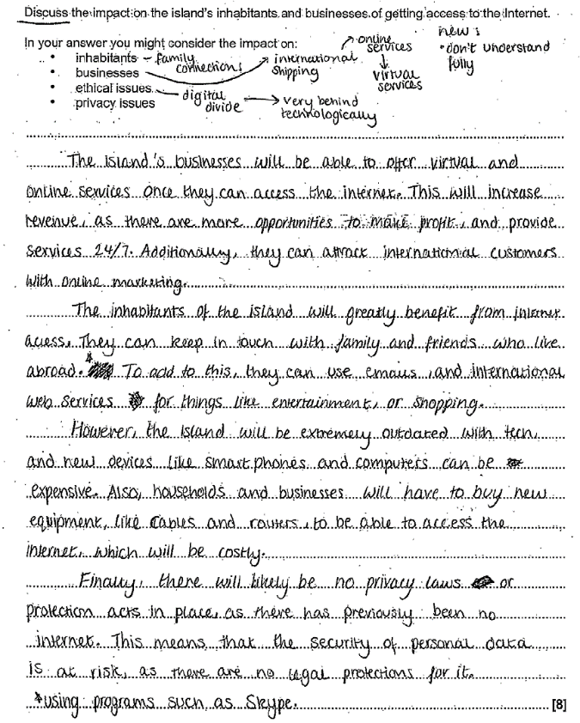  This candidate began by describing the advantages to business, and then the benefits to inhabitants in paragraph 2. They have identified a drawback to inhabitants, and a general drawback of security risks – covering privacy/ethical issues. The candidate has covered at least three of the bullet points given in the question and given both positive and negative impacts. It was not credited with full marks because it was felt there could have been further expansion e.g. how the lack of security could impact the businesses, and an overall conclusion as to the impact.  Exemplar 8  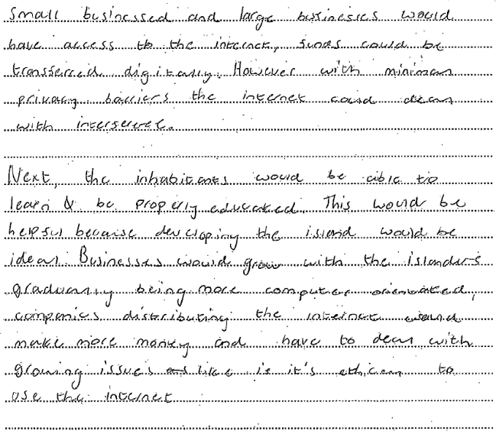  This candidate has given a point of relevance in the first paragraph, but not explained how this is an impact. They have also attempted to give a privacy issue, but this is vague. The second paragraph states that inhabitants can now be educated, but they could be without the Internet – this is not an impact; if they had explained that it gives easier access to a greater range of information then this would have been more relevant. They have identified that businesses can grow through greater distribution, but again this is not expanded suitably into a positive impact. The candidate has given a couple of points of relevance and attempted to explain them, but it is lacking depth and clarity. There are two areas covered. This is a low-medium level response, but the relevant points allowed it to gain access to the medium band.  Exemplar 9  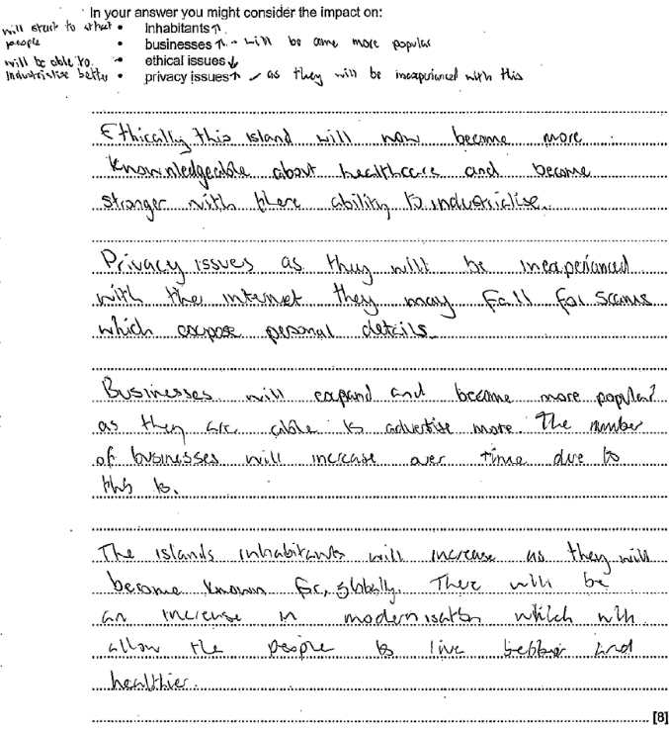  The candidate has given a number of points which are all relevant. They have covered at least three of the bullet points. The response lacked depth for each point, so despite there being a number of points, these were not explained as to their impact. This is therefore restricted to the middle band.
 |  |  | Total | 8

