Lesson element 6.06a Generate terms of a sequence
Below are four different representations of various sequences.

Cut up all of the below into 40 individual cards and give them to students.

Can they sort the cards into groups, where each group shows the same sequence?

Some representations are missing! On the spare cards, tell students to write or draw the missing information for the sequence.

2n + 1 | 3n + 1
2n + 2 | 2n – 1
 | 3n
4n | 3n – 1
3n + 2

3, 5, 7, 9, 11…

4, 6, 8, 10, 12… | 1, 3, 5, 7, 9…
3, 7, 11, 15, 19…

4, 8, 12, 16, 20… | 2, 5, 8, 11, 14…
5, 8, 11, 14, 17… | 1, 4, 7, 10, 13…

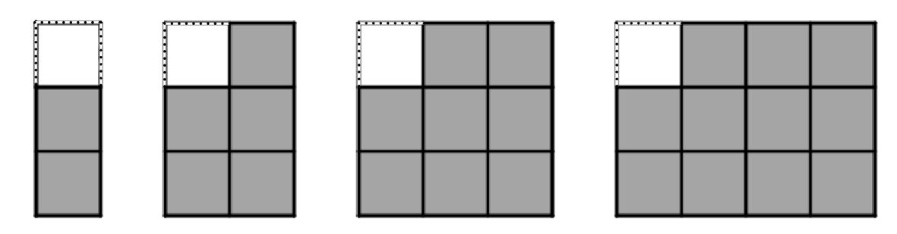

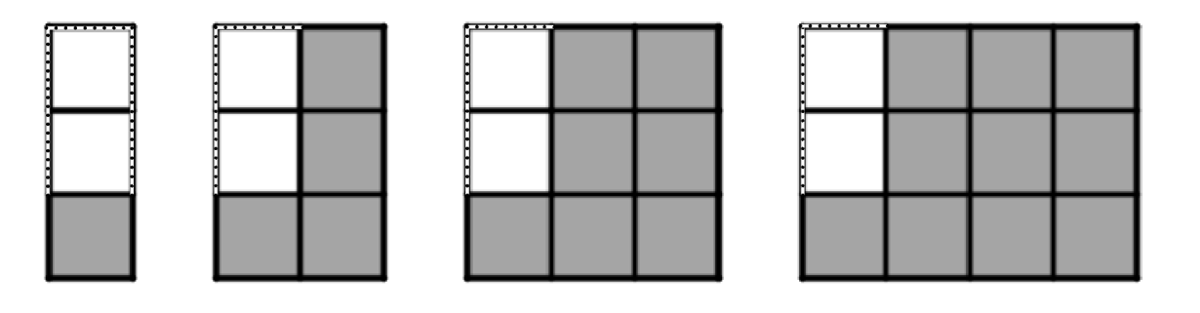

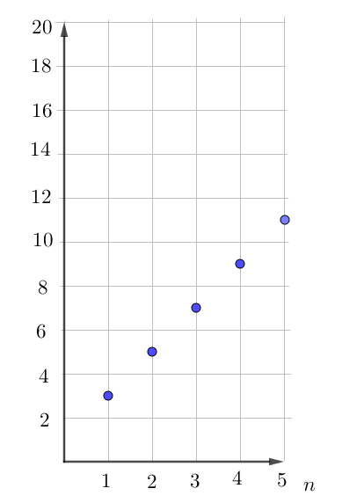 | 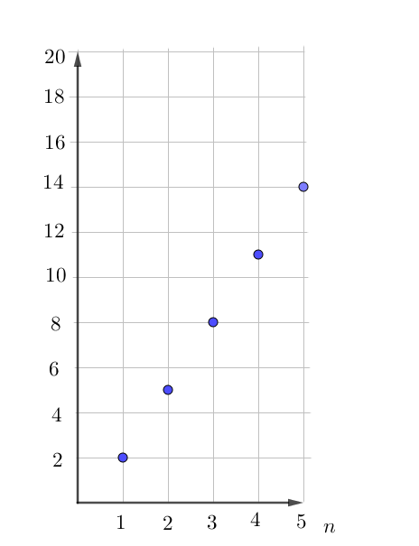
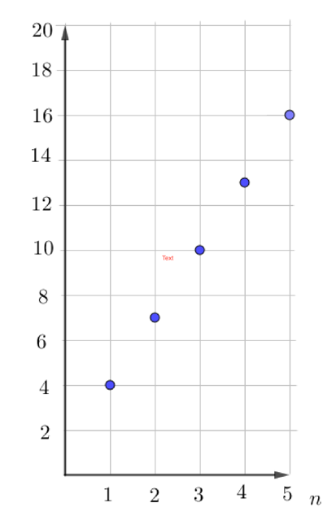 | 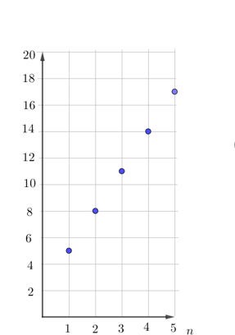
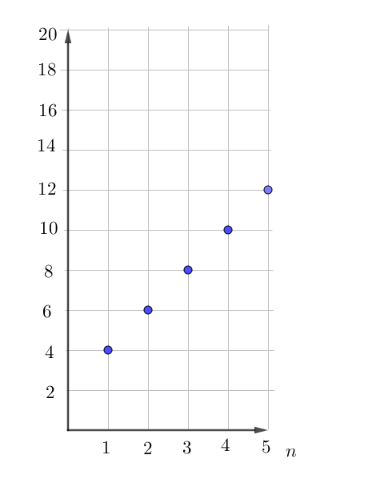 | 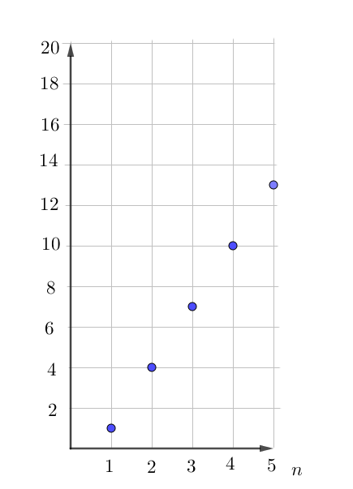
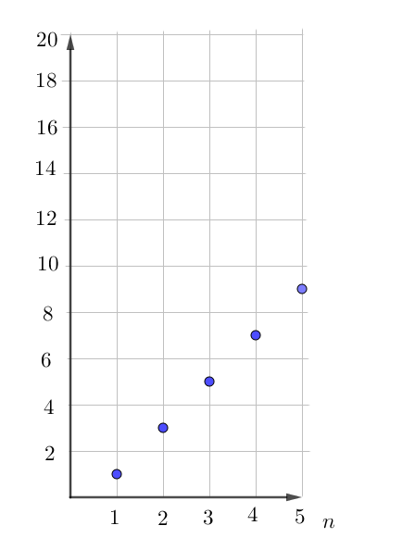

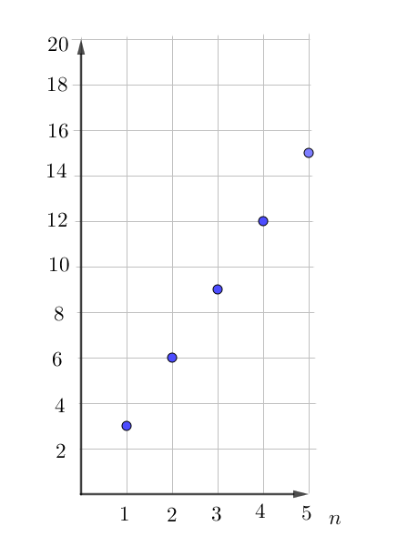 | 