# Curriculum planner for the redeveloped Cambridge National in Engineering Manufacture (J823)

## Welcome to our curriculum planner

We’ve produced this resource to help you plan your delivery of the redeveloped Cambridge National in Engineering Manufacture (J823).

We’ll show you at a high level how you could teach the course over **two or three years**, from September 2022.

A great feature of our redeveloped qualification is the **flexibility** you have in tailoring delivery to suit your needs, so the approaches   
are just suggestions.

By **integrating the theory and principles of manufacturing alongside practical activities**, your students will be able to develop their knowledge   
and understanding and complementary practical skills and so will be well prepared for **both** the examined and NEA assessments.

Contents

Assessment summary 3

A reminder about the terminal assessment rule 5

Curriculum planning suggestions 6

Model 1: One teacher over two years 6

Model 2: One teacher over three years 7

Approaching the content 8

Integrating exam content into practical components 10



Take a look at the [Engineering Manufacture web page](https://www.ocr.org.uk/qualifications/cambridge-nationals/engineering-manufacture-level-1-2-j823/) where you will find the specification, sample assessment material and mapping guide from the current to redeveloped National. You may also find our [guide to understanding assessment](https://www.ocr.org.uk/Images/612302-understanding-the-assessment-examined-and-moderated.pdf) and our [FAQs](https://support.ocr.org.uk/hc/en-gb/articles/360019870179-Cambridge-Nationals-in-Engineering-2022-What-are-the-key-dates-we-need-to-know-) helpful too.

# Assessment summary

| Examined assessment (40% of the course) | |
| --- | --- |
| **R014 Principles of engineering manufacture**  In this unit students will learn about manufacturing processes, how engineering materials are used within manufacturing, scales of manufacture and quality assurance techniques.  Topics include:   * manufacturing processes * engineering materials * manufacturing requirements * developments in engineering manufacture.   Examination: 1 hour 15 minutes | **48 GLH**  70 Marks |

| Non-examined assessment (60% of the course) | |
| --- | --- |
| **R015 Manufacturing a one-off product**  In this unit students will learn how to plan and how to use manual processes and techniques to manufacture a one-off product.  Topics include:   * planning the production of a one-off product * measuring and marking out * safely using processes, tools and equipment to make a product.   OCR-set assignment  Approx. 10-12 hours | **36 GLH**  60 Marks |
| **R016 Manufacturing in quantity**  For this unit students will learn how to manufacture in volume using CAD/CAM methods, and how to use quality control and assurance techniques.  Topics include:   * preparing for manufacture * develop programmes to operate CNC equipment * safely using processes and equipment to make products in quantity.   OCR-set assignment  Approx. 10-12 hours | **36 GLH**  60 Marks |

## A reminder about the terminal assessment rule

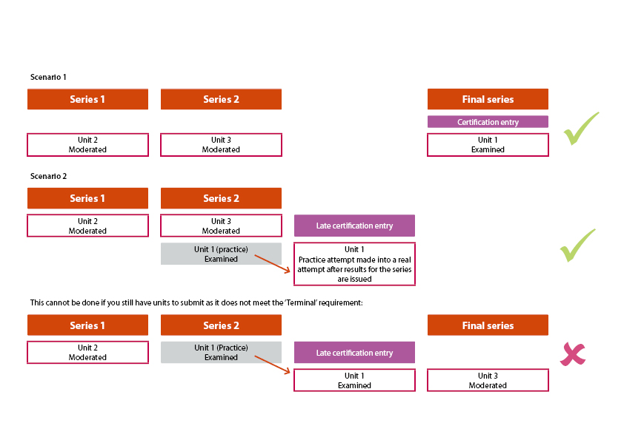  
You must bear in mind the ‘terminal assessment’ requirement; you have to submit all centre-assessed units either **before or in the same series as the final exam is taken.**

Take a look at our guide ‘Understanding the assessment: examined and moderated’ for more detail.

# Curriculum planning suggestions

Models 1 and 2 below allow for students to develop skills, attempt mock versions of the non-exam assessments before submitting OCR-set assignments and also integrate exam content throughout the course, before drawing the focus in the last term’s teaching.

## Model 1: One teacher over two years

Applies if you are teaching over two years, with internally assessed units delivered with integrated exam content.

|  | Autumn 1 | Autumn 2 | Spring 1 | Spring 2 | Summer 1 | Summer 2 |
| --- | --- | --- | --- | --- | --- | --- |
| **Year 10** | **R014:** Reading engineering drawings  **R015:** Interpreting engineering drawing in preparation for manufacture | **R014:** Engineering materials  **R015:** Planning for manufacture/risk assessment | **R014:** Manufacturing processes  **R015**: Workshop practice – marking out and using tools/equipment | **R014:** Manufacturing processes  **R015:** Workshop practice/NEA Assessment (working on) | **R014:** Manufacturing processes  **R015:** Workshop practice/NEA Assessment (working on) | **R015:** NEA Assessment (submit for moderation)[1] |
| **Year 11** | **R014:** Scales of manufacture  **R016:** Preparing for scale manufacture  **R016**: NEA Assessment (working on) | **R014:** Quality  **R016:** CAD/CAM programming  **R016**: NEA Assessment (working on) | **R014:** Inventory management/Lean Manufacturing  **R015:** NEA Assessment (resubmit for moderation)[2]  **R016**: NEA Assessment (submit for moderation)1  **R014**: Examination (early opportunity) | **R014:** Globalisation  **R016:** CNC Setup and operation  **R016:** Quality control activities | **R014** Revision of topic areas/exam revision  **R014**: **Examination** (final opportunity)  **R016:** CNC Setup and operation (continues)  **R016:** Quality control activities (continues)  **R016**: NEA Assessment (submit for moderation)1 |  |

## Model 2: One teacher over three years

Applies if you aim to start teaching in Year 9, with internally assessed units delivered with integrated exam content.

This is just one approach with preparatory work in Year 9.

|  | Autumn 1 | Autumn 2 | Spring 1 | Spring 2 | Summer 1 | Summer 2 |
| --- | --- | --- | --- | --- | --- | --- |
| **Year 9** | Interpreting engineering drawings practice activities | Introduction to engineering materials and properties | Introduction to the engineering workshop – practical activities | Introduction to the engineering workshop – practical activities | Introduction to the engineering workshop – practical activities | Investigation of global manufacturing – group activity |
| **Year 10** | **R014:** Reading engineering drawings  **R015:** Interpreting engineering drawing in preparation for manufacture | **R014:** Engineering materials  **R015:** Planning for manufacture/risk assessment | **R014:** Manufacturing processes  **R015**: Workshop practice – marking out and using tools/equipment | **R014:** Manufacturing processes  **R015:** Workshop practice/NEA Assessment (working on) | **R014:** Manufacturing processes  **R015:** Workshop practice/NEA Assessment (working on) | **R015:** NEA Assessment (submit for moderation)[3] |
| **Year 11** | **R014:** Scales of manufacture  **R016:** Preparing for scale manufacture  **R016**: NEA Assessment (working on) | **R014:** Quality  **R016:** CAD/CAM programming  **R016**: NEA Assessment (working on) | **R014:** Inventory management/Lean Manufacturing  **R015:** NEA Assessment (resubmit for moderation - NB rules about resubmission)[4]  **R016**: NEA Assessment (submit for moderation)1  **R014:** Examination (early opportunity) | **R014:** Globalisation  **R016:** CNC Setup and operation  **R016:** Quality control activities | **R014** Revision of topic areas/exam revision  **R014**: Examination (final opportunity)  **R016:** CNC Setup and operation (continues)  **R016:** Quality control activities (continues)  **R016**: NEA Assessment (submit for moderation) 1 |  |

# Approaching the content

Below are some suggestions about how you could approach the content in each of the units. We’ve designed them to be developed by you   
and your centre to match the needs of your students and your expertise and approach.

| Knowledge and understanding | Practical activities |
| --- | --- |
| **Principles of engineering manufacture**  Knowledge and understanding of engineering materials and processes, how to read engineering drawings, manufacturing in scale and quality control techniques could be integrally taught alongside practical skills and activities developed in the other NEA units. This should provide an excellent opportunity to contextualise manufacturing theory and principles alongside practice, to internalise learning and to prepare students for the terminal assessment.  Types and properties of engineering materials and how these are processed by hand and machine could be taught as an introduction to the three units, and to set the overall scene for the qualification.  Being able to accurately interpret engineering drawings will be a requirement to plan for and manufacture components by hand and machine, and to perform quality control checks, and so will be a key theme throughout the units.  Students will learn about and practically apply a range of manufacturing processes and these could be taught alongside practical activities.  Manufacturing in scale will be covered both theoretically and practically through planning for and performing computer-controlled machining operations.  Quality control techniques will also be taught theoretically, and students will have the opportunity to relate and apply some of these to manufacturing components in scale.  Through integrating theory with practical activities required in NEA units, and using mock and practice assessments, students will be well prepared for the terminal examination in R014. They will be able to relate theory to practice, and to put into context responses to questions they are asked. | **Interpreting engineering drawings** Students will be required to understand standard drawing conventions and interpret drawings in preparation to manufacture components by hand and machine, including programming for computer numerical control (CNC), and to be able to perform quality control checks. They will need to apply their skill at interpreting engineering drawings throughout the NEA units in preparation for the assessments.  **Planning for manufacture** Being able to accurately plan for manufacture by hand and machine will be required in both NEA Units R015 and R016 and this will help students develop a key skill in how to plan.  **Understanding risk** It is crucial that students work safely in all practical aspects of the qualification. This is achieved through risk assessment activities, planning, developing standard operating procedures and through demonstrating safe working in practice in the workshop. This will be a key transferrable skill they will demonstrate in assessment activities, take into other activities and the workplace.  **Using manual processes, tools and machines** Throughout both NEA units, students will gain valuable skills at using hand tools and manual and computer-controlled machines. They will develop and refine these skills through a series of practice activities in preparation for undertaking the NEA assessments in R015 and R016.  **Computer Aided Manufacture and Computer Numerical Control** Manufacturing in scale will require the use of Computer Aided Design (CAD)/Computer Aided Manufacture (CAM) software to programme a CNC machine. Students will develop their skills at interpreting engineering drawings to program, set up and operate a CNC machine. This will prepare them to undertake the NEA assessment in R016.  **Assessing quality** Students will be required to apply their knowledge of quality control techniques and methods to check the quality of components manufactured in scale production. They will use measuring instruments to check and compare critical dimensions with expected values and will perform a statistical process control check. This will prepare them for the NEA assessment in R016. |

# Integrating exam content into practical components

We show you below essential knowledge and understanding that students will need for the examined unit, as outlined in the specification.   
You should aim to include and reinforce this content in your teaching as much as you can.

| Topic area within examined Unit R014 that can be mapped to NEA: | Students must know and understand: | Students should be able to: |
| --- | --- | --- |
| TA1: Manufacturing processes | Types of manufacturing processes and their use | **R015:** Manufacturing a one-off product Students will be able to use manufacturing processes to manufacture a one-off product |
| TA2: Engineering materials | Properties of engineering materials, and how they are processed | **R015:** Manufacturing a one-off product Students will select and process materials to make a one-off product  **R016:** Manufacturing in quantity Students will select and process materials using CNC machines |
| TA3: Manufacturing requirements | How to interpret engineering drawings | **R015:** Manufacturing a one-off product Students will be required to interpret an engineering drawing in preparation to manufacture a one-off product  **R016:** Manufacturing in quantity Students will be required to interpret an engineering drawing in preparation to programme a CNC machine |
| Scales of manufacture, jigs, fixtures and templates, CAM processes | **R016**: Manufacturing in quantity Students are required to select and use jigs, fixtures, and templates for scale manufacture by CNC machine |
| Reasons for implementing quality systems in engineering | **R016**: Manufacturing in quantity Students are required to apply quality control methods to check manufactured components |
| TA4: Developments in engineering manufacture | Inventory management, lean manufacturing and globalisation | Not mapped |

Please note – web links are correct at date of publication but other websites may change over time. If you have any problems with a link you may want to navigate to that organisation’s website for a direct search.



We’d like to know your view on the resources we produce. Click ‘[Like’](mailto:resources.feedback@ocr.org.uk?subject=I%20liked%20the%20Cambridge%20National%20in%20Engineering%20Manufacture%20J823%20Curriculum%20planner) or ‘[Dislike’](mailto:resources.feedback@ocr.org.uk?subject=I%20disliked%20the%20Cambridge%20National%20in%20Engineering%20Manufacture%20J823%20Curriculum%20planner) to send us an auto generated email about this resource. Add comments if you want to. Let us know how we can improve this resource or what else you need. Your email will not be used or shared for any marketing purposes.

Looking for another resource? There is now a quick and easy search [tool to help find free resources](https://www.ocr.org.uk/qualifications/resource-finder/) for your qualification.

OCR is part of Cambridge University Press & Assessment, which is itself a department of the University of Cambridge.

For staff training purposes and as part of our quality assurance programme your call may be recorded or monitored.

Oxford Cambridge and RSA Examinations is a Company Limited by Guarantee. Registered in England.

Registered office The Triangle Building, Shaftesbury Road, Cambridge, CB2 8EA. Registered company number 3484466. OCR is an exempt charity.

OCR operates academic and vocational qualifications regulated by Ofqual, Qualifications Wales and CCEA as listed in their qualifications registers including A Levels, GCSEs, Cambridge Technicals and Cambridge Nationals.

OCR provides resources to help you deliver our qualifications. These resources do not represent any particular teaching method we expect you to use. We update our resources regularly and aim to make sure content is accurate but please check the OCR website so that you have the most up to date version. OCR cannot be held responsible for any errors or omissions in these resources.

Though we make every effort to check our resources, there may be contradictions between published support and the specification, so it is important that you always use information in the latest specification. We indicate any specification changes within the document itself, change the version number and provide a summary of the changes. If you do notice a discrepancy between the specification and a resource, please [contact us](mailto:resources.feedback@ocr.org.uk).

© OCR 2022 - You can copy and distribute this resource freely if you keep the OCR logo and this small print intact and you acknowledge OCR as the originator of the resource.

OCR acknowledges the use of the following content: N/A

Whether you already offer OCR qualifications, are new to OCR or are thinking about switching, you can request more information using our [Expression of Interest form](https://www.ocr.org.uk/qualifications/expression-of-interest/).

Please [get in touch](mailto:resources.feedback@ocr.org.uk) if you want to discuss the accessibility of resources we offer to support you in delivering our qualifications.

1. **See specification for details about submission and resubmission**: OCR-set assignments for NEA units are live for one year. Candidates have one resubmission opportunity. Resubmission of the same work must be in a series that falls in the live assessment dates for the OCR-set assignment on which the work is based. All resubmissions must be based on the assignment that is live for the submission series.
2. **See specification for details about submission and resubmission**: OCR-set assignments for NEA units are live for one year. Candidates have one resubmission opportunity. Resubmission of the same work must be in a series that falls in the live assessment dates for the OCR-set assignment on which the work is based. All resubmissions must be based on the assignment that is live for the submission series.
3. **See specification for details about submission and resubmission**: OCR-set assignments for NEA units are live for one year. Candidates have one resubmission opportunity. Resubmission of the same work must be in a series that falls in the live assessment dates for the OCR-set assignment on which the work is based. All resubmissions must be based on the assignment that is live for the submission series.
4. **See specification for details about submission and resubmission**: OCR-set assignments for NEA units are live for one year. Candidates have one resubmission opportunity. Resubmission of the same work must be in a series that falls in the live assessment dates for the OCR-set assignment on which the work is based. All resubmissions must be based on the assignment that is live for the submission series.