
Support Material
GCE Government and Politics
OCR Advanced GCE in Government and Politics: H495
Unit: F855

This Support Material booklet is designed to accompany the OCR Advanced GCE specification in Government and Politics for teaching from September 2008.

Contents
Contents 2
Introduction 3
Government and Politics H495: US Government and Politics F855 5
Sample Lesson Plan: Government and Politics H495 US Government and Politics F855 12
Other forms of Support 14

Introduction

Background
A new structure of assessment for A Level has been introduced, for first teaching from September 2008. Some of the changes include:
- The introduction of stretch and challenge (including the new A* grade at A2) – to ensure that every young person has the opportunity to reach their full potential
- The reduction or removal of coursework components for many qualifications – to lessen the volume of marking for teachers
- A reduction in the number of units for many qualifications – to lessen the amount of assessment for learners
- Amendments to the content of specifications – to ensure that content is up-to-date and relevant.
OCR has produced an overview document, which summarises the changes to Government and Politics. This can be found at www.ocr.org.uk, along with the new specification.
In order to help you plan effectively for the implementation of the new specification we have produced this Scheme of Work and Sample Lesson Plans for Government and Politics. These Support Materials are designed for guidance only and play a secondary role to the Specification.

Our Ethos
All our Support Materials were produced ‘by teachers for teachers’ in order to capture real life current teaching practices and they are based around OCR’s revised specifications. The aim is for the support materials to inspire teachers and facilitate different ideas and teaching practices.

Each Scheme of Work and set of sample Lesson Plans is provided in:

- PDF format – for immediate use

- Word format – so that you can use it as a foundation to build upon and amend the content to suit your teaching style and students’ needs.

The Scheme of Work and sample Lesson plans provide examples of how to teach this unit and the teaching hours are suggestions only. Some or all of it may be applicable to your teaching.

The Specification is the document on which assessment is based and specifies what content and skills need to be covered in delivering the course. At all times, therefore, this Support Material booklet should be read in conjunction with the Specification. If clarification on a particular point is sought then that clarification should be found in the Specification itself.

A Guided Tour through the Scheme of Work

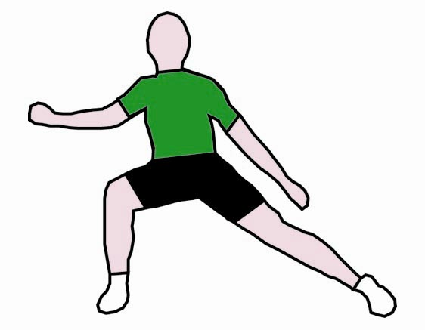
= Innovative Teaching Idea
All the teaching ideas contained in the SOW are innovative, but the icon is used to
Highlight exceptionally innovative ideas.

= Stretch & Challenge Activity
This icon is added at the end of text when there is an explicit opportunity to offer
Stretch and Challenge.

= ICT Opportunity
This icon is used to illustrate when an activity could be taught using ICT facilities.

Government and Politics H495: US Government and Politics F855
Suggested teaching time | 10 hours | Topic | Legislatures. Functions;internal, organisation, second chambers; role of parties in; role of legislators; relationships with executives and judiciaries; contemporary issues concerning representation, accountability, sovereignty and effectiveness.  Each of 7 sections of specifications is allocated a minimum of 10 hours along lines suggested below.
Topic outline |  | Suggested teaching and homework activities | Suggested resources | Points to note
Theories of representation.  Focus on theories which underpin the three legislatures studied and their historical evolution |  | - Preparatory reading set.  - Analysis of political theory underlying UK, US and EU legislatures. Look at evolution of all three. What was their original role? Advisory? Sovereign bodies? Lawmakers?  - Get individual students to talk briefly, based on reading set earlier, on ideas of Locke, Montesquieu, Mill. Ensure focus of session is on theory.  - Set reading for functions and prepare for presentations specified below. | - Heywood ‘Politics’ Cp on Legislatures.  - Mackenzie ‘Political Concepts’ Cp on representation.  - Redhead ’Political Thought from Plato to Nato’ BBC. | - Start with the theory. Don’t focus on details. Make them think broadly. Vital for stretch and challenge/synopticity.
Functions of Legislatures  Focus on both theoretical and actual functions. Ensure clear contrast there  = Innovative teaching idea  = Stretch and challenge opportunity idea  = ICT opportunity |  | - Seminar approach. Students talk on:  - Intended roles of three specified legislatures.  - Actual roles of UK, US and EU legs. Ensure all are covered - lawmaking -representation-executive scrutiny etc.  - Set reading and notes on organisation so students can individually deal with questions in topic outline below. | - C Ridsdell-Smith ‘Parliamentary reform’ Talking Politics Sept 2001.  - Wesserman ‘Basics of US Government’ Cp on Legislatures.  - www.europarl.eu.intt Sections on Budget and external relations. | - Keep it theoretical. Ensure that there is grasping of how they perceive their roles and how the public do. Focus also on why and how roles have changed.
Organisation of legislatures  Who runs them?  Who sets agenda?  Who controls time?  Who decides on legislative leaders?  Who should, in a democracy, do above? |  | - Get a clear picture of what is ideal in a democratic and representative institution. (Ensure they can define those two terms).  - Then compare with actuality. Why has this happened?  - They report on the decision makers in UK.  - US and EU legislatures.  - Contrast actuality with initial theory.  - Reading and notes on second chambers specified below. | - A Adonis ‘Parliament Today’ Specify pages/cps.  - Sinclair ‘Legislators, leaders and leadership’ Specify pages.  - Haywood ‘European Politics today’ Specify pages. | - Keep focus on theory - who should run them?  - What is democratic in this context? Do to get bogged down in details of committees etc.
Second Chambers  Focus on role and necessity  Checks and balances ideas  = Innovative teaching idea  = Stretch and challenge opportunity idea  = ICT opportunity |  | - UK - history and theory. Salisbury doctrine. Current reforms updated.  - US - history and theory- look at debate in Federalist papers.  - EU - why only 1 chamber?  - Discuss which is the most democratic system.  - Discuss which is the most represesentative system.  - Reading and notes on topic below. Students to prepare for seminar on party role in legislatures. One does ‘theory’ for US, another practice etc. | - ‘Reforming the Second Chamber’. Politics Review Feb 2002.  - Hague ‘Comparative government and politics’ Specify pages.  - Norton ‘Reform of the House of Lords’.  - Lords Site – look at both debates and committee work. | - Focus on democratic theory and theory of representation.  - If time, look at either French or Canadian Second Chambers for comparative purposes.
Role of parties in Legislatures  What is, and what should be, their role?  = Innovative teaching idea  = Stretch and challenge opportunity idea  = ICT opportunity |  | - What is, and what should be, the role of parties in legislatures?  - Deal with UK, US and EU systematically, and then work out conclusion as if question above was actual exam question.  - Focus on how essential?  - Set reading and notes on legislators. Structure reading and notes to ensure they think about the role from differing viewpoints – the constituent - the representatives themselves - the need for efficient and effective government and what is most ‘democratic’. | - A Adonis ‘Parliament Today.’ Cp on Party.  - Oxford Guide to US Government. Cp 6 on ‘Political parties in Congress’.  - www.eurativ.com. Section on parties. | - Ensure grasp of details of day to day role in the three legislatures.
Role of Legislators  Focus on both theoretical and actual roles of MPs, Peers, members of Congress and MEPs.  Ensure contrast of above is clear  = Innovative teaching idea  = Stretch and challenge opportunity idea  = ICT opportunity |  | - Focus on individual MP/MEP etc initially and the - theory behind their role - the delegate/representative issue, Burke’s ideas.  - Ensure role of party in getting them elected is known.  - Look at individuals like Galloway and Jeffords, as well as, say, the UKIP MEPs.  - Reading and notes focussing on the underlying theories here - ensure real grasp of separation of powers gained. | - Childs ‘Parliament, women and representation’ Talking politics April 2002.  - Cowley ‘New Labour’s backbenchers’ Talking Politics Sept 2002.  - Federalist Papers 62 on the Senate and 52 on the House of Representatives.  - www.claudemoraes.net ‘What do MEPs do?’ | - Keep focus initially on theory of representative.  - Dilemma of efficiency and practicality over idealism?
Relationships with Executives and Judiciaries.  Theoretical and actual  What is ‘proper’ in a democracy?  = Innovative teaching idea  = Stretch and challenge opportunity idea  = ICT opportunity |  | - Focus on what is and what should be the interrelationship between them.  - Ensure real grasp of theory of separation of powers.  - Look at draft EU Cons on this.  - G Brown is suggesting new UK constitution - draft their own section on the relationship between legislatures and executive and judiciary.  - Check US current practice on this.  - Look at Bush/Blair and their respective legislatures over Iraq War on this to illustrate the issue.  - Look at the Supreme Court and its impact on federal legislation.  - Assign each student an area to research for update along lines suggested below – eg work of Commons on executive scrutiny. | - The draft EU Constitution.  - The US Constitution.  - Cowley ‘The marginalisation of Parliament’.  - www.chartist.org.uk ‘Power to the European parliament’ provides an interesting and modern contrast.
Current issues concerning legislatures.  Update vital for AO1 marks.  = Innovative teaching idea  = Stretch and challenge opportunity idea  = ICT opportunity |  | - Previous 12 months.  - Research-specify sites to cover roles.  - Executive Scrutiny.  - Commons Public Account Committee.  - Senate Foreign Affairs committee.  - EU Parliament on EU Budget.  - Legislation.  - Debate on Second Reading and Standing Committee stage of Commons.  - Senate Judiciary Committee on Homeland Security-passage there and through House of Reps.  - EU Parliament on 2006 Budget.  - Ensure they have accurate examples to illustrate fully roles specified originally- both ‘for’ and ‘against’.  - Homework to ensure all notes to be checked and rationalised for checking when timed essay done. | - Selected sections of:  - Congress.  - Parliament.  - EU Parliament sites.
Plenary on legislatures – focus on essay techniques |  | - In lesson plan for 855.
 |  | - Timed essay under exam conditions.

= Innovative teaching idea
= Stretch and challenge opportunity idea
= ICT opportunity

Sample Lesson Plan: Government and Politics H495 US Government and Politics F855

Legislatures. Stretch, challenge and synopticity
OCR recognises that the teaching of this qualification will vary greatly from school to school and from teacher to teacher. With that in mind, this lesson plan is offered as a possible approach but will be subject to modifications by the individual teacher.
Lesson length is assumed to be one hour.

Learning objectives for the lesson
Objective 1 | To grasp the essential nature of this synoptic paper and its essay requirements and the demands of stretch and challenge.
Objective 2 | Essay planning with particular focus on synoptic techniques.
Objective 3 | Monitoring grasp and understanding of differing roles of legislatures of UK, US and EU.

Recap of previous experience and prior knowledge
- Similarities and differences in roles of US Congress and European Parliament from previous session. This lesson would be final session on legislatures.UK Parliament, US Congress and European Parliament (or Scottish Parliament/Northern Ireland/ Welsh Assembly) knowledge all checked and discussed.

Content
Time | Content
5 minutes | Update as per normal. May 8. Scottish Election results (Scotsman). US House of Representatives and Iraq War.) (Washington Post) European Court of Justice rulings (Economist). Ensure these examples are noted in relevant sections of their notes for recent exemplar material.
10 minutes | Give out photocopy of unmarked essay done under timed conditions previous year entitled “Discuss the view that the most important role of legislatures today is to check executives”. (Ideally C grade/adequate plus).Put up OCR Assessment Grid on PP/give out copy. They read essay, note merits and demerits and extent to which it does not fit into L4 (all 3 assessment objectives). Analyse why it did not achieve L4. What does it need to do to get to L4? Plenary on what was good/bad about essay and what is needed to get to L4 in terms of detail, analysis and communication. Really emphasise need for reflective view/big picture/overview. Stress need not to write another 853 essay.
10 minutes | New title looked at: “Discuss the need for institutional reform within legislatures in different political systems”. Students do initial plan and design opening paragraph for title, either on own or in pairs (pairs works well).Brief plenary on two of plans done.

Time | Content
25 minutes | Model opening paragraph and detailed essay plan produced for them to use as template for future. Ensuring:  - Clear answer is there from beginning, how necessary, or otherwise, is institutional reform in each of the three legislatures studied?  - There is clear evidence of overview - or thinking about legislatures generally.  - There is evidence of their thinking about the roles of legislatures generally and the need for reforms/changes to implement those roles successfully. Ensure that the wider implications for democracy are considered.  - Not too much detail needed in opener-focus on thinking broadly/strategically.  - See how that fits into L4 AO2 of Assessment Grid.  Then:  - Work out detailed plan (in pairs) for remainder of essay. Theme and content of all paragraphs.  - Ensure that objective of each paragraph is totally clear - that it is not just a list of facts, but is developing a point made in initial answer, so the examiner does not just put ‘So?’ at the end of the paragraph.  - Ensure that each paragraph contains relevant, recent and accurate examples to get AO1 marks needed for L4 (put four descriptors up on PP or give out photocopy of it).  - Ensure that exemplar material covers all three legislatures studied - and is fully relevant- and not just odd bits of knowledge put in to impress.  - Discuss whether essay needs a conclusion. If there is a clear case already made and the supportive evidence backs it up - is it necessary? Have they time for it?

Consolidation
Time | Content
10 minutes | Ensure that the essential requirements of synoptic L4 essay are clearly noted. 4/5 key points to consider before they write this type of essay. Look at further title “Discuss the view that legislatures are too dominated by executives’ and ensure that key areas to be discussed are noted. What do they mean by ‘too dominated’? What is too much or too little domination? Is any needed? How essential for democracy is the separation of powers?
1 minute | Timed essay on legislatures for next period. Remind of relevant reading/sites. Newton’s ‘Foundations of Comparative Politics’ has an excellent chapter on legislatures which will help them ‘think broadly’.

Other forms of Support
In order to help you implement these new specification effectively, OCR offers a comprehensive package of support. This includes:

OCR Training

Get Ready…introducing the new specifications
A series of FREE half-day training events are being run during Autumn 2007, to give you an overview of the new specifications.

Get Started…towards successful delivery of the new specifications
These full-day events will run from Spring 2008 and will look at the new specifications in more depth, with emphasis on first delivery.
Visit www.ocr.org.uk for more details.

Mill Wharf Training
Additional events are also available through our partner, Mill Wharf Training. It offers a range of courses on innovative teaching practice and whole-school issues - www.mill-wharf-training.co.uk.

e-Communities
Over 70 e-Communities offer you a fast, dynamic communication channel to make contact with other subject specialists. Our online mailing list covers a wide range of subjects and enables you to share knowledge and views via email.
Visit https://community.ocr.org.uk, choose your community and join the discussion!

Interchange
OCR Interchange has been developed to help you to carry out day to day administration functions online, quickly and easily. The site allows you to register and enter candidates online. In addition, you can gain immediate a free access to candidate information at you convenience. Sign up at https://interchange.ocr.org.uk

Published Resources
Published Resources
OCR offers centres a wealth of quality published support with a fantastic choice of ‘Official Publisher Partner’ and ‘Approved Publication’ resources, all endorsed by OCR for use with OCR specifications.

Publisher partners
OCR works in close collaboration with three Publisher Partners; Hodder, Heinemann and Oxford University Press (OUP) to ensure centres have access to:

- Better published support, available when you need it, tailored to OCR specifications
- Quality resources produced in consultation with OCR subject teams, which are linked to OCR’s teacher support materials
- More resources for specifications with lower candidate entries
- Materials that are subject to a thorough quality assurance process to achieve endorsement

Heinemann is the publisher partner for OCR GCE Government and Politics

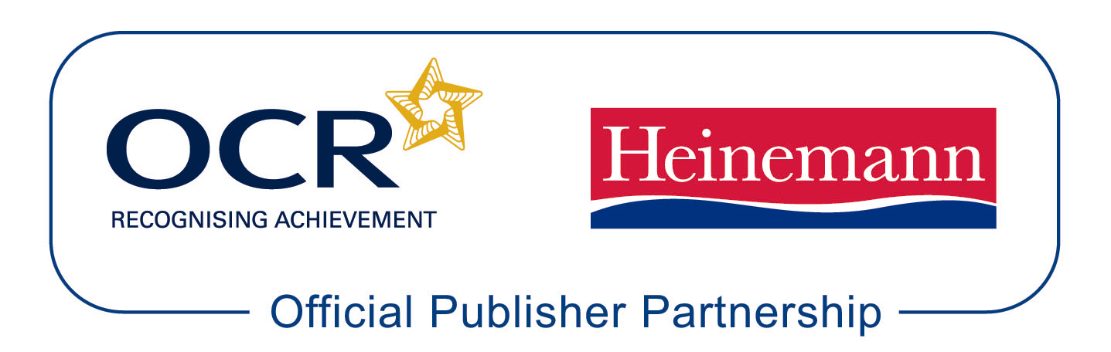

Heinemann is producing the following resources for OCR GCE Government and Politics for first teaching in September 2008.

Sutherland, J, Canwell, D, Walsh-Atikins, P. AS Student Book.

Sutherland, J, Canwell, D, Walsh-Atikins, P. A2 US Government and Politics CD ROM.

Sutherland, J, Canwell, D, Walsh-Atikins, P. A2 Political Ideas and Concepts CD ROM.

Approved publications OCR still endorses other publisher materials, which undergo a thorough quality assurance process to achieve endorsement. By offering a choice of endorsed materials, centres can be assured of quality support for all OCR qualifications.



Endorsement
OCR endorses a range of publisher materials to provide quality support for centres delivering its qualifications. You can be confident that materials branded with OCR’s “Official Publishing Partner” or “Approved publication” logos have undergone a thorough quality assurance process to achieve endorsement. All responsibility for the content of the publisher’s materials rests with the publisher.

These endorsements do not mean that the materials are the only suitable resources available or necessary to achieve an OCR qualification. Any resource lists which are produced by OCR shall include a range of appropriate texts.

