**OCR-set Assignment**

**Sample Assessment Material**

OCR Level 3 Alternative Academic Qualification Cambridge Advanced National in Applied Science

Unit F183: Analytical techniques in chemistry

Scenario Title: Be Well Pharmacy

Give to candidates on or after X June 20XX.  
Valid for assessment until 20XX. For use by students beginning the qualification in September 20XX and finishing by 20XX or 20XX.

This is a sample OCR-set assignment which should only be used for practice**.**

This assignment **must not** be used for live assessment of students.

The live assignments will be available on our secure website, ‘Teach Cambridge’.

**The OCR administrative codes linked to this unit are:**

* unit entry code F183
* certification code H151

**The regulated qualification number linked to this unit is:**

610/3948/2

**Duration**

About:

* 20 hours of supervised time (GLH)  
  (work that **must** be completed under teacher supervised conditions)
* 4 hours of unsupervised time  
  (work that students can complete independently without teacher supervision)

**All** this material **can** be photocopied. Any photocopying will be done under the terms of the Copyright Designs and Patents Act 1988 solely for the purposes of assessment.

Contents

Information and instructions for Teachers 3

Using this assignment 3

Information for delivering tasks 4

Tasks for students and assessment criteria 5

Scenario 5

Task 1 9

Task 2 11

Task 3 13

Task 4 15

Task 5 17

Endorsement 18

Teacher Observation Record Form for Task 2 19

Guidance notes 20

Teacher Observation Record Form for Task 4 21

Guidance notes 22

Risk Assessment Template 23

NEA Command Words 24

Teacher/Technician Advice 25

# Information and instructions for Teachers

## Using this assignment

This assignment provides a scenario and set of related tasks that reflect how people working within analytical chemistry would plan and perform investigations, analyse and interpret data, determine the purity of substances, evaluate techniques used, and make conclusions.

The assignment:

* Is written so that students have the opportunity to meet the requirements of all assessment criteria for the unit.
* Will tell students if their evidence must be in a specific format. If the task does not specify a format, students can choose the format to use.
* **Must** be completed under teacher supervision. Any unsupervised time allowed will be stated below and explained in the assessment guidance.

We have estimated that this assignment will take about 20 hours of supervised time and 4 hours of unsupervised time to complete. Students should need approximately:

* 4 hours to complete Task 1
* 5 hours to complete Task 2
* 5 hours to complete Task 3
* 6 hours to complete Task 4
* 4 hours to complete Task 5

You **must**:

* Use an OCR-set assignment for summative assessment of students.
* Familiarise yourself with the assessment criteria and assessment guidance for the tasks. These are given at the end of each student task. They are also with the unit content in **Section 4** of the Specification.

Assessment guidance is only given where additional information is needed. There might not be assessment guidance for each criterion.

* Make sure students understand that the assessment criteria and assessment guidance tell them in detail what they need to do in each task.
* Read and understand **all** the rules and guidance in **Section 6** of the Specification **before** your students start the set assignments.
* Make sure that your students complete the tasks and that you assess the tasks fully in line with the rules and guidance in **Section 6** of the Specification.
* Give your students the Applied Science[**Student guide to NEA assignment**](https://www.ocr.org.uk/Images/620503-student-guide-to-nea-assignments.pdf)**s** **before** they start the assignments.
* Complete the **Teacher Observation Record** for **Task 2** and **Task 4**. You **must** follow the guidance given when completing it.

You **must** **not**:

* Use live OCR-set assignments for practice or formative assessment. This sample assessment material **can** be used for practice or formative assessment.
* Use this sample assessment material for live assessment of students.
* Allow group work for **any** task in this assignment.
* Change any part of the OCR-set assignments or assessment criteria.

## Information for delivering tasks

|  |  |
| --- | --- |
| **Task** | **Requirements** |
| General | Students will be expected to plan their own investigations. It is essential that teachers check the methods and risk assessments prior to students conducting any practical work to ensure they have chosen equipment and reagents available at the centre and that their methods and reagents are safe to use. |
| 1, 2, 3, and 4 | See accompanying ‘Teacher/Technician Advice’ for guidance specific to this scenario. |

**Pages 1-4** are for teachers only. Please do **not** give **Pages 1-4** to your students.

You can give **any** or **all** of the pages **that follow** to your students.

# Tasks for students and assessment criteria

**Unit F183: Analytical Techniques in Chemistry**

**Scenario Title:** Be Well Pharmacy

Give to candidates on or after X June 20XX.  
Valid for assessment until 20XX. For use by students beginning the qualification in September 20XX and finishing by 20XX or 20XX

Scenario

You are an analytical chemist and have been asked to identify two unknown compounds sent into your laboratory by a local pharmacy called Be Well Pharmacy.

Compound X was found in a colourless, stoppered glass bottle with the word ‘solvent’ written on it. It has been found on a shelf in the pharmacy and its identity needs to be known so that it can be safely disposed of.

Compound Y is known to be an ingredient in a leading brand of eye drops. You have been sent a crystallised, impure sample of this compound and a sample of the eye drop solution to determine the concentration of compound Y.

Your laboratory is well equipped with standard laboratory reagents and equipment, but you had to send a sample of compound X to a colleague for spectroscopic analysis. Other samples from the laboratory have been sent for spectroscopic analysis, so you will need to find out which of the spectra received belongs to compound X.

You will need to use the information given and perform chemical tests to identify the unknown compounds. The compounds have become contaminated so you will also need to perform appropriate purification techniques.

**Information about unknown organic compound X:**

* It has a boiling point below 150 °C.
* A close-up of a sign

  Description automatically generatedIt is impure and is contaminated with salt water.
* The hazard symbols associated with this compound are:

**Information about unknown inorganic compound Y:**

* It has no hazard symbols associated with it.
* It is safe to heat this compound and to react it with common laboratory reagents.
* It is impure and has been contaminated by another ionic salt that has a low solubility in ethanol.
* The eye drops are an aqueous solution of this compound. The label originally indicated a 10% weight/volume (w/v) concentration for this application.

**Spectra received**

**Compound 1**

Percentage composition: 62.0% C, 10.4% H, and 27.5% O

relative intensity

m / z

80

70

60

50

40

30

20

10

0

0

20

40

60

80

100

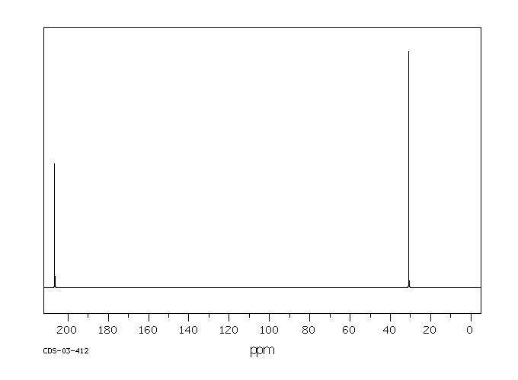

220

concentration / ppm

200

1800

1600

140

120

100

80

60

40

20

0

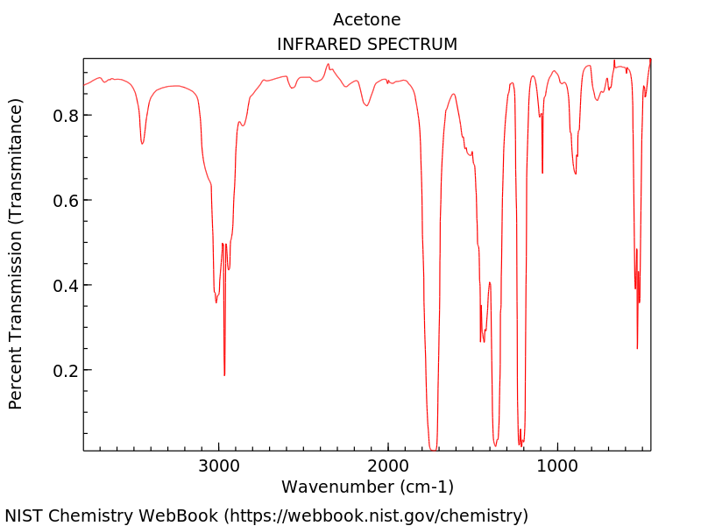

3000

2000

1000

0.0

0.2

0.45

0.6

0.8

1.0

wave number / cm–1

relative transmittance

mass spectrum

infrared spectrum

**13**C-NMR

**Compound 2**

**Percentage Composition:** 66.62% C, 11.18% H, 22.19% O

relative intensity

m / z

80

70

60

50

40

30

20

10

0

0

20

40

60

80

100

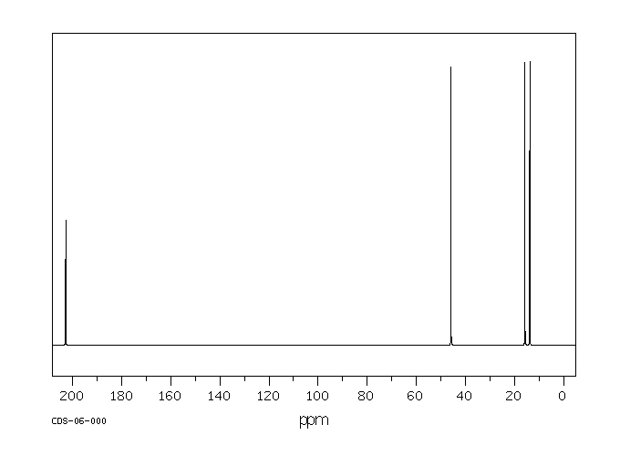

220

concentration / ppm

200

1800

1600

140

120

100

80

60

40

20

0

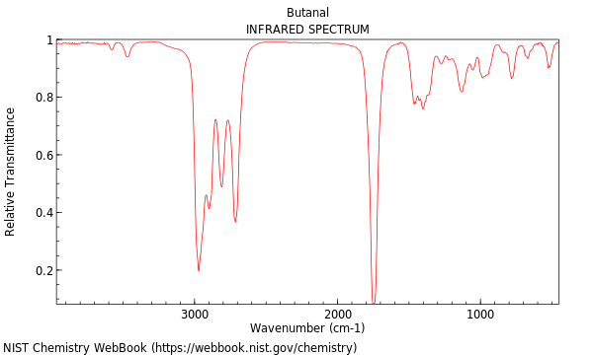

3000

2000

1000

0.0

0.2

0.45

0.6

0.8

1.0

wave number / cm–1

relative transmittance

mass spectrum

infrared spectrum

13C-NMR

**Compound 3**

**Percentage Composition:** 48.64% C, 8.16% H, 43.19% O

relative intensity

m / z

80

70

60

50

40

30

20

10

0

0

20

40

60

80

100

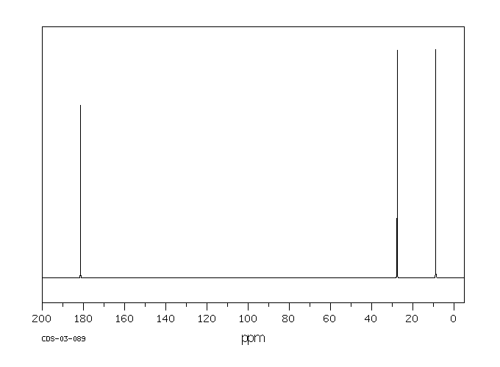

220

concentration / ppm

200

1800

1600

140

120

100

80

60

40

20

0

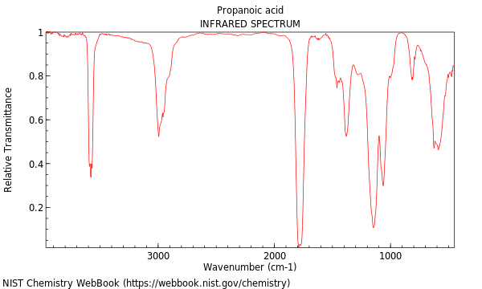

3000

2000

1000

0.0

0.2

0.45

0.6

0.8

1.0

wave number / cm–1

relative transmittance

mass spectrum

infrared spectrum

13C-NMR

## Task 1

**Plan your investigations**

Topic Areas 1 to 3 are assessed in this task.

**The task is:**

Plan how you will separate the two unknown compounds from their mixtures, confirm their purity and then identify them. This should include a plan for gravimetric analysis of the inorganic compound to determine its percentage purity.

Your evidence **must** include:

* A written plan
* A risk assessment using the template provided.

**Use the assessment criteria below to tell you what you need to do in more detail.**

|  |  |  |
| --- | --- | --- |
| **Pass** | **Merit** | **Distinction** |
| **P1: Identify** appropriate tests and techniques to investigate the unknown compounds in a logically sequenced order.  (PO2) |  |  |
| **P2:** **Identify** appropriate equipment, reagents and quantities to investigate the unknown compounds.  (PO2) |  |  |
| **P3:** Use research to **complete** a risk assessment for your investigation.  (PO4) |  |  |

**Assessment Guidance**

This assessment guidance gives you information to meet the assessment criteria. There might not be additional assessment guidance for each criterion. It is only given where it is needed. You must read this guidance before you complete your evidence.

|  |  |
| --- | --- |
| **Assessment Criteria** | **Assessment guidance** |
| P1 | * **P1** does not require research from students, it should be from taught Unit F183 knowledge. * **P1** should not be a standalone list, it should form part of a written, logically sequenced plan for the investigation. |
| P2 | * The size, quantity and type of equipment (e.g. size and type of pipettes/beakers etc.) will need to be specified by the student to achieve **P2**. * **P2** should not be a standalone list, it should form part of the written, logically sequenced plan for the investigation. |
| P3 | * Students will need to complete some basic research to help them identify the risks associated with the reagents and techniques chosen. * References should be included at the end of the risk assessment template. * The research element of this criterion does not need to be completed under supervised conditions. |

**Advice:**

* Following the completion of **Task 1**, your teacher will need to ensure that your planned investigation is safe for you to do in your school laboratory.
* Remember to clearly reference any information used from books, websites or other sources to support your evidence.

## Task 2

**Discover the unknown organic compound**

Topic Areas 1 to 3 are assessed in this task.

**The task is:**

Conduct your planned investigation to determine the identity of the unknown organic compound.

Your evidence **must** include:

* Written evidence
* Photographic evidence of the observations
* A Teacher Observation Record Form.

**Use the assessment criteria below to tell you what you need to do in more detail.**

|  |  |  |
| --- | --- | --- |
| **Pass** | **Merit** | **Distinction** |
| **P4:** **Perform** separating techniques identified in the plan for the unknown organic compound safely and skilfully.  (PO4) | **M1:** **Use** appropriate techniques to confirm the purity of the isolated compound.  (PO4) | **D1:** **Justify** the identity of the organic compound.  (PO3) |
| **P5:** **Perform** qualitative tests identified in the plan to determine the functional group of the organic compound safely.  (PO4) | **M2:** **Interpret** spectra to confirm the identity of the organic compound.  (PO4) |

**Assessment Guidance**

This assessment guidance gives you information to meet the assessment criteria. There might not be additional assessment guidance for each criterion. It is only given where it is needed. You must read this guidance before you complete your evidence.

|  |  |
| --- | --- |
| **Assessment Criteria** | **Assessment guidance** |
| P4 | * Students should use annotated photographic evidence to help them describe qualitative observations. * The teacher observation record form should comment on the safe carrying out of the separating techniques and the skilful use of apparatus by the student to collect data of sufficient quality. * Students must be able to perform the task safely to achieve this criterion. Staff must intervene if safe working practices are not being followed but where this happens the criteria cannot be awarded. |
| P5 | * Students should use annotated photographic evidence to help them describe qualitative observations. * The teacher observation record form should comment on the safe carrying out of the qualitative tests by the student. * Students must be able to perform the task safely to achieve this criterion. Staff must intervene if safe working practices are not being followed but where this happens the criteria cannot be awarded. |
| M2 | * Students should match the evidence collected from **P4**, **P5** and **M1** to the spectroscopic data provided, to identify the type of organic compound. * Students should then use calculations to confirm the identity of the organic compound. * The name of the organic compound should be provided using IUPAC nomenclature, as well as the displayed or structural formula of the organic compound. |
| D1 | * Students should explain how they matched the evidence from **P4**, **P5** and **M1** to the spectroscopic data. Students should also explain why they rejected the other spectroscopic data. * Annotations to the spectroscopic data should be made to help students form their explanation. |

## Task 3

**Discover the unknown inorganic compound**

Topic Areas 1 and 2 are assessed in this task.

**The task is:**

Conduct your planned investigation to determine the identity of the unknown inorganic compound.

Conduct a gravimetric analysis of your sample.

Your evidence **must** include:

* Written evidence
* Photographic evidence of the observations.

**Use the assessment criteria below to tell you what you need to do in more detail.**

|  |  |  |
| --- | --- | --- |
| **Pass** | **Merit** | **Distinction** |
| **P6:** **Perform** appropriate separating techniques for the unknown inorganic compound.  (PO4) | **M3:** **Use** appropriate techniques to confirm the purity of the isolated compound.  (PO4) | **D2:** **Evaluate** the accuracy of the percentage purity of the inorganic compound.  (PO3) |
| **P7: Perform** qualitative tests identified in the plan to confirm the identity of the inorganic compound.  (PO4) | **M4:** **Explain** the identity of the inorganic compound.  (PO2) |

**Assessment Guidance**

This assessment guidance gives you information to meet the assessment criteria. There might not be additional assessment guidance for each criterion. It is only given where it is needed. You must read this guidance before you complete your evidence.

|  |  |
| --- | --- |
| **Assessment Criteria** | **Assessment guidance** |
| P6 | * Students should use annotated photographic evidence to help them describe qualitative observations. |
| P7 | * Students should use annotated photographic evidence to help them describe qualitative observations. |
| M4 | * Students should explain how they collated evidence from **P6**, **P7** and **M3** to identify the ions in the inorganic compound. Students should explain why they rejected the presence of other ions in the inorganic compound. * The name of the inorganic compound should be provided using IUPAC nomenclature, as well as the chemical formula. |
| D2 | * Students should use appropriate techniques (including gravimetric analysis) to calculate the percentage purity of the inorganic compound. * Students should then consider how accurate this value is considering the techniques used in **P6** and **M3**. |

## Task 4

**Determine the concentration of the solution**

Topic Area 2 is assessed in this task.

**The task is:**

Determine the concentration of the solution you have been provided with.

Your evidence **must** include:

* Written evidence
* Photographic evidence of observations
* A Teacher Observation Record Form.

**Use the assessment criteria below to tell you what you need to do in more detail.**

|  |  |  |
| --- | --- | --- |
| **Pass** | **Merit** | **Distinction** |
| **P8:** Use research to **identify** appropriate techniques and reagent(s) to determine concentration.  (PO4) |  |  |
| **P9:** **Prepare** appropriate standard solution(s).  (PO4) |  |  |
| **P10: Use** appropriate technique(s) to determinereacting volumes safely and skilfully.  (PO4) | **M5:** **Calculate** the concentration of the solution and the combined uncertainty in this result.  (PO2) | **D3: Evaluate** concentration of the solution in comparison with the actual concentration that is suggested in the scenario.  (PO3) |

**Assessment Guidance**

This assessment guidance gives you information to meet the assessment criteria. There might not be additional assessment guidance for each criterion. It is only given where it is needed. You must read this guidance before you complete your evidence.

|  |  |
| --- | --- |
| **Assessment Criteria** | **Assessment guidance** |
| P8 | * Research is required to select appropriate reagents to determine the concentration of the unknown inorganic compound. * The research element of this criterion does not need to be completed under supervised conditions. |
| P9 | * The teacher observation record form should comment on the skilful preparation of standard solutions. |
| P10 | * Students should use annotated photographic evidence to help them indicate that they have collected data of sufficient quality. * The teacher observation record form should comment on the safe carrying out of the quantitative tests by the student. * Students must be able to perform the task safely to achieve this criterion. Staff must intervene if safe working practices are not being followed but where this happens the criteria cannot be awarded. |
| M5 | * Students should process raw data appropriately and indicate their decisions in their written evidence. All working out should be included in the written evidence, with appropriate units. |

**Advice:**

* Remember to clearly reference any information used from books, websites or other sources to support your evidence.

## Task 5

**Review of your investigations**

Topic Areas 1 to 3 are assessed in this task.

**The task is:**

Review how well you carried out your investigations, the suitability of the techniques you used in producing a pure sample for analysis, and the tests you used to determine their identities, concentration and purity.

Your evidence **must** include:

* Written evidence.

**Use the assessment criteria below to tell you what you need to do in more detail.**

|  |  |  |
| --- | --- | --- |
| **Pass** | **Merit** | **Distinction** |
| **P11: Explain** other tests or techniques that could be used to help confirm the identity of the compounds and the concentration of the solution.  (PO2) | **M6: Assess** the quality of the data collected.  (PO3) | **D4**: **Evaluate** the tests and techniques used to confirm the identity and concentrations of the compounds.  (PO3) |
|  |  | **D5:** **Justify** suggestions for improvements that could be made.  (PO3) |

**Assessment Guidance**

This assessment guidance gives you information to meet the assessment criteria. There might not be additional assessment guidance for each criterion. It is only given where it is needed. You must read this guidance before you complete your evidence.

|  |  |
| --- | --- |
| **Assessment Criteria** | **Assessment guidance** |
| P11 | * Students should not be restricted to the tests or techniques available in their school. |
| M6 | * Students should use their understanding of quality data to offer a reasoned judgment of the data collected. * Students should consider the purity of the final compounds they isolated, potential losses during separation techniques, and any other errors that may have been introduced during the investigation. * They should not attribute errors in the data to the materials provided by the centre or that provided in the scenario. |
| D4 | * Students should consider the strengths and limitations of the apparatus, tests, and techniques that were used. * Combined uncertainty calculated in **M5** should form part of this judgment. |
| D5 | * Students should consider all techniques explored in Unit F183 when making their decisions about improvements. * The justification should be restricted to the tests or techniques available in their school. |

# Endorsement



Safety checked but not trialled by CLEAPSS

# Teacher Observation Record Form for Task 2

Use this form to record what is observed.

Read the **guidance notes** below the form **before** you complete the form.

**OCR Level 3 Alternative Academic Qualification Cambridge Advanced National in Applied Science (Extended Certificate)**

|  |  |
| --- | --- |
| Unit number: | F183 |
| Unit title: | Analytical techniques in chemistry |
| Task number: | 2 |
| Task title: | Discover the unknown organic compound |

|  |  |
| --- | --- |
| Student’s name: |  |
| Date the activity was completed: |  |

|  |  |
| --- | --- |
| What extra evidence is attached to the form? |  |

The **teacher** fills in this section:

|  |  |
| --- | --- |
| What Assessment Criteria does this activity relate to?  This activity relates to the assessment criteria **P4 and P5**.  For P4, you must comment on the safe carrying out of the separating techniques and the skilful use of apparatus by the student to collect data of sufficient quality.  For P5, you must comment on the safe carrying out of the qualitative tests by the student. | |
| How does the activity meet the requirements of the Assessment Criteria?  You **must** describe:  1. what the student did  2. how it relates to the relevant Assessment Criteria. | |
| Teacher’s name: |  |
| Teacher’s signature: |  |
| Date: |  |

The **student** fills in this section:

|  |  |
| --- | --- |
| I agree with my teacher’s description of how I completed this activity Yes ☐ | |
| Use this space to make any extra comments. | |
| Student’s signature: |  |
| Date: |  |

## Guidance notes

**Both** the teacher **and** the student are responsible for completing this form.

The **teacher** **must**:

* use the form to describe in detail what they observed the student doing.
* give contextualised details of what the student did and how this relates to the Assessment Criteria.
* say how well the activity was completed in relation to the Assessment Criteria with reasons.
* share what they have written with the student and offer the opportunity to discuss if the student disagrees with what is written.
* reach agreement with the student before the work is submitted for moderation.
* sign and date the form as evidence of agreement.

The **student** **must**:

* reach agreement with the teacher before the work is submitted for moderation.
* use the form to show that they agree with the teacher’s record of the activity observed.
* sign and date the form as evidence of agreement.

The form **must**:

* be accompanied by extra evidence, as required by the task.
* provide evidence that is individual to the student.

The form **must not**:

* contain a simple repeat of the Assessment Criteria.
* contain just a list of skills.
* be completed by anyone other than the teacher observing the activity and the student completing the activity.
* be written by the student for the teacher to sign.
* be used to evidence achievement of a whole unit or task in isolation.

# Teacher Observation Record Form for Task 4

Use this form to record what is observed.

Read the **guidance notes** below the form **before** you complete the form.

**OCR Level 3 Alternative Academic Qualification Cambridge Advanced National in Applied Science (Extended Certificate)**

|  |  |
| --- | --- |
| Unit number: | F183 |
| Unit title: | Analytical techniques in chemistry |
| Task number: | 4 |
| Task title: | Determine the concentration of the solution |

|  |  |
| --- | --- |
| Student’s name: |  |
| Date the activity was completed: |  |

|  |  |
| --- | --- |
| What extra evidence is attached to the form? |  |

The **teacher** fills in this section:

|  |  |
| --- | --- |
| What Assessment Criteria does this activity relate to?  This activity relates to the assessment **P9 and P10**.  For P9, you must comment on the skilful preparation of standard solutions  For P10, you must comment on the safe carrying out of the quantitative tests by the student. | |
| How does the activity meet the requirements of the Assessment Criteria?  You **must** describe:  1. what the student did  2. how it relates to the relevant Assessment Criteria. | |
| Teacher’s name: |  |
| Teacher’s signature: |  |
| Date: |  |

The **student** fills in this section:

|  |  |
| --- | --- |
| I agree with my teacher’s description of how I completed this activity Yes ☐ | |
| Use this space to make any extra comments. | |
| Student’s signature: |  |
| Date: |  |

## Guidance notes

**Both** the teacher **and** the student are responsible for completing this form.

The **teacher** **must**:

* use the form to describe in detail what they observed the student doing.
* give contextualised details of what the student did and how this relates to the Assessment Criteria.
* say how well the activity was completed in relation to the Assessment Criteria with reasons.
* share what they have written with the student and offer the opportunity to discuss if the student disagrees with what is written.
* reach agreement with the student before the work is submitted for moderation.
* sign and date the form as evidence of agreement.

The **student** **must**:

* reach agreement with the teacher before the work is submitted for moderation.
* use the form to show that they agree with the teacher’s record of the activity observed.
* sign and date the form as evidence of agreement.

The form **must**:

* be accompanied by extra evidence, as required by the task.
* provide evidence that is individual to the student.

The form **must not**:

* contain a simple repeat of the Assessment Criteria.
* contain just a list of skills.
* be completed by anyone other than the teacher observing the activity and the student completing the activity.
* be written by the student for the teacher to sign.
* be used to evidence achievement of a whole unit or task in isolation.

# Risk Assessment Template

|  |  |
| --- | --- |
| Title of investigation |  |
| Candidate Name |  |
| Date Completed |  |

|  |  |  |  |  |
| --- | --- | --- | --- | --- |
| **Hazardous chemical, procedure or equipment** | **Hazard** | **Risk** | **Control measures** | **Emergency measures** |
|  |  |  |  |  |
|  |  |  |  |  |
|  |  |  |  |  |
|  |  |  |  |  |
|  |  |  |  |  |
|  |  |  |  |  |
|  |  |  |  |  |

# NEA Command Words

The table below shows the command words that may be used in the NEA assignments and/or assessment criteria.

|  |  |
| --- | --- |
| **Command Word** | **Meaning** |
| **Adapt** | * Change to make suitable for a new use or purpose |
| **Analyse** | * Separate or break down information into parts and identify their characteristics or elements * Explain the different elements of a topic or argument and make reasoned comments * Explain the impacts of actions using a logical chain of reasoning |
| **Assess** | * Offer a reasoned judgement of the standard or quality of situations or skills. The reasoned judgement is informed by relevant facts |
| **Calculate** | * Work out the numerical value. Show your working unless otherwise stated |
| **Classify** | * Arrange in categories according to shared qualities or characteristics |
| **Compare** | * Give an account of the similarities and differences between two or more items, situations or actions |
| **Conclude** | * Judge or decide something |
| **Describe** | * Give an account that includes the relevant characteristics, qualities or events |
| **Discuss** (how/whether/etc) | * Present, analyse and evaluate relevant points (for example, for/against an argument) to make a reasoned judgement |
| **Evaluate** | * Make a reasoned qualitative judgement considering different factors and using available knowledge/experience |
| **Examine** | * To look at, inspect, or scrutinise carefully, or in detail |
| **Explain** | * Give reasons for and/or causes of something * Make something clear by describing and/or giving information |
| **Interpret** | * Translate information into recognisable form * Convey one’s understanding to others, e.g. in a performance |
| **Investigate** | * Inquire into (a situation or problem) |
| **Justify** | * Give valid reasons for offering an opinion or reaching a conclusion |
| **Research** | * Do detailed study in order to discover (new) information or reach a (new) understanding |
| **Summarise** | * Express the most important facts or ideas about something in a short and clear form |

We might also use other command words but these will be:

* commonly used words whose meaning will be made clear from the context in which they are used
* subject specific words drawn from the unit content.

**OCR-set Assignment**

**Sample Assessment Material**

# Teacher/Technician Advice

OCR Level 3 Alternative Academic Qualification Cambridge Advanced National in Applied Science (Extended Certificate)

**H151** Unit F183: Analytical techniques in chemistry

Scenario Title: Be Well Pharmacy

This is a sample OCR-set assignment which should only be used for practice**.**

This assignment **must not** be used for live assessment of students.

The live assignments will be available on our secure website, ‘Teach Cambridge’.

**Inorganic Compound Y – Magnesium Chloride**

* Contaminant to mix – Calcium Carbonate
* Ratio MgC*l* 2: CaCO3 ~3:1, ~10 g per student. Label vial **COMPOUND** **Y**.
* **DO NOT** indicate identity of compounds in mixture to students in any other way.

NB. Students could extract the magnesium chloride into ethanol but then carry out liquid-‑liquid extraction in water, followed by recrystallisation to prevent boiling ethanol by Bunsen flame. Precipitation gravimetric analysis may also be indicated by the student in their method – appropriate reagents and equipment (on request) will need to be provided.

Students will likely need access to the following:

* Flame test equipment
* Filtration equipment
* Recrystallisation equipment
* Reagents and equipment for conducting anion and cation precipitation reactions
* Ethanol and distilled water
* Melting point determination equipment
* Digital scales

**Organic Compound X– Propanone (acetone)**

* Contaminant to mix – a dilute salt (sodium chloride) solution
* Ratio of propanone : salt water ~3:2, ~50 ml sample per student.   
  Label vial **COMPOUND X**.
* DO NOT indicate identity of compounds in mixture to students in any other way.
* A few drops of bromophenol blue could be added to help identify the different fractions

(propanone distilling colourless).

Students will likely need access to the following:

* Distillation equipment
* Reagents and equipment for carrying out functional group tests
* Boiling point determination (e.g. Thiele tubes or capillary tube + silicone oil beaker technique)

**Inorganic Compound Y Eye drop solution – 7% w/v solution**

* Use distilled water and magnesium chloride only (10.5 g per 150 ml water)
* Students will need ~150 ml each. Label the containers: **Eye drop solution  
  (COMPOUND Y).**
* **DO NOT** indicate concentration or identity of solution to students in any other way.

Students may choose to determine the concentration of magnesium. Students should determine that they need to titrate against EDTA, a pH 10 ammonia buffer and use an appropriate indicator. These are **Calmagite** and **Eriochrome BlackT (EBT)**. They will also need to make a standard solution of EDTA with an appropriate concentration, knowing they are aiming at 10% w/v concentration.

Students will likely need access to:

* ~2 g EDTA each and ~2 ml of pH 10 ammonia buffer (on request)
* Equipment and distilled water for standard solution (250 cm3)
* Equipment to carry out titration (enough for several repeats)
* Digital scales
* Appropriate indicators

NB. Alternative methods might include the Volhard’s or Mohr’s method to determine chloride concentration. Schools should decide if these are appropriate for students to perform.