End of chapter quiz

Chapter P1: Radiation and waves

Instructions and answers for teachers
These instructions cover the learner activity section which can be found on page 8. This end of chapter quiz supports OCR GCSE (9–1) Physics B (J259), Chapter P1.
When distributing the activity section to the learners either as a printed copy or as a Word file you will need to remove the teacher instructions section.

The Activity
This end of chapter quiz is a teaching and learning resource comprised of 40 marks covering a range of question types. The quiz starts with some multiple choice questions (MCQs) and then moves on to some short answer questions and then finally on to some longer answer questions.
This resource can be used to test and consolidate understanding at the end of teaching the chapter or to revisit and refresh knowledge at a later point in the course.

Learning Outcomes
This end of chapter quiz relates to the specification learning outcomes in Chapter P1: Radiation and waves. The questions in this quiz cover a range of the following topics:
P1.1 What are the risks and benefits of using radiation?
P1.2 What is climate change and what is the evidence for it?
P1.3 How do waves behave?
P1.4 What happens when light and sound meet different materials?

Chapter: P1 of J259 - Answers
Total marks: 40
- The speed of a sound wave is 340 m/s. The wavelength of the sound wave is 5 cm. What is the frequency of the sound wave? [1 mark]
 | A |  | 68 Hz
 | B |  | 6800 Hz
 | C |  | 1700 Hz
 | D |  | 0.015Hz
Your answer
B
- What is the wavelength of the following wave? [1 mark]

Diagram shows the length of 3 ½ wavelengths to be 14 cm.
14 cm ÷ 3.5 = 4 cm
- The diagram below shows the electromagnetic spectrum.
Radio | A | B | Visible | C | D | Gamma

 | (a) |  | Write the correct name for the missing parts of the EM spectrum. [4 marks]
 | A |  | Microwave
 | B |  | Infrared
 | C |  | Ultraviolet
 | D |  | X-rays
 | (b) |  | Which of the above EM waves are ionizing? [3 marks]
Ultraviolet
X-ray
Gamma
 | (c) |  | Which of the above EM waves is most likely to cause damage to DNA?  [1 mark]
 |  |  | Gamma
4. | (a) | (i) | Nicky is looking into a specialised mirror which has lights around the edges. Explain how Nicky can see her reflection in the mirror by describing the path of light. [4 marks]
Light is emitted from the bulb.
Light is reflected off the girl’s face.
Light is reflected from the mirror.
Light is absorbed by the girl’s eye,

 | (b) |  | Nicole is at a concert; however she is at the back and is finding it hard to video her favourite star as there are many people in the way. Nicole uses a simple periscope attached to her phone which allows her to video the star.  Draw a detailed ray diagram showing the incident and reflected rays in the periscope, highlighting the angles of incidence and angles of reflection.  [2 marks]
incident and reflected rays at 90 degrees
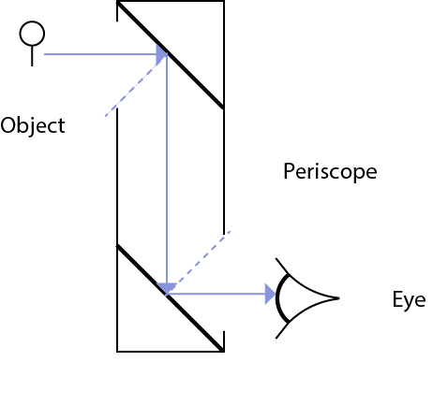
normal showing angle or incidence = angle of reflection
5. | (a) |  | Describe what happens to an atom when it is ionised. [2 marks]
Electron absorbs energy and is removed from the atom
Atom forms an ion
 | (b) |  | Which of the ionising EM waves is the least ionising? [1 mark]
 |  |  | UV
 | (c) |  | State one danger of UV radiation. [1 mark]
Any of the following
Skin cancer/ cataracts

- The natural greenhouse effect ensures that the Earth’s average temperature stays around 15C.
 | (a) |  | State what would happen to the Earth’s temperature if there were less greenhouse gases than normal? [1 mark]
 |  |  | The temperature would decrease
 | (b) |  | What type of radiation contributes to the greenhouse effect? [1 mark]
 |  |  | Infrared
 | (c) |  | Explain how Earth’s atmosphere traps heat. [3 marks]
Infrared is transmitted through the atmosphere and is absorbed by Earth’s surface
Surface re-emits infrared at a lower wavelength back into the atmosphere.
Some greenhouse gases absorb the lower wavelength infrared (heating atmosphere) and re-emitting infrared back to the Earth’s surface (heating Earth’s surface)
7. | (a) |  | What is refraction? Give an example. [2 marks]
The change of direction of a wave
when the have passes between two substances with different densities, examples include air/water, cold air/warm air

 | (b) |  | Complete the ray diagrams for the following lenses[4 marks]

8. | (a) |  | Sound is a longitudinal wave. State another example of a longitudinal wave. [1 mark]
 |  |  | P-waves
 | (b) |  | 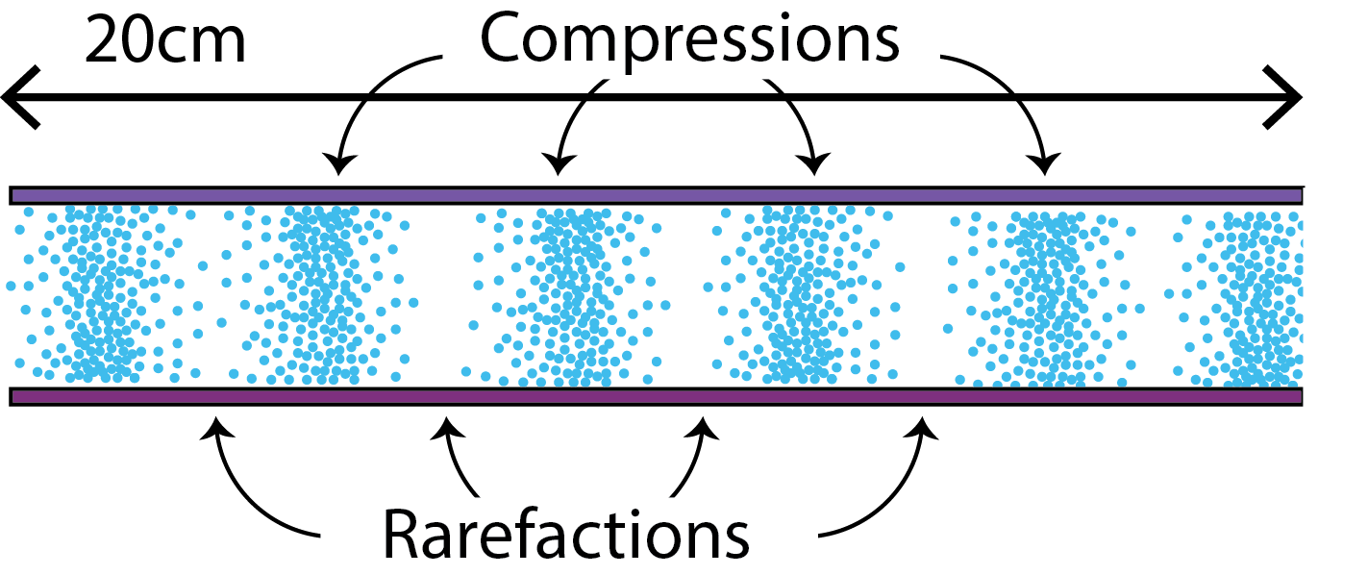  Label the compressions and rarefactions on the following sound wave.  [1 mark]
 | (c) |  | The speed of the above sound is 340 m/s. What is the frequency of the sound wave? [2 marks]
Wavelength from diagram = 4 cm
Frequency = 340 ÷ 4 = 85 Hz
9. | (a) | (i) |  | A pupil stands 300 m away from the outside wall of a sport’s hall on a football pitch and bangs a drum. He hears an echo a short time later. The pupil then bangs the drum continuously and adjusts his drumming speed until his bangs coincides with the echo from the proceeding bang. He records the time between each bang which is 1.8 s.  Explain why he hears an echo. [1 mark]
 |  |  |  | He hears an echo because the sound wave reflects of the wall.
 |  | (ii) |  | The pupil moves to another smaller field which is surrounded by buildings. How will this affect his data? [1 mark]
Any of the following:
Multiple reflections making it harder to record the time.
Shorter distances means timings will be less accurate
Possible interference between sound waves (superposition)
 | (b) | (i) |  | Using data from question 9a, calculate the speed of sound. [2 marks]
calculating the distance the sound wave travels
300 x 2 = 600 m
calculating the speed of sound
600 m ÷ 1.8 s = 333 m/s
 |  | (ii) |  | The speed of sound is 340 m/s at 20°C. Looking at your answer to b(i) do you think it’s a cold or warm day? [1 mark]
This formative assessment resource has been produced as part of our free GCSE teaching and learning support package. All the GCSE teaching and learning resources, including delivery guides, topic exploration packs, lesson elements and more are available on the qualification webpages.  If you are looking for examination practice materials, you can find the Sample Assessment Materials (SAMs) on the qualification webpage: Physics B (9-1). |  |  |  | Cold day

We’d like to know your view on the resources we produce. By clicking on ‘Like’ or ‘Dislike’ you can help us to ensure that our resources work for you. When the email template pops up please add additional comments if you wish and then just click ‘Send’. Thank you.
If you do not currently offer this OCR qualification but would like to do so, please complete the Expression of Interest Form which can be found here: www.ocr.org.uk/expression-of-interest

OCR Resources: the small print
OCR’s resources are provided to support the teaching of OCR specifications, but in no way constitute an endorsed teaching method that is required by the Board, and the decision to use them lies with the individual teacher. Whilst every effort is made to ensure the accuracy of the content, OCR cannot be held responsible for any errors or omissions within these resources.
© OCR 2016 - This resource may be freely copied and distributed, as long as the OCR logo and this message remain intact and OCR is acknowledged as the originator of this work.
OCR acknowledges the use of the following content: chromatic aberration: Durden Images/Shutterstock.com, girl looking in mirror: kryzhov/Shutterstock.com
Please get in touch if you want to discuss the accessibility of resources we offer to support delivery of our qualifications: resources.feedback@ocr.org.uk

End of chapter quiz

Chapter P1: Radiation and waves

Learner Activity

Chapter: P1 of J259
Total marks: 40
- The speed of a sound wave is 340 m/s. The wavelength of the sound wave is 5 cm. What is the frequency of the sound wave? [1 mark]
 | A |  | 68 Hz
 | B |  | 6800 Hz
 | C |  | 1700 Hz
 | D |  | 0.015Hz
Your answer

- What is the wavelength of the following wave? [1 mark]

- The diagram below shows the electromagnetic spectrum.
Radio | A | B | Visible | C | D | Gamma

 | (a) |  | Write the correct name for the missing parts of the EM spectrum. [4 marks]
 | A
 | B
 | C
 | D
 | (b) |  | Which of the above EM waves are ionizing? [3 marks]
 | (c) |  | Which of the above EM waves is most likely to cause damage to DNA?  [1 mark]

4. | (a) | (i) | Nicky is looking into a specialised mirror which has lights around the edges. Explain how Nicky can see her reflection in the mirror by describing the path of light. [4 marks]
 | (b) |  | Nicole is at a concert; however she is at the back and is finding it hard to video her favourite star as there are many people in the way. Nicole uses a simple periscope attached to her phone which allows her to video the star.  Draw a detailed ray diagram showing the incident and reflected rays in the periscope, highlighting the angles of incidence and angles of reflection.  [2 marks]
 |  |  | 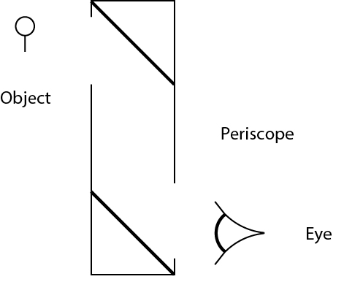
5. | (a) |  | Describe what happens to an atom when it is ionised. [2 marks]
 | (b) |  | Which of the ionising EM waves is the least ionising? [1 mark]
 | (c) |  | State one danger of UV radiation. [1 mark]
- The natural greenhouse effect ensures that the Earth’s average temperature stays around 15C.
 | (a) |  | State what would happen to the Earth’s temperature if there were less greenhouse gases than normal? [1 mark]
 | (b) |  | What type of radiation contributes to the greenhouse effect? [1 mark]
 | (c) |  | Explain how Earth’s atmosphere traps heat. [3 marks]
7. | (a) |  | What is refraction? Give an example. [2 marks]
 | (b) |  | Complete the ray diagrams for the following lenses[4 marks]

8. | (a) |  | Sound is a longitudinal wave. State another example of a longitudinal wave. [1 mark]
 | (b) |  | 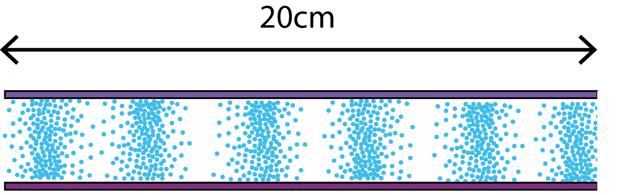  Label the compressions and rarefactions on the following sound wave.  [1 mark]
 | (c) |  | The speed of the above sound is 340 m/s. What is the frequency of the sound wave? [2 marks]
9. | (a) | (i) |  | A pupil stands 300 m away from the outside wall of a sport’s hall on a football pitch and bangs a drum. He hears an echo a short time later. The pupil then bangs the drum continuously and adjusts his drumming speed until his bangs coincides with the echo from the proceeding bang. He records the time between each bang which is 1.8 s.  Explain why he hears an echo. [1 mark]
 |  | (ii) |  | The pupil moves to another smaller field which is surrounded by buildings. How will this affect his data? [1 mark]
 | (b) | (i) |  | Using data from question 9a, calculate the speed of sound. [2 marks]
 |  | (ii) |  | The speed of sound is 340 m/s at 20°C. Looking at your answer to b(i) do you think it’s a cold or warm day? [1 mark]

