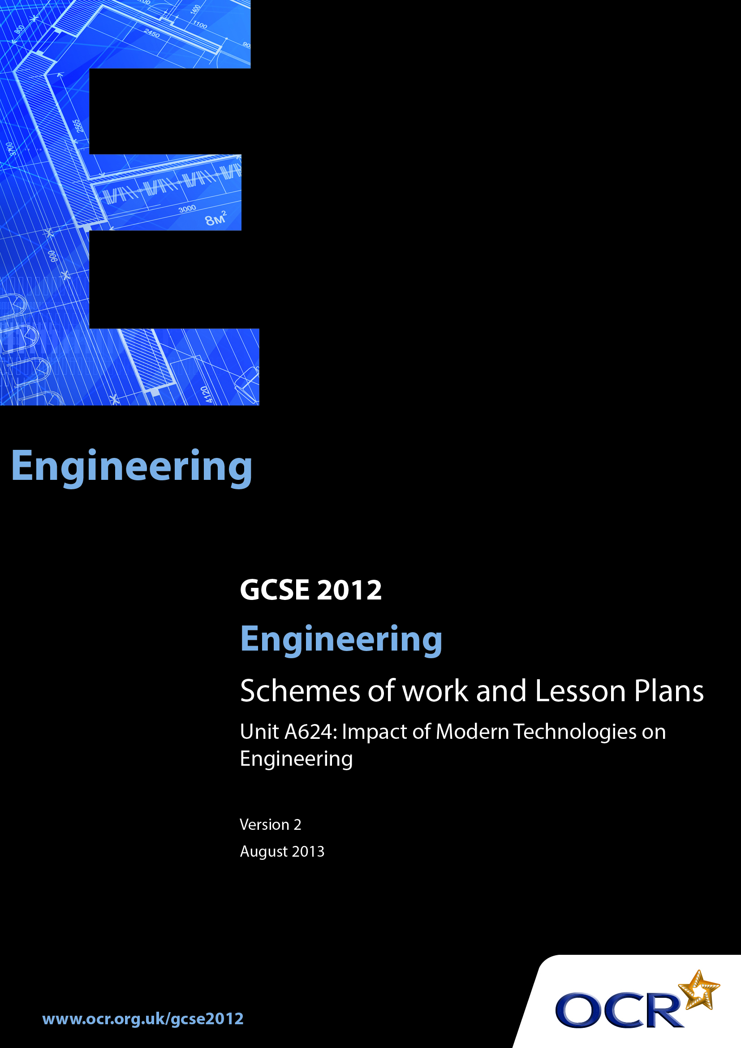

Contents
Introduction 3
Sample Scheme of Work: OCR GCSE Engineering J344 Unit A624:
Impact of Modern Technologies on Engineering 5
Sample Lesson Plan: OCR GCSE Engineering J344 Unit A624:
Impact of Modern Technologies on Engineering 14

Introduction

Background
OCR has produced a brochure, which summarises the changes to Engineering. This can be found at www.ocr.org.uk along with the new 2012 specification.
In addition and in response to reforms announced by the Government and in response to Ofqual mandated changes to GCSEs, unitised assessment of this qualification is being replaced by linear assessment from September 2012. This means that candidates commencing a two year course from September 2012 will take all of their GCSE units at the end of the course in June 2014.
In order to help you plan effectively for the implementation of the specification we have produced these Schemes of Work and Sample Lesson Plans for Engineering. These Support Materials are designed for guidance only and play a secondary role to the Specification.

Our Ethos
OCR involves teachers in the development of new support materials to capture current teaching practices tailored to our new specifications. These support materials are designed to inspire teachers and facilitate different ideas and teaching practices.
Each scheme of work and sample Lesson Plans are in Word format to be used as a foundation to build upon and amend the content to suit your teaching style and students’ needs.
The scheme of work and sample Lesson Plans provide examples of how to deliver these units and suggested teaching hours which could be applicable to your teaching.
The Specification is the document on which assessment is based and specifies what content and skills need to be covered in delivering the course. At all times, therefore, this Support Material booklet should be read in conjunction with the Specification. Any clarification should be found in the Specification.

A Guided Tour through the Scheme of Work

= Innovative Teaching Idea
This icon is used to highlight exceptionally innovative ideas.

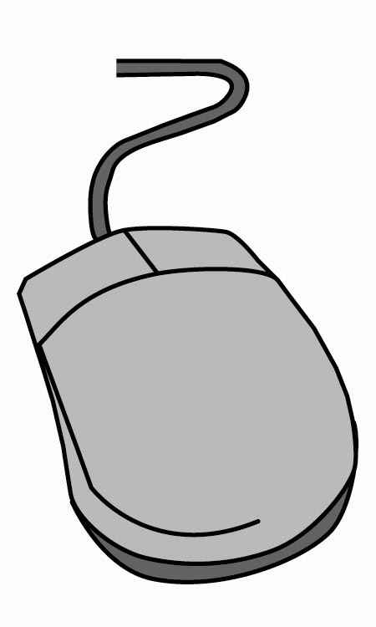
= ICT Opportunity
This icon is used to illustrate when an activity could be taught using ICT facilities.

OCR GCSE Engineering J344 Unit A624: Impact of Modern Technologies on Engineering
Suggested teaching time | 40 hours | Topic | Impact of modern technologies on engineering
Topic outline |  | Suggested teaching and homework activities | Suggested resources | Points to note
Unit Overview: This examined unit is assessed by a one hour written examination. Questions will be a mix of short answer and free response styles, and will require candidates to demonstrate practical application of knowledge related to engineered products and engineering environments they have studied. In particular they should focus on engineering for sustainability. Where possible, links should be made with an engineering company to allow candidates access and exposure to real-life engineering practice. Candidates should study a range of products from at least two engineering sectors.
Candidates will consider:
- sustainability design for the environment
- engineering materials and their properties
- the functions of components
- the properties, characteristics and features of materials
- engineering processes
- quality control techniques
- new technologies used in and by the engineering industries
- the impact of modern technologies
- advantages and disadvantages that the use of modern technology has brought to society
- engineered products
- designing a product
- engineering a product
with knowledge and understanding being gained in a variety of ways during the course and also from final examination preparation.

Candidates will demonstrate knowledge and understanding of the following:  Sustainability: design for the environment:  - manufacture without producing hazardous waste  - use of clean technologies  - reduction of product chemical emissions  - reduction of product energy consumption  - use of non-hazardous recyclable materials  - use of recycled material and reused components  - design for ease of disassembly ❷  - product reuse or recycling at end of life  Engineering materials and their properties in the following groups:  - ferrous and non-ferrous metals and alloys ❸  - polymers  - ceramics  - composites that combine the properties of different materials  The functions of:  - mechanical components  - electrical/electronic components  - pneumatic/hydraulic components  The properties, characteristics and features of materials that affect:  - ability to be shaped and formed  - ability to be treated  - ability to be given a surface finish  - ease of handling  - cost implications  - availability, form and supply  Engineering processes:  - material removal  - shaping and manipulation  - joining and assembly  - heat and chemical treatment  - surface finishing  Quality control techniques:  - sampling  - comparing  - action  New technology used in and by the engineering industries:  - information, communications and digital technologies – research, production planning systems, digital communication with clients, suppliers  - modern and smart materials and components  - systems and control technology to organise, monitor and control production:  - automation  - sensors  - inputs  - outputs  - CAD CAM CIE  Impact of modern technologies:  - when manufacturing an engineered product – impact on workforce, company and local environment:  - on engineered products – to end user  - on engineering industries – sustainability  - stages in manufacturing an engineered product:  - design  - marketing  - production planning  - material supply and control  - processing and production  - assembly and finishing  - packaging and dispatch  - disposal  Advantages and disadvantages that the use of modern technology has brought to society:  - redundancy  - working conditions  - cost  - availability of products  - impact on the environment  - training  - transport  - lifestyle  - Health and Safety  Engineered products:  - a variety of engineered products that use modern technology  - the impact of modern technology on the design and production of a range of engineered products  Designing a product:  - analysing client design briefs for engineered products  - producing, using and modifying design specifications for engineered products  - generating design solutions for engineered products  - reading, understanding and creating a range of appropriate engineering drawings to current industry standards  - presenting a design solution for engineered products  - responding to client feedback  Engineering a product:  - producing and using production plans  - selecting and using a range of appropriate materials, parts and components  - selecting and using appropriate processes  - applying quality control techniques  - selecting and using appropriate tools and equipment  - applying Health and Safety procedures  - analysing and revising the completed product, taking into account how it could be improved |  | - A key point to note about this unit is the fact that candidates should study a range of products from at least two engineering sectors. This is a requirement of the specification and so will enable them to more readily respond to the written questions in this externally assessed unit.  - It is expected that the SOW for this unit will have two parts.  Part A: the topic content is fully interwoven with that of units A 621 and A621 parts A and B, plus A623 parts A and B  Part B: will consist of the “top up” topic content which, for each centre, has not been covered in their individual Part A.  - So a centre based structured plan, building on students existing experience gained at KS3 should be prepared by each centre. This should be alongside a mapping exercise of the topic contents against the products from two different engineering sectors in preparation for the teaching.  - It is suggested that students study, with the support of structured teaching, all three of the products identified in the specification ❶ for each of the two chosen sectors.  - These sectors will differ dependent on the teacher(s) delivering the specification, centre resources and arrangements (e.g. links with other establishments) and the centres actual timetables and teacher contact times.  - It is anticipated that rather than “theory” dealing with each of the topics in turn many will naturally link together to gradually complete a matrix of taught content. For example a lesson when some product analysis now referred to as “reverse engineering” (the process of learning how a product is made by taking it apart and examining it) on a component or a simple artefact could draw together a number of the taught topics in a natural and holistic way. ❶  - Areas where knowledge is new (i.e. has not been covered during previous teaching or candidates controlled assessment activities (A621 parts A &B and A623 Parts A & B), demonstrations, media support – CD-ROMs, Videos, industrial visits – should be re-enforced by practical or visual duplication of information. ❷  - There is topic overlap ❹ with unit A622 and this unit, A624, but centres can expect different questions in both the January and June sittings for any overlap content. i.e. the questions will not be the same for the Single Award A622 paper and the Double Award A624 paper for any common content.  - Centres should note that there are also some common products from some of the Engineering Sectors between Single Award content (A622) and Double Award content (A624). One example is “Electrical and Electronics” sector and “electric toothbrush”  Centres are strongly advised to ensure students study entirely different products in preparation for A624 and A622 to ensure full specification coverage❺  - Ideally the majority of the topics will be addressed at least once during the “controlled assessment” activities and activities which precede the controlled assessment. ❸  - Support can be gained by linking directly with activities in Unit A621, A Study of an Engineered Product where the work students are engaged in has this unit in mind. ❹  - Support can be gained by linking directly with activities undertaken in Unit A 621B Engineering a Product: Acquisition of practical skills ❺ with teachers naturally extending their teaching input to encompass the topics needing to be covered by this unit.  - It is therefore suggested that centres produce some form of mapping, possibly a spreadsheet, with sector specific “topic content” cross referenced to:  - the practical pre-“controlled assessment” activities students will undertake  - KS3 experiences  - The two “controlled assessment” activities A621 and A623  - This will then reveal topic areas which have not naturally been covered which will then need “theory” inputs for final examination preparation.  - Sample Assessment materials should be used initially and then past papers as they become available following each examination sitting as a template for centres generating their own worksheets and homework sheets for fortnightly exposure to all students. The structure of the questions should be copied and should remain unchanged, a range of different mark responses should be incorporated to give all students regular experience of what the papers will look and feel like and the types of things they will be asked to respond to. If centres generate sector specific questions for preparation to this unit they should be given the style and feel of the sample assessment materials and past papers which is an important “familiarisation” exercise and one which should not be underestimated as a student support mechanism.  - Where these work sheets and homework sheets are used there should be comprehensive group and/or individual feedback on the responses made by students to identify:  - Common misunderstandings  - Gaps in the teaching groups knowledge  - Types of questions which students respond to poorly  - Use of the “non-rewardable” generic responses ❻`  - Examination techniques e.g. marks allocations in brackets [4] ❼  - Time management  - Reading the whole question paper through before stating to answer  - Legibility  - Use of technical terms  - Quality of written communication  - Understanding and use of the Computer based software  - Remedial input for any of the areas identified should then be incorporated into the SOW and form part of the preparatory content for any subsequent SOW  - The associated lesson plan for this unit has several opportunities for ITI and ICT | - http://www.ocr.org.uk/Data/publications/  assessment_materials  /GCSE_Engineering_SAM_Unit_A624.pdf  - http://www.ocr.org.uk/Data/publications/  assessment_materials/  GCSE_Engineering_  SAM_Unit_A622.pdf will also be useful. | - It is expected that preparation for this unit will be an on-going activity and not just a final “theory” input immediately prior to the examination.  - ❹ Where possible, links should be made with an engineering company to allow candidates access to ‘real-life’ engineering practice. They should study a range of products from at least two engineering sectors.  Aerospace  - landing gear  - turbines  - passenger aircraft doors  Automotive  - fairings  - seating  - displays  Chemical & Process  - cement  - washing up liquid ❸  - coatings (paint, plastics)  Computers, Communication and IT  - PDA  - video conferencing systems  - radio  Electrical and Electronics  - electric toothbrush  - vending machine  - security system  Medical and Pharmaceutical  - household disability aids (eating and drinking, gripping and turning, reaching)  - mobility aids (scooters, powered wheelchairs)  - heart monitors  Rail and Marine  - drive systems  - navigation  - safety features  Structural and Civil  - tunnels ❷  - temporary accommodation (site buildings, emergency)  - outdoor storage  - For some products there will be topic coverage which is not directly applicable for example “design for ease of disassembly” ❷ does not apply to Structural and Civil and Tunnel building. However the principle involved can be applied to the equipment used in the tunnel building.  - ❸ Where the topic for example “ferrous and non-ferrous metals and alloys” will not directly apply to, for example “Chemical & Process when producing washing up liquid” the selection of the alternative sector and product will provide appropriate and necessary coverage of the specification and unit content.  - ❹ There is overlap content with the Single Engineering Award (A622) for the following areas:  - engineering materials and their properties  - the function of components  - the properties, characteristics and features of materials  - engineering processes  - quality control techniques and  - engineering a product  - ❺ Failure to study a different products and engineering sectors will limit students‘ ability to respond flexibly and appropriately to examination questions. It should no account should be seen as a short cut to taught content.  - Similar SOW content to that of A622, point ❶ in the Points to note column should be employed whilst preparing students for this examination.  - ❻ In written examinations candidates should be advised to avoid responses such as:  Cheap / very cheap / cheaper, strong / stronger / very strong, light / very light / lighter, tough / very tough / tougher, unless they are qualified in some way.  - ❼ Guidance should be given as to the length and breadth of responses expected in an examination question. For example if a question has three marks [3] there is an expectation of a three “bits” to their response. This might be two different points with some extension of a point of one point with several points of extension / explanation.

OCR GCSE Engineering J344 Unit A624: Impact of Modern Technologies on Engineering

Magnetism: Ferrous and composite materials
OCR recognises that the teaching of this qualification above will vary greatly from school to school and from teacher to teacher. With that in mind this lesson plan is offered as a possible approach but will be subject to modifications by the individual teacher.
Lesson length is assumed to be one hour.
Analysis by the teacher of an advertisement for a mobility mechanical “reacher” will provide a range of teaching opportunities related to the topics for Unit A624 for the Medical and Pharmaceutical Sector.
Text from an advertisement such as “Made from lightweight aluminium, this “reacher” is designed for people with limited reach and/or mobility. The jaw opening is highly visible and features a slip resistant surface for a secure hold on the object.
Constructed with a cord running through the tube, which operates the plastic jaw. This cord style allows the “reacher” to be folded in the centre for ease of storage and transportation.
Include a magnet tip, a hook for dressing, a rubber lined jaw and a device that allows the “reacher” to be clipped to a stick or walker.”
Opportunities to address the topics are identified and have been italicised and emboldened:
“Made from lightweight (ease of handling) aluminium (non-ferrous metals), this “reacher” is designed for people with limited reach and/or mobility. The jaw opening is highly visible and features a slip resistant surface (ability to be given a surface finish) for a secure hold on the object.
Constructed with a cord running through the tube (assembly and finishing), which operates the plastic jaw ( = selecting and using a range of appropriate materials, parts and components). This cord style allows the “reacher” to be folded in the centre design (for ease of disassembly) for ease of storage and transportation.
Include a magnet tip ferrous metals / composites that combine the properties of different materials, a hook for dressing, a rubber lined jaw mechanical components and a device mechanical components that allows the “reacher” to be clipped to a stick or walker (lifestyle). “
Areas selected for lesson: “magnet tip ferrous metals / composites that combine the properties of different materials” and different assembly methods

Learning Objectives for the Lesson
Objective 1 | Students to understand that both ferrous and composite materials can be magnetised
Objective 2 | Students to understand the appropriate assembly methods for magnets to aluminium
Objective 3 | Students to suggest alternative methods of assembly with advantages and disadvantages
Objective 4 | Students to know the lifestyle changes brought about by the employment of a “reacher”

Recap of Previous Experience and Prior Knowledge
Metals: Knowledge of Ferrous and composite materials
Knowledge of the property of magnetism
Restrictions of “reach” for certain people:

Materials and Equipment required for demonstration: | Method 1: White board, OHP, chalk board or equivalent  Method 2: Laptop with LCD projection  Images of “reacher” and disabled person
Materials and Equipment required for student practical: | An existing “reacher” probably borrowed from the caretaker.

Content
Time | Content
5 minutes | Introduction.  Class view an advertisement for a mobility mechanical “reacher”.  OR  Request volunteer student to “do a little job”. Student is asked to get something from a shelf or soothing which is out of reach.  The concept of an “extension” to reach for getting jars,  keys etc. from higher or further away places introduced.
10 minutes | Student Activity: Students, in controlled, measured fashion  undertake product Analysis (reverse engineering) on an  image of a “reacher” in use presented for them.  The use of the product should be considered  in addition to the materials, possible  construction.  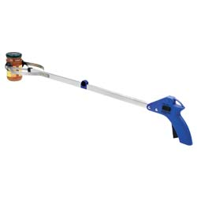
15 minutes | Summative collation of student findings written up on whiteboard / media projection.  Contrived situation of dropping a safety pin on floor and asking a student to pick it up. Brief discussion as to associated problems i.e. not being able to see the pin, feel the pin, grab the pin. Introduction of magnet on the end of the “reacher”.  Question to students: What might be the problems of fixing a 10mm square of ferrous magnet to the end of a “reacher”?  Responses obtained or supplied by teacher: Brittle so if dropped might break, difficulty in “drilling” a hole through and fixing to “reacher” (they are normally pop riveted), general restriction of having a standard component, costs associated with purchase of limited numbers of ferrous units.  A modern alternative is required – enter the plastic magnet.  Details of magnetic attachment given:  Recap on understood facts that ferrous materials can be magnetised but exciting introduction of “plastic” magnetic materials introduced. (The chemical content is not required at this level of study). The range of available plastic magnets is unveiled.
15 minutes | Student Activity 1: Working in pairs students: small sample of the plastic magnet is issued for handling testing. Testing such as cutting, drilling, stickling / bonding, punching, flame / heat /burn test, water testing and other testing as appropriate  Student Activity 2: Working in pairs students:  1] analyse / discuss the engineering possibilities of the attachment of this material to the “reacher”  2] discuss the engineering possibilities of this modern material  3] discuss the possible limitations of this modern material
10 minutes | Clear away and re-form group ensuring they have written “notes” of the previous 2 x 15 minute slots of activity. Student Activity: Consolidate and begin preparations for an individual 3 - 4 minute presentation on the properties of the modern material, it advantages and uses and its direct relationship to the “reacher”.  ICT and ITI Opportunities. The presentation can be in any of the following formats:  - OHP presentation  - PowerPoint presentation  - Handouts  - Worksheet with answers  - Quiz with answers

Consolidation
Time | Content
5 minutes | Recap with set questions pre-written on cards which are numbered.  Each student asks for a number and has that question asked to them.  If they get it right appropriate praise given  If incorrect or partially correct the correct answer is 1] sought from the group or 2] clarified by the teacher.  Home work: To complete the presentations for possible delivery to the group next lesson.  All work would be collected in and checked / marked and returned.  A small selection which uses different methods of presentation will be delivered by the students at the start of the next lesson.  This will serve several purposes one of which will be to expose students to alternative presentation methods for their own work so possibly taking them out of their comfort zones.

