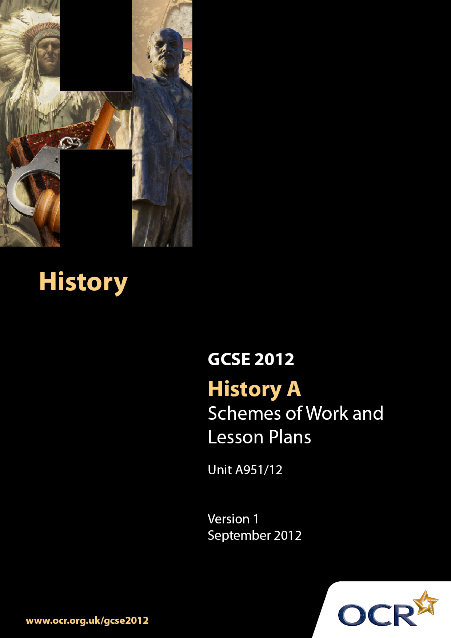

Contents
Contents 2
Introduction 3
A951/12: Depth Study 12: Britain, 1815–51 6
Unit A951/12: Depth Study 12: Britain,1815–51 12

Introduction

Background
Following a review of 14–19 education and the Secondary Curriculum Review, the Qualifications and Curriculum Authority (QCA) has revised the subject criteria for GCSEs for first teaching in September 2009. This applies to all awarding bodies.
The new GCSEs have more up-to-date content and encourage the development of personal learning and thinking skills in your students.
We have taken this opportunity to redevelop all our GCSEs to ensure they meet your requirements. These changes will give you greater control of assessment activities and make the assessment process more manageable for you and your students. Controlled assessment will be introduced for most subjects.
From September 2012, assessment tasks may be undertaken at any point between release of the task and the examination series for which the task must be submitted. Centres must ensure that candidates undertake a task that is valid for submission in the year in which the candidate intends to submit it.
OCR has produced a summary brochure, which summarises the changes to History. This can be found at www.ocr.org.uk along with the new specification.
In order to help you plan effectively for the implementation of the new specification, we have produced these Schemes of Work and sample Lesson Plans for History. These Support Materials are designed for guidance only and play a secondary role to the Specification.

Our Ethos
OCR involves teachers in the development of new support materials to capture current teaching practices tailored to our new specifications. These support materials are designed to inspire teachers and facilitate different ideas and teaching practices.
Each Scheme of Work and set of sample Lesson Plans is provided in Word format – so that you can use it as a foundation to build upon and amend the content to suit your teaching style and students’ needs.
The Scheme of Work and sample Lesson Plans provide examples of how to teach this unit and the teaching hours are suggestions only. Some or all of them may be applicable to your teaching.
The specification is the document on which assessment is based and specifies what content and skills need to be covered in delivering the course. At all times, therefore, this Support Material booklet should be read in conjunction with the specification. If clarification on a particular point is sought, then that clarification should be found in the specification itself.

A Guided Tour through the Scheme of Work

= Innovative Teaching Idea
This icon is used to highlight exceptionally innovative ideas.


= ICT Opportunity
This icon is used to illustrate when an activity could be taught using ICT facilities.

Unit A951/12: Britain, 1815–51
Suggested teaching time | 12 hours | Topic | How were the living and working conditions of the urban working classes improved during this period?
Topic outline |  | Suggested teaching and homework activities |  | Suggested resources | Points to note
Key Question 3: How were the living and working conditions of the urban working classes improved during this period?  Introduction |  | - Discussion of class structure in the early nineteenth century  - Introduce key terms:-  - Working class (rural and urban)  - Middle class  - Upper class/Aristocracy  - Students debate in small groups factors that determine class i.e. occupation, birth, accent, neighbourhood, income, wealth and education. Then feedback to class which they think are the most important factors today and in the 19th century |  |  | - Teacher could use the 21st century class system to draw comparisons and to make explicit the differences between what we mean by class today and what was meant in the 1800s
The Industrial Revolution and its impact on towns |  | - Introduce idea of ‘Revolution’  - Students study population data of regions around the UK  - Students discuss what changes this population shift might cause  - Students brainstorm advantages and disadvantages of this population shift e.g. crowded housing, bigger cities |  | - Population data is available in ‘Britain 1815-51 A study in depth’ by Dave Martin; (2000, John Murray) page 70 | - The BBC website contains an interactive UK population timeline that students can explore:  - http://www.bbc.co.uk/history/british/launch  - _ani_population.shtml  - Pupils could use the internet to compile presentations about what historians mean by the ‘industrial revolution’ for instance  - http://en.wikipedia.org/wiki/Industrial_Revolution
The living conditions of the working classes in the towns |  | - Students recap and categorise ‘push’ and ‘pull’ factors that encouraged people to move to towns e.g. rural poverty, railway growth, jobs  - Students understand problems of working class housing in new towns. Students investigate these through primary sources or through text books |  | - Descriptions of imaginary towns which students could read are:-  - ‘ North and South’ (Elizabeth Gaskell, 1854)  - ‘Hard Times’ (Charles Dickens, 1854) | - Teacher should ensure problems discussed and noted include overcrowding; damp and poor ventilation; drinking water; rural housing; air pollution; hygiene; rubbish; sewage; rising crime; poverty and threats to public order
Main features of working conditions in factories |  | - Students to understand dramatic changes to working conditions in textile factories resulting from industrial revolution  - Students use evidence given by factory workers to House of Commons to compile list of key features of life in factories  - Students work in groups to produce posters to campaign against problems in factories e.g. hot conditions for cotton, throat and lung conditions, dangerous machines, long hours, frequent accidents, harsh rules |  | - Very detailed resources for students can be found at http://www.spartacus.schoolnet.co.uk/Textiles.htm  - Factory conditions text is available in ‘Britain 1815-51 A study in depth’ by Dave Martin; (2000, John Murray) pp 90-91 | - Students can use data about cotton imports and exports from the Spartacus website to produce charts/graphs to demonstrate industrial growth
Main features of working conditions in coal mines |  | - Students use a variety of sources to compile a table outlining the common dangers in coal mines for men and women |  | - Coal mine conditions sources are available in ‘Britain 1815-51 A study in depth’ by Dave Martin; (2000, John Murray) pp 95-97 | - Examples should include England, Ireland, Scotland, Wales  - http://www.bbc.co.uk/nationonfilm/topics/coal-mining/ excellent videos of miner’s stories from the North East for a starter activity
Conditions for children in factories and coal mines |  | - Discuss causal explanation - why were children allowed to work in such poor conditions?  - Students to place in order of importance poverty of parents; self-interest of employers; laissez-faire attitude of government; ignorance of what working conditions were like |  | - The Victorians (A.N. Wilson)  - The Royal Commission on the Employment of Women and Children in Mines and Collieries, 1842 | - Long hours, young children, heavy work, dust causes lung conditions, dangers of cleaning the machines, harsh punishment, overseers, poor pay
Changing attitude of government towards intervention into working conditions |  | - Students make guided notes about the arguments in favour of reform of working conditions  - Students to understand terms and effects of Public Health Act 1848 and Municipal Corporation Act 1855  - Enquiries into living conditions  - Chadwick’s Poor Law Commissioner’s Report of 1842 |  | - Arguments outlined in text of ‘Britain 1815-51 A study in depth’ by Dave Martin; (2000, John Murray) pg 98-99 | - Students should understand that some towns obtained an ‘Improvement Act’ and ‘Improvement Commissioners’- and should assess the problems and effectiveness of this system
The Role of Women |  | - Students annotate Hick’s painting to access views towards women in nineteenth century e.g. ‘private sphere’ and ‘public sphere’  - Explore views of Lord Shaftesbury through his speeches  - Pupils debate how far working class women could inhabit the ‘private sphere’ |  | - George Hicks narrative painting ‘Woman’s Mission: Companion of Manhood’  - Coventry Patmore’s poem ‘Angel in the House’ | - http://www.tate.org.uk has the Hicks painting which pupils can annotate to show how women were viewed and expected to behave
Arguments against passing legislation to improve working conditions, including laissez-faire |  | - Students sort arguments on small cards for and against government intervention  - Collaborative learning- students work in pairs to produce speeches/podcasts to argue for or against intervention/laissez-faire |  | - Arguments outlined in text of ‘Britain 1815-51 A study in depth’ by Dave Martin; (2000, John Murray) pg 98-99  - A useful article to explain laissez-faire by Professor Eric Evans is found at  http://www.bbc.co.uk/history/trail/victorian_britain
Role of groups and individuals in reform |  | - Students research and create presentations and feedback to class including:-  - The work of Lord Shaftesbury and other reformers to promote reform  - Edwin Chadwick  - Church and charity reformers  - Pupils complete research homework on the Duke of Bedford, family and life  - Students can conclude how far each reformer affected people’s lives |  | - The Oxford History of Britain (K.O. Morgan) contains useful support resources  There is a useful section on Shaftesbury and women workers in Peace and War, C Shephard, A Reid, K Shephard (John Murray), pages 80-81 | - Students use world wide web to research and make PowerPoint presentations to research Shaftesbury, Chadwick, Duke of Bedford and church reformers.
Factory Reforms and their effectiveness |  | - Students complete source exercise about Robert Owen’s factories and the Ten Hours Movement  - Students make guided notes about the 1833 (Ten Hour) Factory Act and the later Factory Acts. Students complete grid/table to compare their effects/limitations |  | - Terms and effectiveness of act included at http://www.learningcurve.gov.uk/
Coal mine reforms and their effectiveness. |  | - Students role play and write up discussion between politicians, factory owners and reformers  - Students draft their own factory and mines acts to counter the problems they learned about earlier  - These can then be compared to the terms of 1842 Mines and Colliery Act which are then noted and discussed. |  | - Acts described in text of ‘Britain 1815-51 A study in depth’ by Dave Martin; (2000, John Murray) pg 100-101 | - Terms and effectiveness of act included at http://www.learningcurve.gov.uk/  - Pupils can research visual sources at this website

Unit A951/12: Britain, 1815–51

What was it like to live in an industrial town?
OCR recognises that the teaching of this qualification above will vary greatly from school to school and from teacher to teacher. With that in mind, this lesson plan is offered as a possible approach but will be subject to modification by the individual teacher.
Lesson length is assumed to be one hour.

Learning Objectives for the Lesson
Objective 1 | Students to be able to describe key features of an industrial town/city c. 1815-51.
Objective 2 | Students to evaluate problems associated with living in an industrial town for the working classes.
Objective 3 | Students to explain and analyse why, despite so many problems, so many people moved into towns.

Recap of Previous Experience and Prior Knowledge
- Students should be familiar with the idea of the Industrial Revolution and its associated effects (e.g. population growth; factories and building; urbanisation; improved transport; new jobs; wealth creation). Students need to know who would have benefitted from the industrialisation and the difference between working class, middle class and aristocracy. How did the old landed gentry make their money? How do the newly rich industrialists make their money? What impact will this have on society?

Content
Time | Content
10 minutes | - Starter task: Students brainstorm what we mean by the term ‘Industrial Revolution’. Students share their ideas with a partner and in turn they share with another pair. Whole class feedback onto board. Key ideas to be drawn out are described above.
5 minutes | - Teacher exposition: rapid industrialisation encouraged people to flood into towns and cities from rural areas. Why did they do this? Guide and compile list on board of all the reasons why people would move to towns.
10 minutes | - Student activity: Students write factors onto index cards why people moved to towns. They sort them into the two categories- ‘push’ and ‘pull’ factors. (Factors to include: job shortages in rural areas; extreme poverty in Scotland and Ireland; growth of railways; more jobs in factories in cities; more jobs to make houses/food/clothes in cities; low wages in rural areas.)  - Teacher to extend students’ understanding through questioning: Which is the strongest push/pull factor? Are there any that fit into both categories? (e.g. railways)
10 minutes | - Student activity: Students to read extract from ‘Hard Times’ (Charles Dickens) and/or ‘North and South’ (Elizabeth Gaskell) and highlight or underline any problems they can deduce about the new industrial towns.
20 minutes | - Student activity: Students receive a picture of a town on an A3 piece of paper. Around the picture, they pick out problems they can see, and then try to think of other problems caused by the new towns that they can’t see.  - Problems discussed and noted must include overcrowding; damp and poor ventilation; drinking water; rural housing; air pollution; hygiene; rubbish; sewage; rising crime; poverty and threats to public order.
5 minutes | - Students complete a ‘Learning Triangle’. Teacher draws large triangle on board or poster paper and students copy it into their books.  - Students complete their individual learning triangle in their book by writing in the three corners ‘One thing I learned today is…’; ‘One thing I already knew is…’ and ‘One thing I don’t understand is...’ This can then be used by the teacher in order to assess misconceptions and questions arising from students’ learning.

Consolidation
Time | Content
10 minutes | Students to sum up in 5/10 bullet points:  - Why did people move to towns?  - Why did the growth of towns cause problems?
Potential Homework 1 | Students to complete piece of extended writing answering the 2 questions above. The focus of this should be causation, as well as describing and explaining the key problems.
Potential  Homework 2 | Students could design a poster/leaflet to warn people of the problems of living in towns c. 1815-51.

