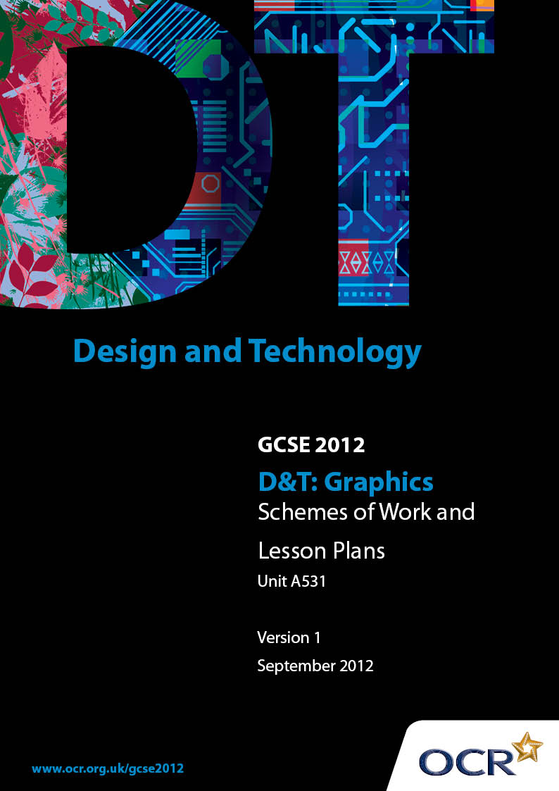

Contents
Contents 2
Introduction 3
OCR GCSE in Design and Technology Graphics: Sample Scheme of Work 5
OCR GCSE in Design and Technology Graphics: Sample Lesson Plan 17

Introduction

Background
OCR has produced a summary brochure, which summarises the changes to Design & Technology. This can be found at www.ocr.org.uk, along with the 2012 specification.
In order to help you plan effectively for the implementation of the new specification we have produced these schemes of work and sample lesson plans for Design & Technology. These support materials are designed for guidance only and play a secondary role to the specification.

Our Ethos
OCR involves teachers in the development of new support materials to capture current teaching practices tailored to our new specifications. These support materials are designed to inspire teachers and facilitate different ideas and teaching practices.
Each scheme of work and set of sample lesson plans are provided in Word format to be used as a foundation to build upon and amend the content to suit your teaching style and students’ needs.
The scheme of work and sample lesson plans provide examples of how to deliver these units and suggested teaching hours which could be applicable to your teaching.
The specification is the document on which assessment is based and specifies what content and skills need to be covered in delivering the course. At all times, therefore, this support material booklet should be read in conjunction with the specification. Any clarification should be found in the specification.

A Guided Tour through the Scheme of Work

= Innovative Teaching Idea
This icon is used to highlight exceptionally innovative ideas.

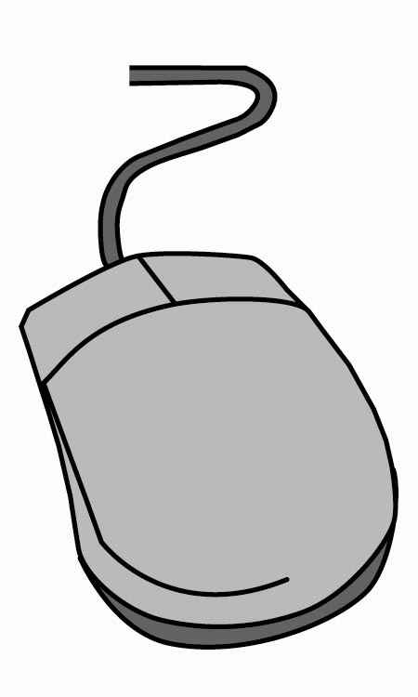
= ICT Opportunity
This icon is used to illustrate when an activity could be taught using ICT facilities.

OCR GCSE in D&T Graphics Unit A531: Introduction to designing and making
Suggested teaching time | 30 hours | Topic | Introduction to designing and making
Topic outline |  | Suggested teaching and homework activities |  | Suggested resources | Points to note
Introduction to graphics |  | - Pose the question: What is Graphics? Explain that Graphics is a form of visual communication. Show examples of different forms of graphics (eg signs, symbols, packaging, posters, corporate identity or advertising)  - Group students into small groups with large paper and pens - each group should discuss and devise two lists ‘What are good graphics?’ and ‘What are bad graphics?’ - approximately 8 minutes  - Whole class feedback to teacher who writes a ‘definitive’ list and then explains the difference between quality of design and quality of manufacture and how surface graphics impact upon the user/customer |  | - Show students a PowerPoint or similar presentation showing a range of examples of graphics  - Range of sample products could include; packaging, DVD/game covers/sleeves, point of sale displays, leaflets, maps or corporate merchandise  - Students could video their findings and decisions and present them back to the whole class - this could be included in an e-portfolio | - Many students will be beginning this unit with considerable experience of designing and making at KS3  - Students should be able to identify some key features for ‘good graphics’ (eg easily recognisable/memorable, eye-catching) and ‘bad graphics’ (eg confusing, unsuitable for the target audience). They could be encouraged to develop their own definitions but this should be developed and expanded upon during the feedback to the teacher  - The homework is a good opportunity for the students to consolidate what they have learnt in the lesson and an opportunity for the teacher to assess the students drawing skills
- Each group is given three examples of products with surface graphics. Groups to discuss their products/examples and ‘rank’ them in order using the list as a guide to their decision making
- Students then present their decisions to the rest of the group
- Homework: Draw a sketch of two products that have the same purpose (eg chocolate/sweet wrappers) - one should be an example of ‘good graphics’ the other ‘bad graphics’. List the good/bad qualities
Unit Introduction |  | - Show students an example of product(s) that could be considered ‘old fashioned’ (eg a package or poster that is 5-10 +yrs old)  - Question: How could this product be improved?  - Class discussion |  | - This could be a real product/package if available, otherwise a PowerPoint or video clip could be shown using images of products that are ‘old fashioned’  - http://farm3.static.flickr.com/2058/2111387300_7b6a765293.jpg gives a good example of a 1940/50 poster advert for Cadbury that could be used as a discussion point | - Students should consider ‘What makes good design?’ and how the customers/audience are influenced by graphics
 |  | - Question: Why is it important that graphics change? (eg to appeal to target audience, reflect changes in technology)  - Class discussion  - Show students classic example(s) of graphic images/products that have ‘evolved’ over time  - Introduce the unit by outlining the task. Students are to ‘re-invent’ an existing product chosen from the published theme list and produce a prototype of their improved product, as well as producing a portfolio/e-portfolio of supporting research/design work |  | - Suggestions for examples of ‘evolving’ products; Coca-cola or Cadbury  - Suggestions for examples of ‘modern’ graphics; Apple or Nike  - Specification outline for Unit A531
Product selection |  | - Students should select a product from within the published themes that they feel could be improved or ‘re-invented’ - students should have the actual product to work from, not a photograph |  | - Suggestions for products; packaging ie food/toiletries, bags, game/CD/DVD sleeves/packages. There are many examples of these products around from both the past and present  - Teachers may collect some suitable examples (that fall within the theme(s) and then let students chose | - Students should be carefully guided as to product selection – this must be from the published theme(s) but centres may use the theme(s) as a starting point and select a suitable product from within the theme. Centres should note
 |  | - Teacher explains how to write a ‘Design brief’ and identify the ‘Target audience’  - Students write their own design brief and target audience profile |  |  | that students are to design and make an improved or similarly functioning product  - Students must have a good understanding of ‘who’ the product is intended for and be able to relate to this user(s) needs/wants
Product analysis |  | - Teacher explains the importance of Product analysis - key questions; design, graphics, construction, manufacture, sustainability, recycling, target audience etc  - Students may work in groups looking at their products in order to really develop and challenge their thinking in relation to the user(s) needs/wants  - Students work on individual analysis of their chosen product |  | - http://www.bbc.co.uk/ schools/gcsebitesize/ design/resistantmaterials/designanalysisevaluationrev1.shtml  gives a good overview of how to start a product analysis.  - Photographs, the actual product and real time videos (only for students completing an e-portfolio) should be used to complete the product analysis | - Students must have the product in front of them in order to complete the analysis  - Students could present their product analysis to each other to help improve their understanding

OCR GCSE in D&T Graphics Unit A531: Introduction to designing and making
Suggested teaching time | 30 hours | Topic | Introduction to designing and making
Topic outline |  | Suggested teaching and homework activities |  | Suggested resources | Points to note
Research |  | - The teacher explains the importance of research  - Students prepare a research plan that outlines what research they need to collect and analyse, and how long they have to complete their research  - Students conduct research into the ‘background’ of their product/company, and then analyse issues such as graphic design, recycling/environmental issues and sustainability of their product/company |  | - http://www.eco-schools.org.uk/ gives good background knowledge on environmental issues  - http://www.packagingenvironmental.co.uk/ shows some good examples of sustainable packaging | - It is important to keep this focus to a time schedule so that students learn how to undertake specific and meaningful research. Students should reflect on their research plan to ensure they are keeping to schedule
Specification |  | - Students should initially evaluate their research and identify the key issues that they have discovered and what it means in relation to the design of their product |  | - http://www.design-technology.info/designcycle/specification/ is a good website for students to read through  - http://en.wikipedia.org/wiki/Product_designspecification gives a good list of the characteristics that should be considered | - This aspect is revisited in later modules of work for this unit and unit 3, and is an important aspect that will need to be re-enforced throughout the course

OCR GCSE in D&T Graphics Unit A531: Introduction to designing and making
Suggested teaching time | 30 hours | Topic | Introduction to designing and making
Topic outline |  | Suggested teaching and homework activities |  | Suggested resources | Points to note
 |  | - Class discussion on ‘What is a specification?’ Discuss key issues such as aesthetics, sustainability, function etc  - Students devise their own specification for their new and improved ‘re-invented’ product |  |  | - The specification should be clear but detailed - bullet points are recommended

OCR GCSE in D&T Graphics Unit A531: Introduction to designing and making
Suggested teaching time | 30 hours | Topic | Materials
Topic outline |  | Suggested teaching and homework activities |  | Suggested resources | Points to note
Design ideas |  | - Students should be encouraged to explore a wide range of different design ideas that show innovation and flair - they should be encouraged to think ‘outside the box’  - A range of drawings (2D and 3D) for their prototype product should be presented using a range of appropriate techniques including |  | - http://en.wikipedia.org/wiki/Smart_material gives a good definition of a smart material and an explanation of the main types of smart materials  - http://www.tep.org.uk/Frames/_f_leaflets.html contains a leaflet on smart materials.  - www.xara.com/uk a good CAD program that students can use to develop graphics  - www.techsoftuk.co.uk are the producers of 2D Design, an excellent program for students to use for developments (nets) | - It is important that students get the chance to try out different drawing techniques including ICT to develop their prototype design  - Students should ensure that they consider environmental/sustainable issues when designing  - Students may start to model possible design ideas
 |  | - Students should consider very carefully the ‘surface graphics’ required for the re-invented prototype product  - Students should be encouraged to explore modern and smart materials and nanotechnology where appropriate |  | - http://www.eco-schools.org.uk/ gives good background knowledge on environmental issues  - http://www.packagingenvironmental.co.uk/ shows some good examples of sustainable packaging | - Students should consider suitable materials that are environmentally sound

OCR GCSE in D&T Graphics Unit A531: Introduction to designing and making
Suggested teaching time | 30 hours | Topic | Materials
Topic outline |  | Suggested teaching and homework activities |  | Suggested resources | Points to note
 |  | - Students should annotate their design ideas appropriately in relation to their specification, the target user needs/wants and sustainability  - Students should present their ‘final design’ for their ‘re-invented’ product explaining why it will be a successful product design  - Group critique. In small groups students should look at each other’s completed coursework and review what progress each student has made and suggest how it might be improved |  |  | - This is a good exercise to start a lesson, allow about 15 mins. Students could write a target and a positive point about each other’s work
Initial modelling |  | - Students should develop their prototype product through firsthand modelling, identifying any initial problems and rectifying these as appropriate - this may be to the surface graphics or the shape of the product |  | - Photographs, screen shots, actual models and real time videos (only for students completing an e-portfolio) should be used to show the identification and rectifying of highlighted problems | - Students may model their prototype in any material/media suitable for their prototype product and must record and assess changes made to any initial prototypes  - Centres should note that the final product is a prototype that could be further improved - graphically or physically
 |  | - Students should fully explain changes/developments made and why - this should be clearly linked to the needs of the user(s)
Making the final prototype |  | - Students need to model their final version of their prototype, ensuring that they;  - Select appropriate materials  - Use the correct tools and equipment  - Work skilfully and safely  - Record the key stages in the making of the final prototype |  | - Photographs, screen shots, actual models and real time videos (only for students completing an e-portfolio) should be used to show the making of their final prototype | - Centres should note that the final product is a prototype that could be further improved - graphically or physically
Evaluating |  | - Class discussion on how to effectively evaluate a product -devise a list of criteria that the prototype can be evaluated against critically  - Class could split into small groups and provide feedback to each other using the criteria before the student completes their own evaluation process |  | - Photographs, screen shots, actual models and real time videos (only for students completing an e-portfolio) should be used to accompany the evaluation and clearly show the areas to be developed | - Students must consider how successful the prototype product is to the target user  - Centres should note that the final product is a prototype that could be further improved - graphically or physically
 |  | - Students should clearly identify how they could improve their making process  - Final review of work before submission; check photographs, models, spellings etc  - Completion of Candidate Authentication form |  | - Check against the specification

OCR GCSE in D&T Graphics Unit A531: Introduction to designing and making

Introduction to designing and making
OCR recognises that the teaching of this qualification above will vary greatly from school to school and from teacher to teacher. With that in mind this lesson plan is offered as a possible approach but will be subject to modifications by the individual teacher.
Lesson length is assumed to be one hour.

Learning Objectives for the Lesson
Objective 1 | Students to understand that graphics are a form of communication.
Objective 2 | Students to develop an understanding of what is meant by good and bad design.
Objective 3 | Students to be able to distinguish between quality of design and quality of manufacture.
Objective 4 | Students to develop their discussion and group skills.

Recap of Previous Experience and Prior Knowledge
- This is the first lesson of the unit A531 - Introduction to designing and making. Many students will have had considerable experience of designing and making at KS3 but not necessarily in the area of graphics.

Content
Time | Content
5 minutes | Pose the question: ‘What are graphics?’ Explain that graphics are a form of visual communication. Show examples of different forms of graphics (eg signs, symbols, packaging, posters, corporate identity or advertising.) Teacher to show a PowerPoint presentation or movie of examples.
8 minutes | Warm up exercise in response to the questions: What is good design/graphics? and What is bad design/graphics? In small groups students discuss their understanding and draw up lists of good and bad design/graphics.
10 minutes | Groups to share their thoughts through the teacher. Teacher writes the ‘list’ on the whiteboard. In discussion with the class the teacher then expands on the meaning and understanding of each point. Good graphics (eg easily recognisable/memorable or eye-catching) and bad graphics (eg confusing, unsuitable for the target audience). Teacher to show an example of both.
5 minutes | Teacher explains the definition of quality of design and quality of manufacture and the influence of surface graphics upon the user/customer. Show examples of products or images of products.

Time | Content
12 minutes | In groups, students are given (or have brought to the lesson) three examples of products with surface graphics. Students then discuss and devise a rank order for the products using the criteria discussed with the teacher. Teacher observes and directs groups where necessary. Students record their decisions (this may be by video recording).
10 minutes | Class present their findings/decisions to the rest of the class clearly showing where they have applied the criteria in their decision making. Students and teacher may question groups as to their reasoning.

Consolidation
Time | Content
10 minutes | Teacher re-caps on key principles of good and bad design/graphics. Class identify the best and worst products overall. Teacher gives a brief introduction of synopsis of the Unit A531 Introduction to designing and making (ie select a product that you feel can be redesigned/modified and launched back onto the market, then design and make a prototype of your improved product).
Homework | Homework: Draw a sketch of two products that have the same purpose (eg chocolate/sweet wrappers) - one should be an example of ‘good graphics’ the other ‘bad graphics’. List the good/bad qualities.

