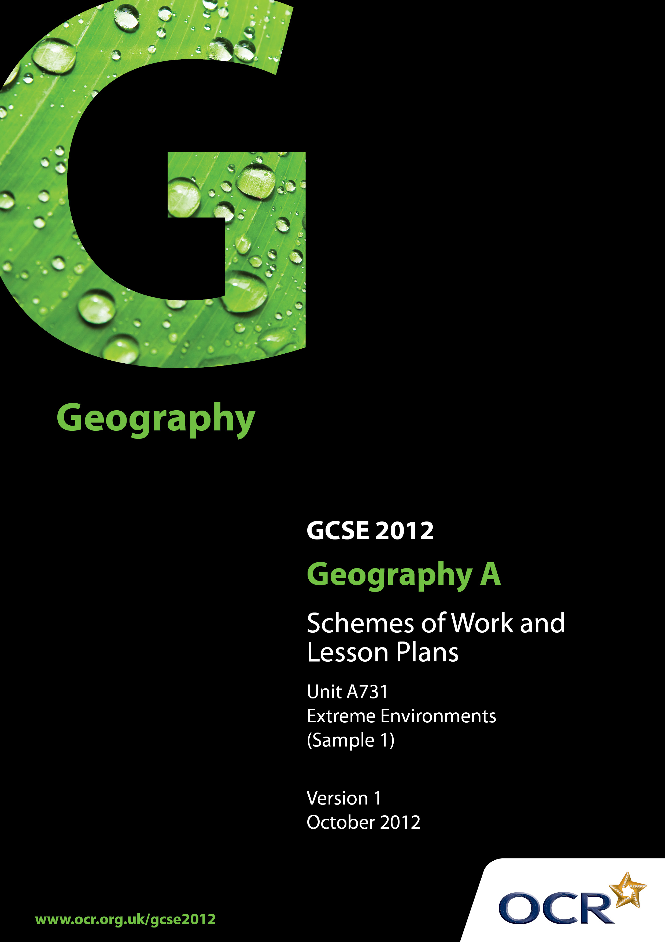
Contents

Contents 2
Introduction 3
Sample Scheme of Work: OCR GCSE Geography A - Extreme Environments 4
Sample Lesson Plan: OCR GCSE Geography A - Extreme Environments 16

Introduction

OCR involves teachers in the development of new support materials to capture current teaching practices tailored to our new specifications. These support materials are designed to inspire teachers and facilitate different ideas and teaching practices.
Each Scheme of Work and set of Sample Lesson Plans is provided in Word format – so that you can use it as a foundation to build upon and amend the content to suit your teaching style and students’ needs.
The Scheme of Work and sample Lesson plans provide examples of how to teach this unit and the teaching hours are suggestions only. Some or all of it may be applicable to your teaching.
The Specification is the document on which assessment is based and specifies what content and skills need to be covered in delivering the course. At all times, therefore, this Support Material booklet should be read in conjunction with the Specification. If clarification on a particular point is sought then that clarification should be found in the Specification itself.

Topic: Extreme Environments
Suggested teaching time: 30 hours

Topic outline | Suggested teaching and homework activities | Suggested resources | Points to note
1) Classification of ‘extreme environments’ | - Use a series of photos to give student groups the opportunity to identify:  (a) what sort of environment this is  (b) how each is being used by people  (c) what makes it an extreme environment  - Class discussion of extreme environments shown. Identification of key characteristics.  - Groups to consider factors that define an extreme environment and write their own definition.  - Display definitions and discuss.  - Display media clips and discuss feelings towards these environments. | - Photo-cards or PowerPoint  - BBC Media clips on deserts and mountains http://www.bbc.co.uk/learningzone/clips/
2) Introducing hot deserts:  - Locate deserts  - Identify common features of location  - Explain the factors influencing desert location | - Use a ‘Maps from memory’ activity to introduce the location of deserts (refer to Leat’s book for full details).  - Produce a map with the detail on it that you want the students to learn including list from specification. Place map outside the classroom. Students work in groups of 5. Their task is to reproduce from memory the detail contained on the master map.  - Following the activity emphasise the key characteristics of desert locations.  - You are the expert activity – complete a diagram explaining one physical factor that influences the location of hot deserts – use as a carousel activity to teach other groups covering different factors. | - ‘BBC Planet Earth – Deserts’ provides a good introduction to a variety of desert landscapes.  - More Thinking Through Geography – David Leat.  - Use page 11 of OCR A GCSE student book (Clemens et al, Pearson publishing) to develop ideas. | - It is important that most of the teaching on hot deserts is exemplified predominantly from ONE desert. There is a wealth of resources on the Sahara but the American deserts, Atacama or Namib Desert might provide alternatives. Clearly the choice should be made in the light of accumulated resources.
3) The physical characteristics of hot deserts | - Annotate a climate graph of your chosen hot desert to highlight annual temperature and rainfall patterns.  - Use climate data to produce graph of climate typical for your chosen desert and compare with UK climate.  - Emphasise desert characteristics: <250 mm rain, rainfall varies significantly from year to year.  - Complete “Living Graph” exercise based on UK and desert climates.  - Use photograph of desert environments to consider the effect this climate has on the landscape and vegetation of hot desert areas.  - Homework: Compare climate of 4 different desert locations – consolidation exercise. | - See Thinking Through Geography David Leat for Living Graphs.  - Some good photographs of the Australian desert found here: http://www.gowilder.org.uk/Uluru/Uluru-2004/index.htm
4) Explaining the desert climate  - Diurnal temperature range  - Intermittent rainfall patterns | - Refer back to desert location. Emphasise common characteristics: latitude, western side of continents, climatic points in common.  - Emphasise desert characteristics: <250 mm rain, rainfall varies significantly from year to year, diurnal as well as seasonal temperature range, opportunity for skills practice – analysis of graphs showing evaporation>precipitation.  - Extended writing task – explain the main features of the desert climate.
5) Desert landscapes | - Starter: use 2 photos – one of a rocky desert environment, the other of sand dunes and pose the question: “How does this turn to this?”  - Discussion about possible processes, focusing on the key processes of: weathering, freeze-thaw action, exfoliation, salt crystallisation, hydration.  - Match photographs to a description of each of the following landforms: sand dune, wadi, yardang, rock pedestal, canyon, salt pan, mesa and butte.  - Students to produce storyboard, display board, magazine page(s), movie (Movie Maker) to cover erosional processes and landforms. | - Photographs or PowerPoint  - Text based resources.  - http://www.edupic.net/desert.htm is a good source of images for desert landforms. | - Most people believe that deserts are sand; in fact sand deserts account for only about 1/3 of desert areas. The area of rock desert is significantly larger.
6) Plant and animal adaptation | - Provide photo of desert plant. Starter discussion: ”How has this plant adapted to survive?”  - Provide table for students to complete:  (a) type of plant  (b) how it has adapted  (c) how this has helped it survive.  - Design an animal: use ‘making animals’ activity to select characteristics and produce an annotated sketch of an ideal animal to survive in the desert.  - Complete diagram of a desert food chain. | - Table and basic resources on a variety of plants.  - Making animals activities explained in “More thinking through Geography” Leat et al.  - http://www.bbc.co.uk/nature/habitats/Deserts_and_xeric_shrublands
7) How are deserts portrayed in cultural resources? | - Use video to set the scene of media portrayal of deserts.  - Provide additional sources on paper or on-line. For each source students should fill out relevant boxes on worksheet:  (a) where is the desert?  (b) what impression of deserts does the source give us?  (c) how are or how could deserts be used?  - Class discussion: how do these resources reinforce or challenge our preconceived notion of what a desert is like? Use these resources to explore ideas of wilderness, what fits into/falls outside our vision of wilderness? Does this view match reality?  - Reflection: how has looking at these resources changed the students’ perception of deserts?  - Write a poem/piece of prose to give an image of hot deserts (Max word limit: 200). | - “Pole to Pole” (Palin) DVD – the section within Egypt  - “Wild Africa” – the BBC programme,  - “Lawrence of Arabia”  - “The English Patient”  - Bear Grylls  - “Ozymandias” by Shelley  - “Across the empty quarter” by Thesiger  - “To the desert” by Saenz  - “Pear blossom highway” by Hockney  - “St John in the desert” by Veneziano | - There are a wide range of sources in both art and literature which might be used. Those to the left have been used by one school. It would be a good idea if possible to choose resources related to your chosen desert.
8) Impact of deserts on humans | - Use population density maps to describe effect of deserts on human habitation.  - Look at examples of people who live and work in hot deserts e.g. oil company workers. |  | - This is a good opportunity to integrate some of the work for the skills paper into this unit. A range of styles of density maps e.g. dot, choropleth migth be assessed for strengths/weaknesses.
9) People’s use of hot deserts | - Recap – why is the desert such a challenging environment for humans? Consider challenges of: accessibility and transport, water supplies, extreme temperatures, drought and famine.  - Show examples of the life of indigenous groups e.g. the Bedouin or Tuareg. Discuss with students views about traditional ways of life and why some indigenous people are moving to the city for work.  - Discuss uses of deserts for Energy e.g oil, solar power.  - Complete a conflict matrix for different uses e.g. oil, solar, traditional. | - Ray Mears clip of desert survival might be used for an introduction: http://www.youtube.com/watch?v=dahR9sJG1b8  - http://www.bradshawfoundation.com/tuareg/tuareg.php has details of Tuareg trading routes  - Oil use - http://www.sahara-group.com/index.php  - Good example for the Arabian desert can be found here: http://www.desertenergyproject.net/Arabian_Consortium.pdf | - Complete this work in relation to the chosen desert area.  - It would be useful to provide photos online or on paper for the process, as well as online or text based resources.
10) The impact of desertification | - Starter photo(s) of encroaching desert. Discussion related to what is happening.  - Consider human and physical causes of desertification – complete a flow diagram.  - Use images to assess impact on the landscape and people.  - Use a case study of chosen desert area to look at how desertification can be managed. | - Afforestation video: http://www.youtube.com/watch?v=5LJRrDAPuWA  - Range of resources also available at UNESDOC.
11) Desert futures | - Consider alternative futures for the desert – sustainable and unsustainable.  - Evaluation of proposed solutions to the problems of deserts. Which will be most likely to succeed? | - http://www.guardian.co.uk/environment/2009/nov/17/earthwatch-institute-drought?intcmp=239
1) The challenge of mountain environments | - Use video/photo images to create perceptions of mountains and how they are used. Could use adaptation of true/false quiz to introduce challenges and myths about mountain areas.  - Ask students to use the stimuli seen to create a record in some form of the challenges and opportunities provided by mountains in general. | - Clips of “Touching the Void” – or passage from the book. | - Challenges may relate to altitude, gradient, accessibility and transport, food and water supplies and how they are managed.  - Other challenges related to extreme natural events and how they are managed including avalanche, landslip/landslide, earthquake and volcanic eruption must also be considered.
2) Representation of mountain environments | - Use video to set the scene of media portrayal of mountains.  - Provide additional sources on paper or online. For each source students should fill out relevant boxes on worksheet. What impression of mountains does the source give us?  - Class discussion: how do these resources reinforce or challenge our preconceived notion of what mountain environments are like? Use these resources to explore ideas of wilderness, what fits into/falls outside our vision of wilderness? Does this view match reality?  - Reflection: how has looking at these resources changed the students’ perception of mountains? | - Touching the Void, Alive, Cliffhanger,K2 are all films set in Mountain environments.  - http://www.poetryinnature.com/nature/mountain-poems.asp for some poems about mountains.
3) Location of mountain environments | - Use atlas and map based resources to produce a fact-file of the world’s main mountain areas.  - Begin to focus in on your chosen mountain range, be it the Alps, Andes, Himalayas or some other. Use some lesson and homework time to produce a general introduction to your chosen area. | - http://maps.howstuffworks.com/world-mountain-ranges-map.htm | - Location of Rockies, Andes, Alps, Himalayas, Great Dividing Range, Pyrenees and Atlas.
4) Climatic characteristics of mountain environments | - Brainstorm how mountains influence the weather and climate in an area. Formulate hypotheses about how mountains influence climate.  - For selected mountain range, produce climate graph(s) to illustrate climate. Complete “living graphs” exercise for the location graphed.  - Find climate data for an area nearby but at or close to sea level. Analyse the impact that altitude has on the mountain climate. Check hypotheses. | - http://www.unlockingthearchives.rgs.org/ has a range of resources based on Mount Everest.  - See “Thinking Through Geography” David Leat for Living Graphs.
5) Formation of mountain environments | - Show image(s) of your selected mountain range’s scenery. Discuss processes likely to be at work creating this scenery.  - Ask students to focus on one type of plate boundary – use carousel activity to get them to explain each type of boundary. | - Chapter 8 of http://www.classzone.com/books/earth_science/terc/navigation/visualization.cfm has some useful animations of plate boundaries. | - The tectonic activity covered here is likely to have some overlap with the ‘earthquake issue’ section.
6) Physical processes in mountain environments | - Show image(s) of your selected mountain range’s scenery. Discuss processes likely to be at work creating this scenery.  - Set students task of producing magazine article to cover the formation of mountain landforms and the processes responsible for their existence. IT access essential. | - “Geography in Animation” is a good basic starting point. Many textbooks and websites cover this well.
7) Human use of mountain environments | - Brainstorm the different human uses of mountain environments.  - All class to complete a report on one key use as a model of the sort of information that needs to be included.  - Each individual/sub group to complete a similar report on a second use – topic must include a named type of tourism, HEP and Geothermal Power.  - Report back to class on second area studied, producing summary sheet for rest of class use. | - Indigenous uses - http://himalayanvoices.org/  - Case study of human use in the Andes http://www.coolgeography.co.uk/GCSE/AQA/Restless%20Earth/Andes/Andes%20Case%20study.htm  - Ecotourism in Nepal http://education.nationalgeographic.com/archive/xpeditions/lessons/10/g912/nepaltourism.html?ar_a=1  - Geothermal energy in California http://www.geothermal.org/articles/California.pdf
8) The future of mountain environments | - Identify key challenges to the future of your chosen area. Students to summarise these in diagrammatic form.  - Allocate one or more per small group for research and presentation of a report covering: the cause(s) of the threat, the impact it is having, the outcome if it is not managed, and a proposed management strategy.  - Class debate on the future choices for your mountain area. | - IPCC report on climate change http://www.ipcc-wg2.gov/publications/SAR/SAR_Chapter%205.pdf  - http://www.theatlantic.com/technology/archive/2012/06/can-this-photograph-of-a-himalayan-glacier-persuade-people-that-climate-change-is-happening/259080/ | - Climate change is an important area to cover here, but other factors affecting the future of mountain regions should aslo be considered.

Topic: Issues in our Fast Changing World - Earthquake
Suggested teaching time: 10 hours

Topic outline | Suggested teaching and homework activities | Suggested resources | Points to note
1) What is the Issue?  Identify a range of hazards and what causes them. | - Define different types of hazards  - World map, mark on where different types of hazard occur, i.e. tectonic, atmospheric and geomorphological.  - Focus in on chosen earthquake event using 5W’s technique. | - Blank world map locating a range of different hazards.  - Use following website to compare recent earthquake activity with plate boundaries  http://earthquake.usgs.gov/earthquakes/map/ | - A ‘recent’ earthquake event in the context of this specification is considered to be one occurring within the last five years of the students starting their course.
2) What are the causes of the issue?  Physical processes along plate boundaries that cause earthquakes.  Measuring earthquakes. | - Recap physical processes. Completion of annotated diagrams explaining the processes that lead to earthquakes.  - Place a range of recent earthquakes on the Magnitude (Richter) scale and Modified Mercalli Intensity scale.  - Do both scales agree? Evaluation of strengths/weaknesses of each. | - BBC Animation of causes of earthquakes http://news.bbc.co.uk/1/hi/4126809.stm  - Info specific to 2011 Canterbury earthquake found here: http://www.gns.cri.nz/Home/Learning/Science-Topics/Earthquakes/Earthquakes-and-Faults  - Alternatively range of resources on the Japan 2011 earthquake and Tsunami on SLN http://www.sln.org.uk/geography/  and from the GA http://www.geography.org.uk/resources/japantsunami/ | - Some similarities with content for the earlier work on fold mountain formation. Centres should concentrate on the processes that lead to an earthquake occurring, rather than different plate boundaries.
3) What are the short- and long-term impacts of this event, both positive and negative? | - Discuss and define physical, social and economic effects of earthquakes including ground shaking, liquefaction, landslides and tsunami.  - Impacts on people, buildings, infrastructure economy and the natural environment.  - Complete Venn diagram of the effects- social-economic-environmental for chosen earthquake event. | - Range of resources on the 2011 Canterbury Earthquake http://nzcurriculum.tki.org.nz/News/Canterbury-earthquake-resources-for-schools  http://www.dreamteach.co.uk/uploads/news/files/30.swf
4) How and why do these impacts differ across the world? | - Compare chosen earthquake event with one in a country with contrasting level of development. e.g. Chinese earthquake Sichuan and New Zealand earthquake.  - Through the above two case studies illustrate the key ideas of differing hazard impact and how these impacts differ according to development levels. What role do national government, local government and non-governmental organisations play? | - Chinese earthquake BBC Web Site. Blank map of China and New Zealand.  - GA resources on New Zealand earthquake http://www.geography.org.uk/resources/earthquakes/
5) How is this issue managed?  Why do responses to hazards differ in different parts of the world? | - Pupils to work in groups discussing WHY responses are different.  - Look at earthquake management techniques used for chosen case study and contrasting example. | - Use the above two case studies to look at differing responses. LEDC v MEDC.  - BBC Bitesize has some useful notes on this http://www.bbc.co.uk/schools/gcsebitesize/geography/natural_hazards/earthquakes_rev4.shtml
6) How may this issue be managed in the future?  How may similar natural events and their impacts be managed in the future? | - Show images of a range of different earthquake engineering techniques.  - Evaluate usefulness for both MEDC and LEDC.  - Students could design (and possibly build) their own earthquake proof building. Designs might be tested with an earthquake simulator. | - Useful report on how New Zealand schools prepare: http://www.em.gov.au/Documents/Johnston.PDF  - http://en.wikipedia.org/wiki/Earthquake_engineering  - See juicy geography website for an earthquake shaker design http://www.juicygeography.co.uk/shaker.htm

OCR Geography GCSE A

Introducing Extreme Environments
OCR recognises that the teaching of this qualification above will vary greatly from school to school and from teacher to teacher. With that in mind this lesson plan is offered as a possible approach but will be subject to modifications by the individual teacher.
Lesson length is assumed to be one hour.

Learning Objectives for the Lesson
Objective 1 | To be able to define “extreme environments”
Objective 2 | To know what conditions make these environments extreme
Objective 3 | To appreciate that these environments are portrayed in different ways by different people
Objective 4 | To appreciate that these environments evoke different responses in different people

Recap of Previous Experience and Prior Knowledge
- This is the first lesson in the scheme of work. Recap of areas already met in KS3 will come in discussion.

Content
Time | Content
5 minutes | Put title “Extreme Environments” and images of desert and mountain environments on the screen. Discuss: “What makes these environments extreme?”
15 minutes | Look at a definition of the word ‘extreme’. Explore the idea of it meaning ‘far from normal’. Discuss what we might expect in a ‘normal’ environment.  Provide groups with about 12 contrasting photographs of the environments, either using photo-cards or using PowerPoint. Ask students to record the sort of environment in each photo, how it is being used by people and what specifically makes it extreme. (Choose photos which will bring out different facets of extremity).
5 minutes | Plenary: what makes each environment extreme? To what extent are these images a portrayal of different people’s perceptions?
10 minutes | Ask groups to write an agreed definition for the term “extreme environment”. (It must be short and memorable).
10 minutes | Display definitions: discuss strengths of each and agree class definition. (It may be useful to have other definitions at hand if the class’s contributions are deficient in any area).
10 minutes | Use photos or media clips to elicit student response to these environments. Are they safe/dangerous? challenging/frightening? etc. Discuss why people can respond to extreme environments in different ways.

Consolidation
Time | Content
5 minutes | Plenary: discuss what is extreme about each environment.  What is agreed definition? Are they still happy with it?  In what ways are their responses and the responses of others to extreme environments different?

